GABECE Technical Drawing
Complete Past Question Compendium (2002 – 2026)

Prepared by S&P Group

A comprehensive collection of past GABECE Technical Drawing questions
from 2002 to 2026, organized by year with detailed answer keys.
Includes mock exam papers and topic cross-references.

Copyright © S&P Group. All rights reserved.

Preface
This compendium is a comprehensive collection of
past GABECE (Botswana General Certificate of Secondary Education) Technical Drawing examination questions, spanning from 2002 to 2026. It has been carefully compiled to serve as the ultimate study companion for students preparing for their Technical Drawing examinations.
The book contains 393 past examination questions organized by exam year. Each year's section contains the questions first, followed by a complete Answer Key with explanations at the end of the section. This format allows you to attempt all questions before checking your answers.
Key features of this book:
- Answer key at end of each year — attempt questions first, then check
- Topic tags on every question for focused revision
- 157 embedded diagrams in compact WAEC style
- Chief Examiner insights from real GABECE reports (2018–2023)
- 3 mock exam papers for final revision practice
- Topic cross-reference to find all questions by topic
Work through each year's paper under timed conditions (2 hours 30 minutes), then check your answers using the Answer Key at the end of that section.
We wish you every success in your examinations.
— The S&P Group Team

How to Use This Book
▸ Study by Topic: Use the Topic Cross-Reference Index at the back of this book to find all questions on a specific topic (e.g., all circle questions across all years). This helps you master one concept at a time.
▸ Practice by Year: Work through each year's paper in order to simulate the real exam experience. Time yourself for 2-3 hours per paper. Check your answers using the Answer Key table at the end of each year section.
▸ Mock Exams: The 3 Mock Exam Papers at the back mix questions from all years. Use these for final revision after you have studied all the topic areas.
▸ Understand Explanations: Every question includes an explanation of the correct answer. Read these carefully even for questions you got right — they often contain important additional information.
▸ Identify Weak Areas: Keep track of which topics you find difficult. Revisit those chapters and practice more questions from the Topic Cross-Reference Index.

Quick Reference Guide

Line Types
Line Type | Usage
Continuous Thick | Outlines, visible edges
Continuous Thin | Dimension lines, extension lines, hatching
Dashed (Short) | Hidden details
Chain Thin (Long-short) | Centre lines, lines of symmetry
Wavy | Long break lines
Zig-zag | Short break lines
Chain Thin (Double) | Cutting planes

Angle Types
Type | Definition
Acute | Less than 90°
Right | Exactly 90°
Obtuse | Between 90° and 180°
Straight | Exactly 180°
Reflex | Between 180° and 360°
Complementary | Two angles that sum to 90°
Supplementary | Two angles that sum to 180°

Quadrilaterals

Shape | Properties
Square | 4 equal sides, 4 right angles, diagonals bisect at 90°
Rectangle | Opposite sides equal, 4 right angles, diagonals equal
Rhombus | 4 equal sides, opposite angles equal, diagonals bisect at 90°
Parallelogram | Opposite sides parallel and equal, opposite angles equal

Trapezium | Only one pair of parallel sides
Kite (Deltoid) | Two pairs of adjacent equal sides

Key Formulas
- Sum of interior angles of a triangle = 180°
- Sum of interior angles of a quadrilateral = 360°
- Sum of interior angles of an n-sided polygon = (n − 2) × 180°
- Exterior angle of a regular polygon = 360° ÷ n
- Interior angle of a regular polygon = 180° − exterior angle
- A4 paper size = 210 mm × 297 mm
- A3 paper size = 297 mm × 420 mm
- Standard border margin = 10 mm
- Standard lettering height (capitals) = 5 mm
- Minimum lettering height = 3 mm
- Hatching angle = 45°
- Isometric receding angle = 30°
- Oblique receding angle = 45°
- Cabinet projection reduces depth by half

GABECE Technical Drawing — 2002
Paper: 2002 | Total Questions: 46

Q1. The distance PO in the diagram above is one metre. What does OQ represent in mm? [Freehand & Solids]
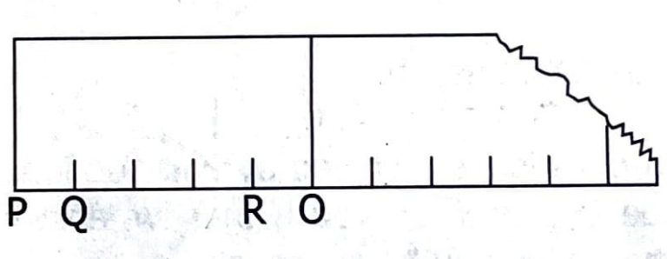
A. 400 mm
B. 600 mm
C. 800 mm
D. 900 mm

Q2. The diagram above illustrates a/an [Lines & Conventions]
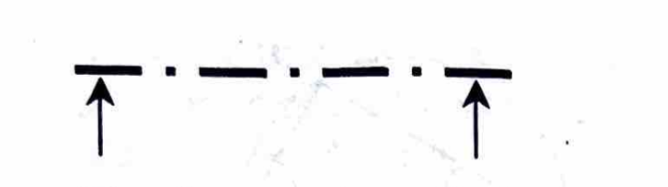
A. centre line
B. cutting plane
C. dimension line
D. outline

Q3. In the diagram above, line YZ is known as [Angles & Construction]
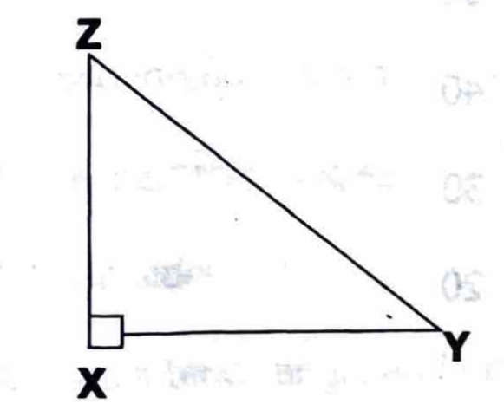
A. adjacent side
B. inclined side
C. hypotenuse
D. opposite side

Q4. In triangle ABC above, line CD is called a/an [Lines & Conventions]
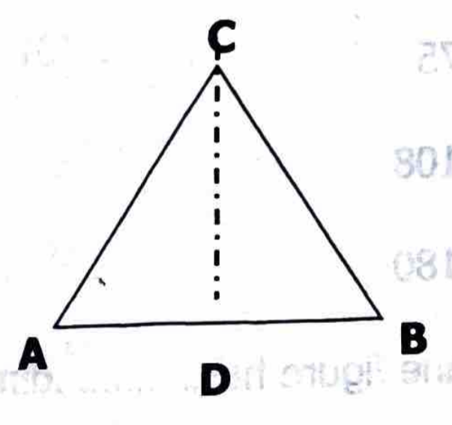
A. adjacent side
B. diagonal
C. hidden line
D. vertical height

Q5. In the diagram above X is called a … line. [Lines & Conventions]
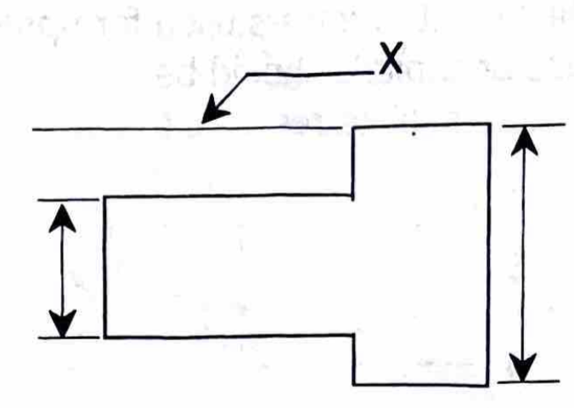
A. dimension
B. extension
C. horizontal
D. projection

Q6. Hidden details of objects are shown by [Lines & Conventions]
A. a continuous thin line
B. short dashed lines
C. a continuous thick line
D. short chain lines

Q7. When two lines are equidistant throughout their lengths, they are said to be [Lines & Conventions]
A. horizontal
B. parallel
C. perpendicular
D. vertical

Q8. The height of letters used for upper case or capitals should be … millimetres. [Dimensioning & Lettering]
A. 3
B. 4
C. 5
D. 8

Q9. In third angle projection the plan is normally drawn [Projections]
A. above the front elevation
B. below the front elevation
C. on the left side of the front elevation
D. on the right side of the front elevation

Q10. The number of views shown in an isometric drawing is [Projections]
A. 2
B. 3
C. 4
D. 5

Q11. Two angles that add up to 180º are called … angles. [Angles & Construction]
A. alternate
B. complimentary
C. supplementary
D. vertically opposite

Q12. The diagram above shows a triangle drawn in a circle, centre O. The value of angle y is … degrees. [Angles & Construction]
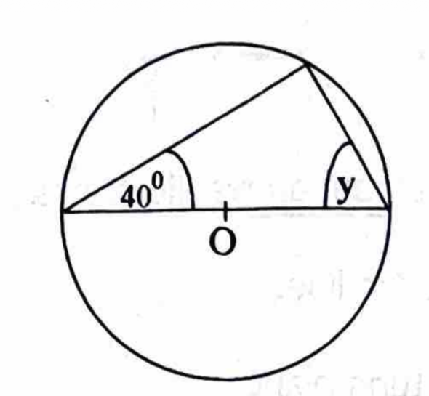
A. 50
B. 40
C. 30
D. 20

Q13. In the diagram above the sum of angles x and y is … degrees. [Angles & Construction]
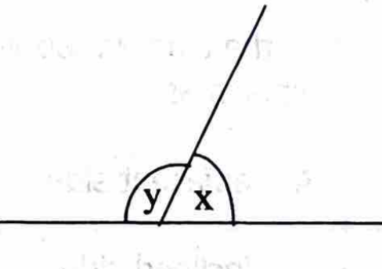
A. 45
B. 75
C. 108
D. 180

Q14. A plane figure has … dimensions. [Dimensioning & Lettering]
A. 2
B. 3
C. 4
D. 5

Q15. A triangle that has none of its sides and angles equal is called a/an … triangle. [Triangles]
A. equilateral
B. isosceles
C. right-angled
D. scalene

Q16. To inscribe a circle in a triangle, it is necessary to bisect any [Angles & Construction]
A. two interior angles
B. two exterior angles
C. two sides
D. one interior angle and one side

Q17. In the diagram above, angle ACD is [Angles & Construction]
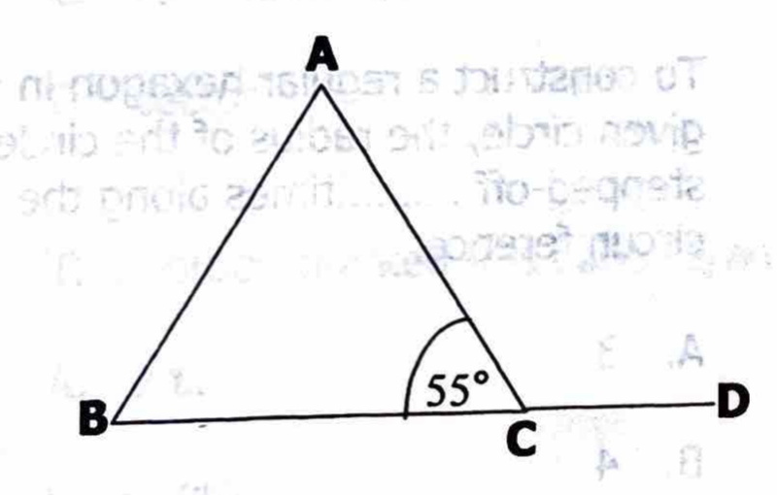
A. 105°
B. 115°
C. 125°
D. 155°

Q18. The minimum number of arcs needed to bisect an angle is [Angles & Construction]
A. 2
B. 3
C. 4
D. 5

Q19. In the diagram above X is a 45° set square and Y a 30°/60° set square. What is the value of angle θ? [Drawing Instruments]
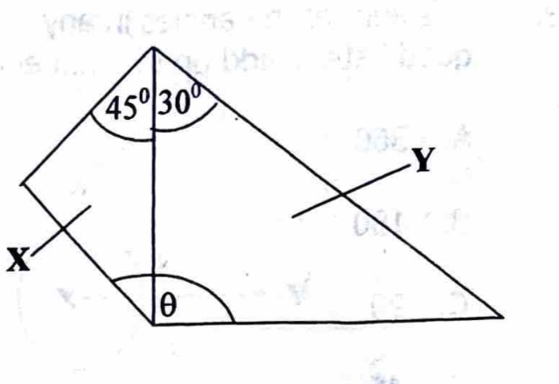
A. 105°
B. 125°
C. 130°
D. 135°

Q20. The vertical angle of an isosceles triangle is 70°. What is the value of each of the other two angles? [Triangles]
A. 55°
B. 65°
C. 75°
D. 110°

Q21. The diagram above is called a [Lines & Conventions]
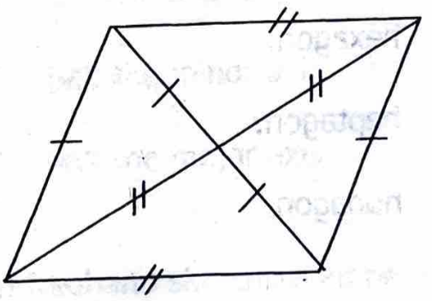
A. parallelogram
B. rhombus
C. rhomboid
D. square

Q22. The sum of the angles in any quadrilateral add up to … degrees. [Angles & Construction]
A. 360
B. 180
C. 90
D. 45

Q23. The figure above is called a/an [Quadrilaterals]
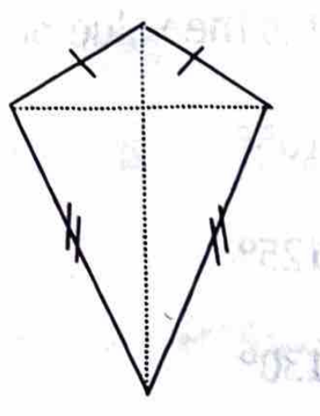
A. deltoid
B. isosceles triangle
C. trapezoid
D. wedge

Q24. A nine-sided polygon is called a [Polygons]
A. pentagon
B. hexagon
C. heptagon
D. nonagon

Q25. The figure above shows a regular pentagon. What is the value of angle QRS? [Polygons]
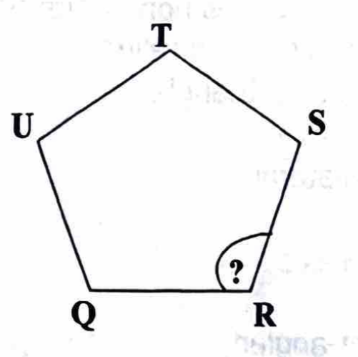
A. 60°
B. 75°
C. 108°
D. 180°

Q26. To construct a regular hexagon in a given circle, the radius of the circle is stepped-off … times along the circumference. [Circles & Ellipses]
A. 3
B. 4
C. 5
D. 6

Q27. The regular polygon which can be drawn using 60° set square and a Tee square only is a [Polygons]
A. pentagon
B. hexagon
C. heptagon
D. nonagon

Q28. The portion marked Q is called a/an [Circles & Ellipses]
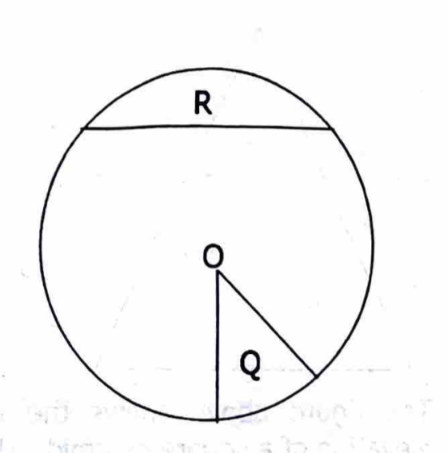
A. arc
B. arch
C. circumference
D. sector

Q29. The portion marked R is called a/an [Circles & Ellipses]
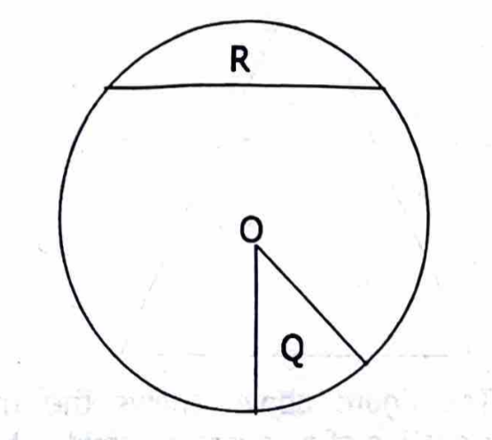
A. arc
B. chord
C. diameter
D. segment

Q30. The sum of the angles in a circle is equal to … degrees. [Angles & Construction]
A. 90
B. 180
C. 270
D. 360

Q31. In which of the drawings above is the line X–Y a tangent? [Circles & Ellipses]
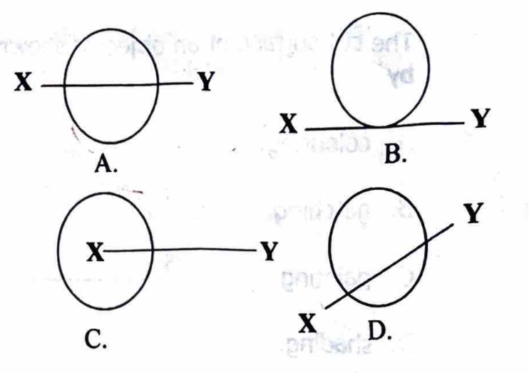
Q32. The diagram above shows VW as the major axis and ST as the minor axis of an ellipse. F1 and F2 are the focal points and P is a point on the curve. The distance TF2 is equal to [Circles & Ellipses]
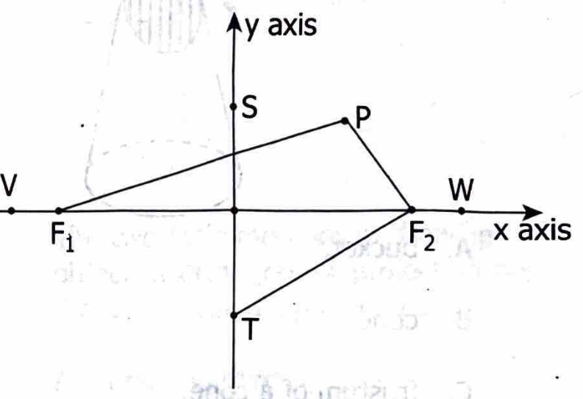
A. the major axis
B. the minor axis
C. half the minor axis
D. half the major axis

Q33. In freehand sketching emphasis should be laid on [Freehand & Solids]
A. the type of pencil used
B. guide lines
C. good proportion
D. shading

Q34. The cut surface of an object is shown by [Lines & Conventions]
A. colouring
B. hatching
C. painting
D. shading

Q35. The figure above is called a [Freehand & Solids]
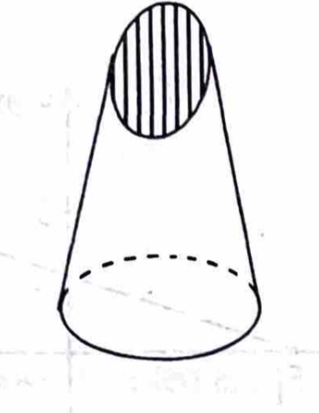
A. bucket
B. cone
C. frustum of a cone
D. pyramid

Q36. In an isometric projection, receding lines are drawn at … degrees to the horizontal. [Projections]
A. 60
B. 45
C. 30
D. 15

Q37. A pyramid can be identified by [Freehand & Solids]
A. its height
B. its weight
C. the area of its base
D. the shape of its base

Q38. The diagram of a cone is shown above, what shape would be produced by the cutring plane A A. [Lines & Conventions]
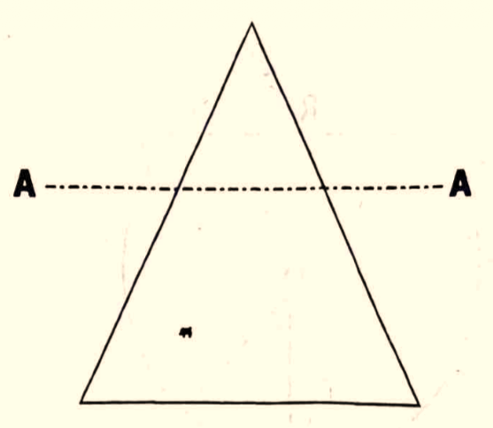
A. circle
B. ellipse
C. parabola
D. hyperbola

Q39. The diagram above shows a/an … view of a cuboid. [Projections]
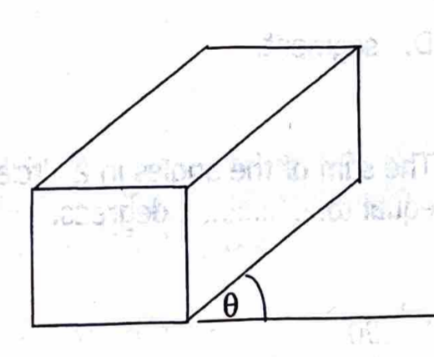
A. isometric
B. oblique
C. orthographic
D. perspective

Q40. In an oblique cabinet drawing the length of the object is divided by [Projections]
A. 2
B. 3
C. 4
D. 5

Q41. The diagram above illustrates a/an … axis. [Projections]
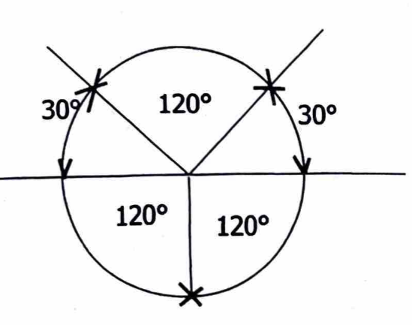
A. isometric
B. oblique
C. perspective
D. axonometric

Q42. Which of the figures above is correctly dimensioned? [Dimensioning & Lettering]
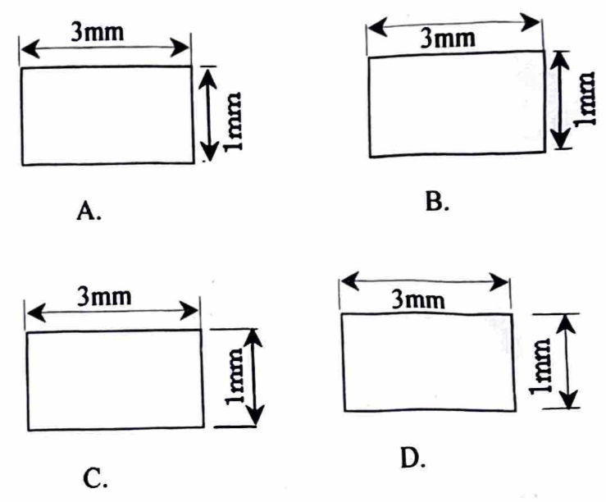
Q43. The two main methods of drawing an object in orthographic projection are the … angle projection. [Projections]
A. first and third
B. first and second
C. second and fourth
D. second and third

Q44. The skills of movement controlled by the brain are called [Circles & Ellipses]
A. perception
B. motor skills
C. technical drawing
D. intellectual skill

Q45. Which of the following is true about Technical Drawing? [General]
A. It is meaningless
B. It is easy and useless
C. It encourages tidy and accurate work
D. It confuses people at work

Q46. Which of the following items could be used in the absence of drawing clips? [Drawing Instruments]
A. Paper tape
B. Glue
C. Screws
D. Nails

GABECE 2002 — Answer Key
Q# | Answer | Explanation
1 | C | 1 metre equals 1000 mm; proportionally OQ represents 800 mm.
2 | A | Centre lines are thin long short dashes line used to indicate centres of objects.
3 | C | In a right triangle, the hypotenuse is the longest side opposite the right angle.
4 | D | Line CD represents the vertical height of the triangle.
5 | D | Projection lines are used to project views in technical drawing.
6 | B | Hidden details are represented by short dashed lines.
7 | B | Parallel lines remain equidistant at all points.
8 | C | Standard lettering height for capitals is 5 mm.
9 | A | In third angle projection, the plan is drawn above the front elevation.
10 | B | Isometric drawings show three views simultaneously.
11 | C | Supplementary angles sum to 180°.
12 | A | By circle theorems, the inscribed angle is 50°.
13 | D | Angles on a straight line sum to 180°.
14 | A | Plane figures have two dimensions: length and breadth.
15 | D | A scalene triangle has all sides and angles unequal.
16 | A | Bisecting two interior angles locates the incenter for the inscribed circle.
17 | C | By geometric construction, angle ACD measures 125°.
18 | A | Two arcs are sufficient to bisect an angle using compass construction.
19 | D | Combining the set squares gives an angle of 135°.
20 | A | The base angles of an isosceles triangle are equal; each is (180° - 70°) ÷ 2 = 55°.
21 | A | The figure shown has opposite sides parallel, identifying it as a parallelogram.
22 | A | Quadrilaterals have four interior angles that sum to 360°.
23 | A | The figure shown has pairs of adjacent sides equal, making it a deltoid or kite.
24 | D | A polygon with nine sides is called a nonagon.
25 | C | Each interior angle of a regular pentagon is 108°.
26 | D | The radius is stepped off six times to form a hexagon.
27 | B | A hexagon can be constructed using a 60° set square and Tee square.
28 | D | The portion marked Q is a sector of the circle.
29 | D | The portion marked R is a segment of the circle.
30 | D | A full circle measures 360°.
31 | B | A tangent touches a circle at exactly one point.
32 | D | The distance from T to F2 corresponds to the length of half the major axis.
33 | C | Good proportion ensures accuracy in freehand sketching.
34 | B | Hatching lines are used to indicate cut surfaces.
35 | C | The figure shown is a frustum of a cone.
36 | C | Isometric receding lines are drawn at 30° to the horizontal.
37 | D | The shape of the base determines the type of pyramid.
38 | A | Line A A is cut parallel to the base, the shape exposed is circle.
39 | B | The cuboid is shown in oblique view.
40 | A | Cabinet projection reduces receding lengths by half.
41 | A | The diagram shows isometric axes.
42 | A | Option A follows correct dimensioning standards.
43 | A | Orthographic projection uses first and third angle methods.
44 | B | Motor skills are physical movements coordinated by the brain.
45 | C | Technical drawing promotes accuracy and neatness in work.
46 | A | Paper tape can temporarily hold drawing sheets in place.

GABECE Technical Drawing — 2015
Paper: 2015 | Total Questions: 54

Q1. In the diagram above, part “y” and “z” are fixed together at x°. The value of angle xº is [Drawing Instruments]
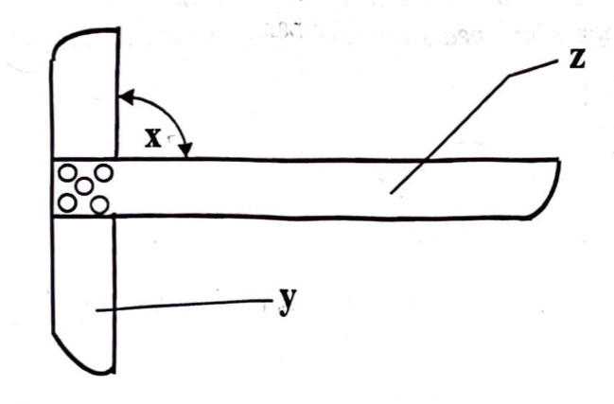
A. 180°
B. 100°
C. 90°
D. 45°

Q2. The part labeled “y” is called the [Drawing Instruments]
A. blade
B. long piece
C. stock
D. handle

Q3. Which of the following equipment is used for measuring angles? [Drawing Instruments]
A. French curve
B. Compass
C. Protractor
D. Straight edge

Q4. In measuring distance, how many millimetres will be equal to 9.6 cm? [General]
A. 960 cm
B. 96 mm
C. 0.96 mm
D. 906 mm

Q5. What name is given to the old system of measuring? [General]
A. Imperial system
B. New system
C. Poles
D. Metric system

Q6. Line XY above is divided in the ratio of [Lines & Conventions]
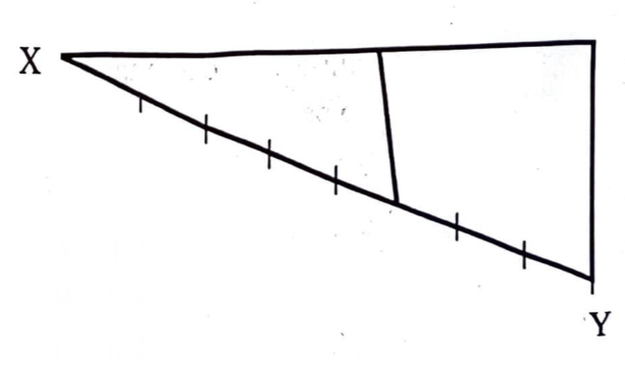
A. 4:2
B. 5:3
C. 6:4
D. 8:5

Q7. Which of the following represent perpendicular lines? [Lines & Conventions]
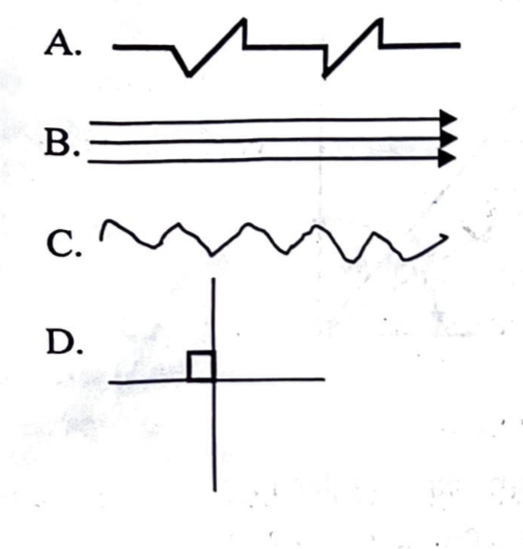
Q8. Lines which move towards a point are known as … lines. [Lines & Conventions]
A. inclined
B. converging
C. radial
D. diverging

Q9. … lines are used to show long break lines. [Lines & Conventions]
A. Wavy
B. Thick continuous
C. Zig-zag
D. Long chain

Q10. Lines that are equidistant throughout their length are said to be [Lines & Conventions]
A. parallel
B. horizontal
C. equal
D. perpendicular

Q11. Which of the following points need to be considered when lettering on a diagram? [Dimensioning & Lettering]
A. Letters should be neat and legible
B. Letters should be thick and slanted
C. Letters should be clear and slanted
D. Letters should be thin and stenciled

Q12. The horizontal position of a drawing sheet is known as … layout. [Dimensioning & Lettering]
A. artistic
B. landscape
C. up-right
D. portrait

Q13. Which of the following is likely not to be included in a title block? [Dimensioning & Lettering]
A. Scale
B. Title
C. Address
D. Name

Q14. To triset an angle means to divide an angle into … equal parts. [Angles & Construction]
A. 2
B. 3
C. 4
D. 5

Q15. In the diagram above angle P is called … angle. [Angles & Construction]
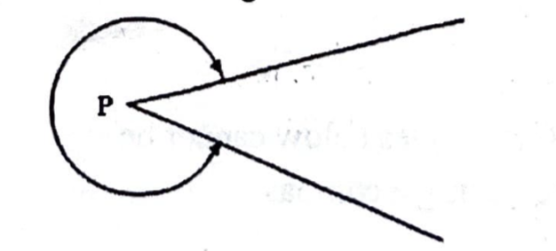
A. reflex
B. obtuse
C. acute
D. incomplete

Q16. Which of the following angles can be called an acute angle? [Angles & Construction]
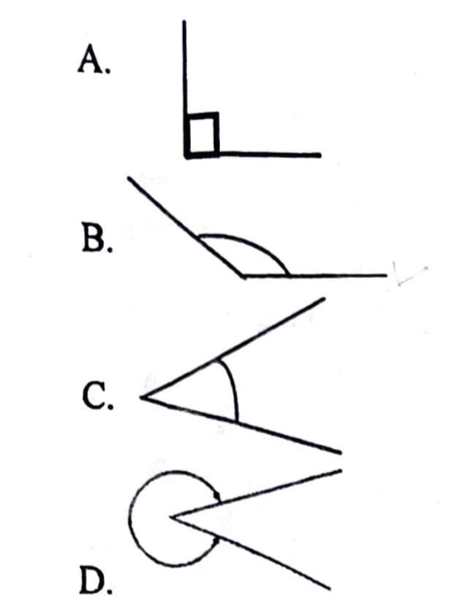
Q17. The sum of the angles in a triangle totals to [Angles & Construction]
A. 90°
B. 120°
C. 180°
D. 360°

Q18. If angle a and angle b in the diagram above are equal to 60° each, what is angle ĉ? [Angles & Construction]
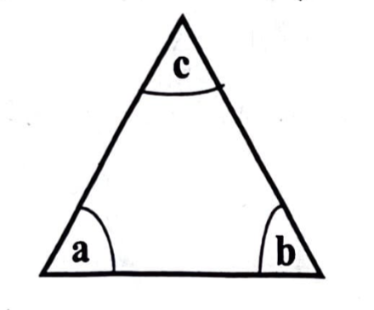
A. 30°
B. 45°
C. 60°
D. 90°

Q19. Which of the angles above cannot be constructed using a compass? [Angles & Construction]
A. 105°
B. 70°
C. 60°
D. 15°

Q20. The diagram above shows the relationship of three angles. What name could be given to the three angles? [Angles & Construction]
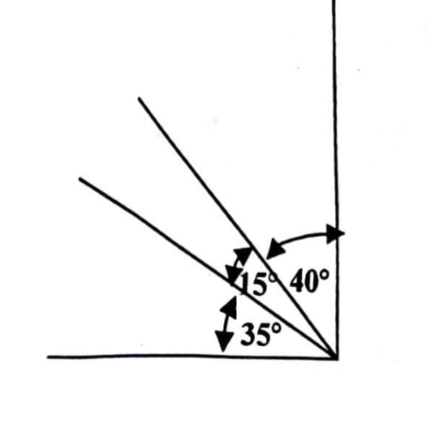
A. Complementary angles
B. Right angles
C. Supplementary angles
D. Reflex angles

Q21. The distance between the opposite corners of a quadrilateral is called the [Lines & Conventions]
A. arms
B. diagonal
C. side
D. diameter

Q22. Which of the following is not an example of a quadrilateral? [Circles & Ellipses]
A. Kite
B. Trapezoid
C. Rhombus
D. Quadrant

Q23. Which of the following is not true about a rhombus? [Angles & Construction]
A. The diagonals bisect each other at 90º
B. The opposite angles are not equal
C. All the sides are equal
D. The opposite sides are parallel to each other

Q24. In quadrilaterals, a rectangle is to parallelogram as square is to [Quadrilaterals]
A. trapezium
B. trapezoid
C. rhombus
D. kite

Q25. The radius of a circle in a square as shown above is 40 mm. What is the length of sides of the square? [Circles & Ellipses]
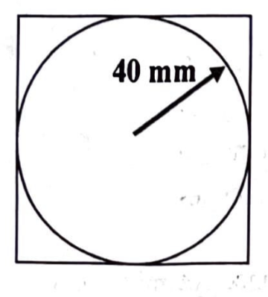
A. 80 mm
B. 90 mm
C. 100 mm
D. 120 mm

Q26. A polygon is a plane figure with more than … sides. [Polygons]
A. 2
B. 3
C. 4
D. 5

Q27. A regular polygon which contains exactly ten sides is called [Polygons]
A. heptagon
B. octagon
C. decagon
D. nonagon

Q28. Which of the polygons can be constructed using 45° set-square? [Drawing Instruments]
A. Hexagon
B. Pentagon
C. Heptagon
D. Octagon

Q29. What are the internal angles of a pentagon? [Polygons]
A. 108°
B. 72°
C. 45°
D. 27°

Q30. Circles with the same centre but different radiuses are called … circles. [Circles & Ellipses]
A. central
B. concentric
C. eccentric
D. tangential

Q31. The angle between the normal and the tangent is [Circles & Ellipses]
A. 60°
B. 90°
C. 180°
D. 360°

Q32. What is the value of angle Xº as shown in the diagram above? [Angles & Construction]
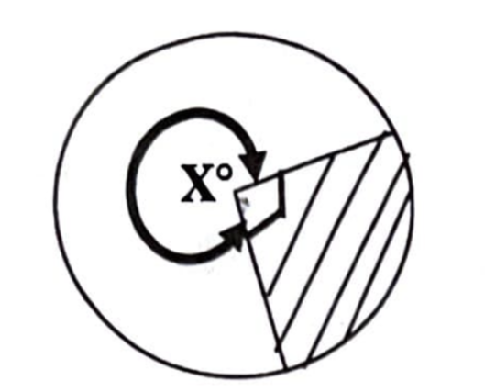
A. 90°
B. 180°
C. 270°
D. 360°

Q33. What fraction of the circle does the shaded portion cover? [Circles & Ellipses]
A. 1/3
B. 1/2
C. 1/4
D. 3/4

Q34. Which of the following parts cannot be found on an ellipse? [Circles & Ellipses]
A. Minor axis
B. Apex
C. Point of tangency
D. Major axis

Q35. F1 and F2 are usually points located on an ellipse. What does “F” stand for? [Circles & Ellipses]
A. Fixed
B. First
C. Focal
D. Form

Q36. A good freehand sketch can be determined by its [Freehand & Solids]
A. legibility
B. accuracy
C. neatness
D. proportionality

Q37. What is the name given to the geometrical solid shown above? [Freehand & Solids]
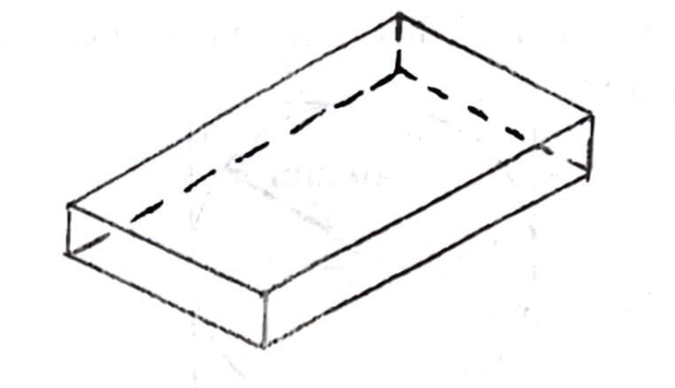
A. Square pyramid
B. Rectangular prism
C. Triangular pyramid
D. Cube

Q38. Another name given to a square prism is called [Freehand & Solids]
A. pyramid
B. cube
C. geometrical
D. cylinder

Q39. A cutting plane P–P of a cone is shown above. What section will be exposed by the cutting plane? [Projections]
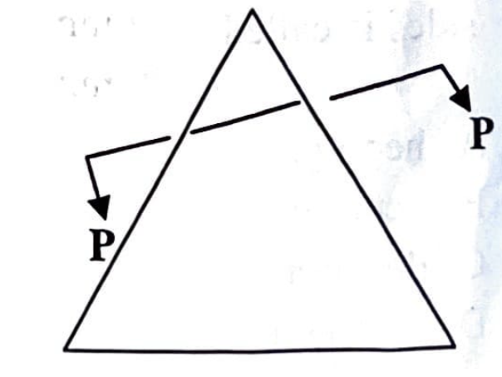
A. Hyperbola
B. Ellipse
C. Parabola
D. Circle

Q40. The drawing method shown above is called [Projections]
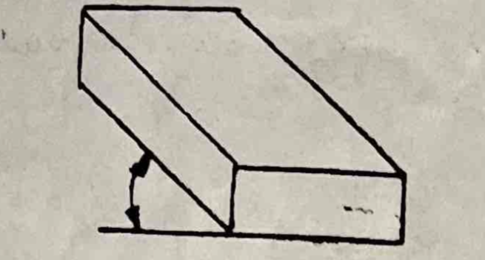
A. oblique projection
B. isometric projection
C. orthographic projection
D. first angle projection

Q41. Which of the following angle projections is normally used in orthographic projection? [Projections]
A. 2nd and 3rd angle
B. 1st and 4th angle
C. 1st and 2nd angle
D. 1st and 3rd angle

Q42. The receding angle generally used in isometric projection is [Projections]
A. 20°
B. 30°
C. 45°
D. 60°

Q43. What is the standard dimension of an A4 paper? [Dimensioning & Lettering]
A. 420 mm × 594 mm
B. 143 mm × 210 mm
C. 210 mm × 297 mm
D. 297 mm × 420 mm

Q44. The line marked Q in the diagram above is called a/an [Lines & Conventions]
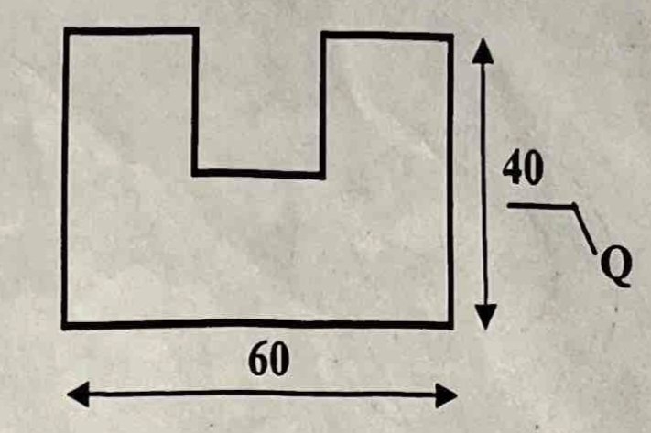
A. projection line
B. dimension line
C. outline
D. chain line

Q45. The true shape of a section can be shaded using hatching lines usually at an angle of [Projections]
A. 90°
B. 60°
C. 45°
D. 30°

Q46. The plan view of an object is a drawing which shows the view from [Projections]
A. left hand side
B. the front
C. above
D. right hand

Q47. Good draughtmanship involves … [Dimensioning & Lettering]
A. the use of compasses alone
B. division of the drawing area
C. drawing border lines and title block
D. using all the types of lines in one particular drawing

Q48. In visualization one uses … [Freehand & Solids]
A. intellectual skills
B. visual skills
C. motor skills
D. light

Q49. The main function of a ruler is to … [Drawing Instruments]
A. transfer measurement from an object to a drawing
B. measure in meters
C. mark points on a drawing
D. measure distances on a drawing

Q50. The instrument used to measure angles is a … [Drawing Instruments]
A. ruler
B. protractor
C. pair of compasses
D. French curve

Q51. The drawing sheet is set parallel to the top edge of the drawing board using … [Drawing Instruments]
A. drawing clips
B. ruler
C. try square
D. tee square

Q52. All the following pencils are used in technical drawing except … [Drawing Instruments]
A. HB
B. 2B
C. 4B
D. H

Q53. What is the base unit for measuring distance in the metric system? [General]
A. Hectometer
B. Meter
C. Decimeter
D. Acre

Q54. The common unit of linear measurement on drawings is … [Lines & Conventions]
A. kilometer
B. hectometer
C. decimeter
D. millimeter

GABECE 2015 — Answer Key
Q# | Answer | Explanation
1 | C | The blade and stock of a T-square meet at 90°.
2 | C | The part label y is the stock.
3 | C | A protractor is designed for measuring angles.
4 | B | 1 cm = 10 mm, so 9.6 cm = 96 mm.
5 | A | The Imperial system was used before the metric system.
6 | B | The division shown corresponds to a 5:3 ratio.
7 | D | Perpendicular lines intersect at 90°.
8 | B | Converging lines meet at a point.
9 | A | Wavy lines indicate long breaks in objects.
10 | A | Parallel lines remain equidistant at all points.
11 | A | Legibility and neatness are essential in lettering.
12 | B | Landscape layout means the long side is horizontal.
13 | C | Title blocks usually exclude addresses.
14 | B | Trisecting divides an angle into three equal parts.
15 | A | A reflex angle is an angle greater than 180° but less than 360°.
16 | C | Acute angles are less than 90°.
17 | C | The interior angles of a triangle sum to 180°.
18 | C | The third angle is 180° - (60° + 60°) = 60°.
19 | A | 105° cannot be constructed directly with compass and straightedge.
20 | A | complementary angles sum to 90°.
21 | B | A diagonal connects opposite corners of a quadrilateral.
22 | D | A quadrant is not a quadrilateral; it is a quarter of a circle.
23 | B | In a rhombus, opposite angles are equal; the statement 'not equal' is false.
24 | C | A square is a special type of rhombus, just as a rectangle is a special parallelogram.
25 | A | The diameter is twice the radius (80 mm), equal to the side of the square.
26 | C | In technical drawing, a polygon is defined as a plane figure bounded by more than 4 sides.
27 | C | A polygon with ten sides is a decagon.
28 | D | An octagon can be constructed using a 45° set-square.
29 | A | Exterior angles of a polygon is 72° hence the interior angle becomes 180-72 = 108.
30 | B | Concentric circles share the same centre but have different radii.
31 | B | A tangent is perpendicular to the radius at the point of contact, forming 90°.
32 | A | The diagram shows a right angle of 90°.
33 | C | The shaded portion represents one quarter of the circle.
34 | B | An ellipse does not have an apex; that term applies to cones.
35 | C | F1 and F2 are focal points of the ellipse.
36 | D | Proportionality ensures the sketch resembles the intended object.
37 | B | The figure shown is a rectangular prism.
38 | B | A square prism with equal sides is a cube.
39 | B | A slanted cut through a cone produces an ellipse.
40 | A | The method shown is oblique projection.
41 | D | Orthographic projection uses first and third angle methods.
42 | B | Isometric projection uses 30° receding angles.
43 | C | A4 paper measures 210 mm × 297 mm.
44 | B | Dimension lines indicate measurements on drawings.
45 | C | Hatching is conventionally drawn at 45°.
46 | C | Plan view shows the object as seen from above.
47 | C | Good draughtsmanship requires proper border lines and a title block.
48 | B | Visualization depends on visual skills to imagine objects.
49 | D | A ruler is used to measure distances on a drawing.
50 | B | A protractor is specifically used to measure angles.
51 | D | A tee square aligns the sheet parallel to the board edge.
52 | C | 4B is too soft; technical drawing uses harder pencils.
53 | B | The metre is the base unit of the metric system.
54 | D | Millimetres are the standard unit for technical drawings.

GABECE Technical Drawing — 2016
Paper: 2016 | Total Questions: 44

Q1. Line TU is called … line. [Lines & Conventions]
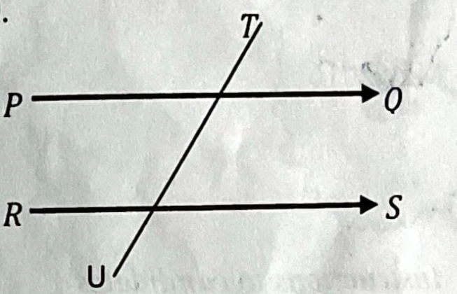
A. transversal
B. intersecting
C. bisecting
D. perpendicular

Q2. One property of lines PQ and RS is that they … [Lines & Conventions]
A. are equal
B. have a constant perpendicular distance between them
C. will meet at a point
D. are both vertical

Q3. The recommended type of line that drawings should start with is a … line. [Lines & Conventions]
A. wavy
B. thick continuous
C. thin continuous
D. zigzag

Q4. The line shown above is used for … [Lines & Conventions]
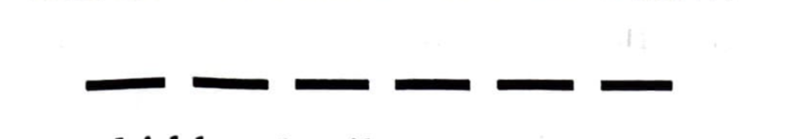
A. hidden details
B. cut surfaces
C. centre lines
D. cutting plane

Q5. The construction shown above indicates that line LM is … to line PQ. [Lines & Conventions]
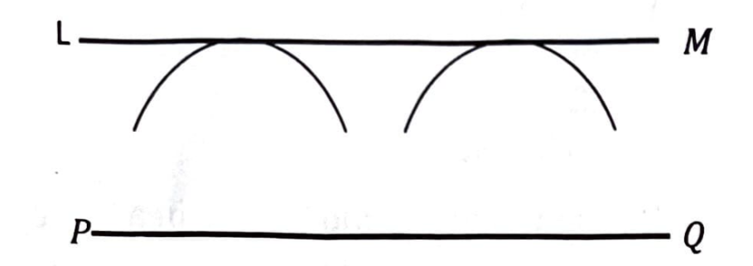
A. perpendicular
B. parallel
C. similar
D. equal

Q6. Which of the following could be of good help in lettering and numerals? [Dimensioning & Lettering]
A. French curve
B. Compasses
C. Ruler
D. Stencil

Q7. The size of A3 drawing paper is … [Dimensioning & Lettering]
A. 210 mm × 420 mm
B. 297 mm × 420 mm
C. 420 mm × 594 mm
D. 594 mm × 841 mm

Q8. The distance between the border line and the edge of a drawing paper is … [Dimensioning & Lettering]
A. 17 mm
B. 15 mm
C. 10 mm
D. 8 mm

Q9. In the diagram above angle PRS is equal to … [Angles & Construction]
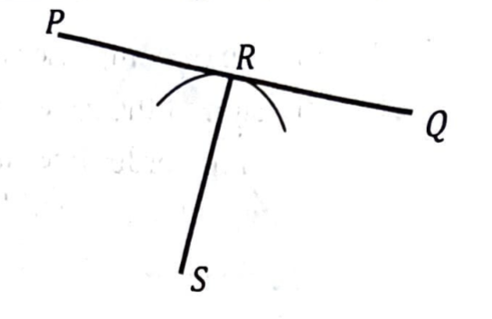
A. 180°
B. 120°
C. 90°
D. 60°

Q10. In the figure above … [Angles & Construction]
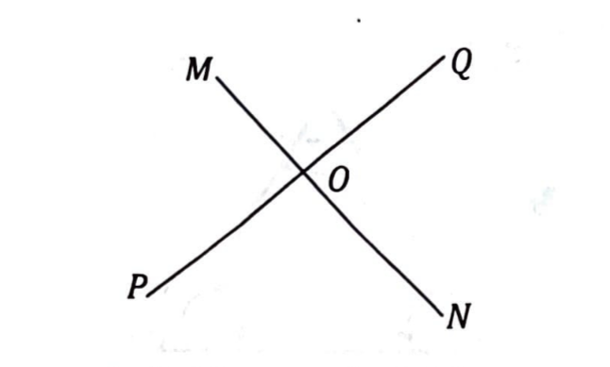
A. angle MOQ = angle PON
B. angle MOP = angle MOQ
C. angle QON = angle PON
D. angle MOP + angle PON = 180°

Q11. When two straight lines meet at a point, they form a/an … [Lines & Conventions]
A. space
B. area
C. angle
D. shape

Q12. The value of angle x in the figure above is … [Angles & Construction]
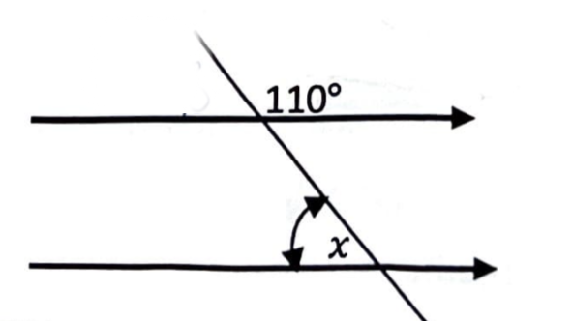
A. 70°
B. 71°
C. 80°
D. 110°

Q13. In the figure above, angle y is equal to … [Angles & Construction]
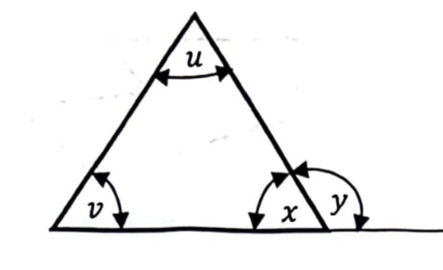
A. v° + x°
B. x° + u°
C. 180° + v°
D. v° + u°

Q14. The type of triangle shown above is … triangle. [Triangles]
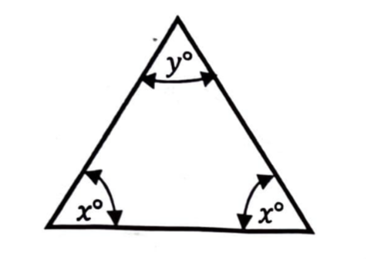
A. scalene
B. equilateral
C. isosceles
D. obtuse angled

Q15. In the figure above, line QS and line PT are called … [Triangles]
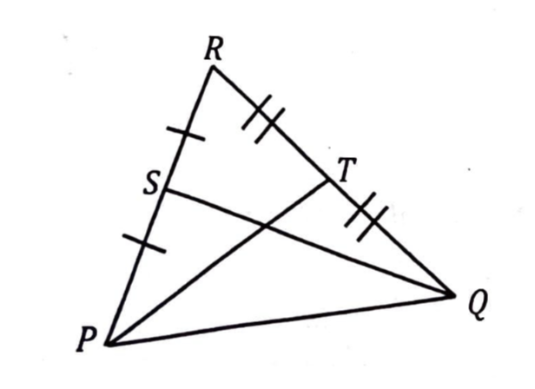
A. slant heights
B. medians
C. diagonals
D. attitudes

Q16. The perimeter of the triangle shown above is 130 mm. The length of side EF is equal to … [Angles & Construction]
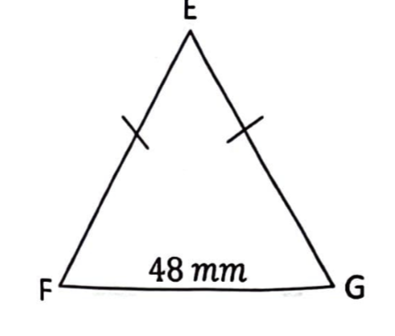
A. 41 mm
B. 48 mm
C. 82 mm
D. 178 mm

Q17. The sum of the interior angles in a quadrilateral is equal to … [Angles & Construction]
A. 720°
B. 540°
C. 360°
D. 180°

Q18. Line FH in the figure is called … [Lines & Conventions]
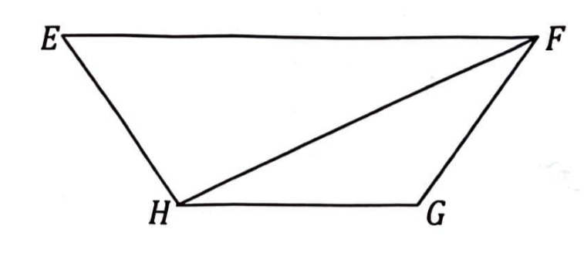
A. trapezium
B. diagonal
C. across corners
D. slant height

Q19. The figure above represents a … [Quadrilaterals]
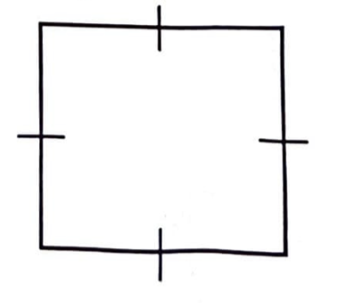
A. rhombus
B. rectangle
C. kite
D. square

Q20. A plane figure bounded by seven sides is known as … [Polygons]
A. heptagon
B. hexagon
C. pentagon
D. octagon

Q21. In the figure above, angle X° is given by … [Angles & Construction]

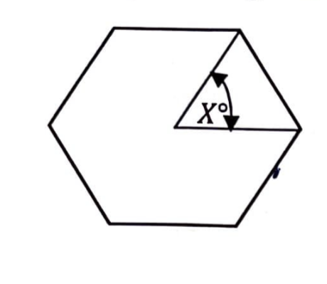
A. 360° ÷ 6
B. 360° ÷ 5
C. 180° ÷ 6
D. 90° ÷ 6

Q22. A plane figure bounded by four straight lines is called a … [Lines & Conventions]
A. deltoid
B. quadrilateral
C. trapezoid
D. pentagon

Q23. The figure above shows a … [Lines & Conventions]
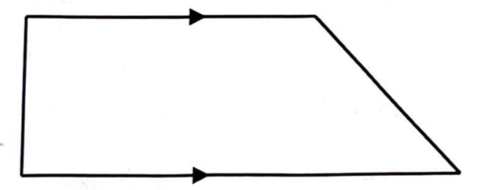
A. trapezoid
B. parallelogram
C. trapezium
D. deltoid

Q24. The figure above is called a/an … [Polygons]
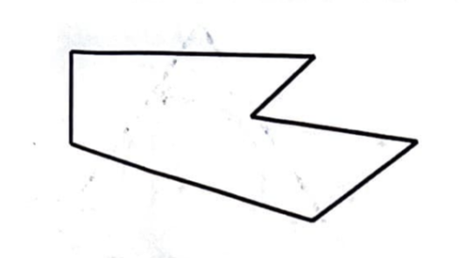
A. irregular hexagon
B. convex polygon
C. irregular quadrilateral
D. re-entrant polygon

Q25. How many times can the radius R of the circle above be stepped off the circumference of the circle to obtain a polygon? [Circles & Ellipses]

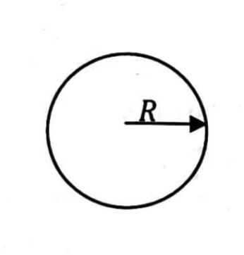
A. 8
B. 7
C. 6
D. 5

Q26. The type of circles shown above is described as … circles. [Circles & Ellipses]

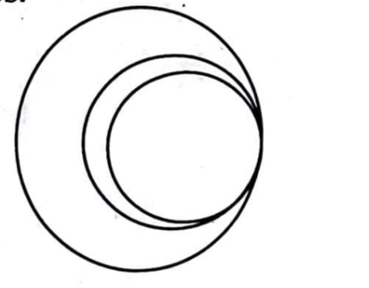
A. inscribed
B. eccentric
C. concentric
D. circumscribed

Q27. In the diagram, line PQ can be referred to as a common … [Circles & Ellipses]
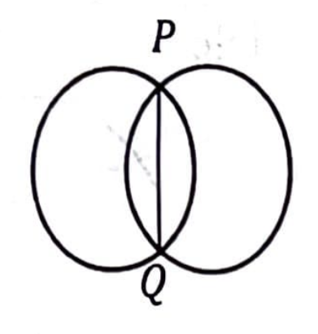
A. chord
B. radius
C. diameter
D. tangent

Q28. To find the centre of the arc EF … [Lines & Conventions]
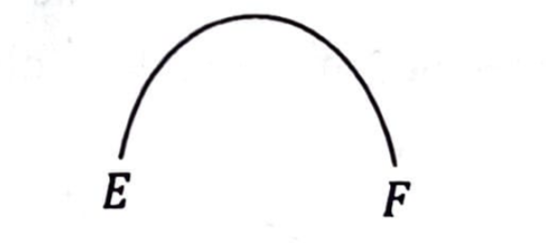
A. bisect any two tangents of the arc
B. join E and F and bisect the line
C. bisect any two normals of the arc
D. bisect any two chords of the arc

Q29. In the diagram above, line EF is the diameter of the semicircle. Angle x is equal to … [Circles & Ellipses]

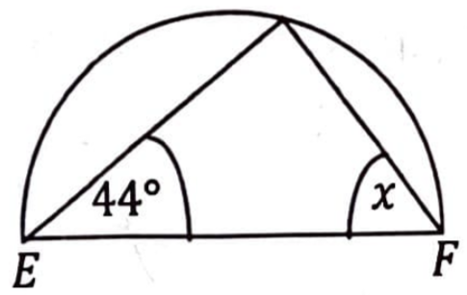
A. 44°
B. 46°
C. 56°
D. 90°

Q30. Freehand sketching emphasizes … [Freehand & Solids]
A. proportionality and neatness
B. accuracy and neatness
C. clarity and neatness
D. careful layout

Q31. The distance F2 to G is equal to … of the ellipse. [Circles & Ellipses]
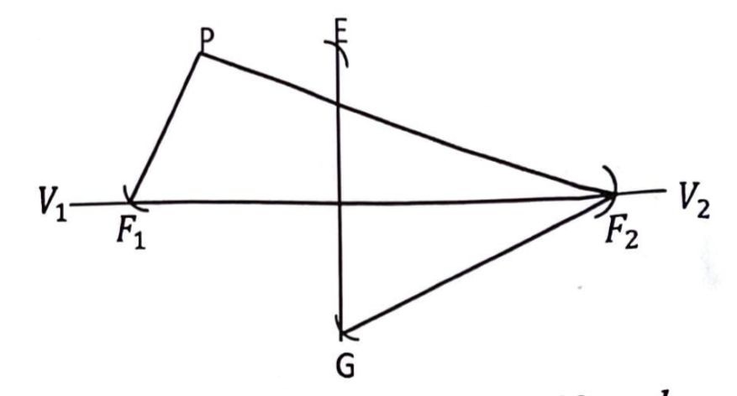
A. the minor axis
B. the major axis
C. half the minor axis
D. half the major axis

Q32. A possible method that could be used to construct the ellipse is … [Circles & Ellipses]
A. auxiliary circles method
B. concentric circles method
C. foci method
D. rectangular method

Q33. The main difference between a cylinder and a prism is that … [Freehand & Solids]
A. both have rectangles as front elevation
B. a cylinder has a circular end or base
C. a prism has a circular end or base
D. a cylinder has edge on its sides

Q34. An elevation of a solid geometrical figure is shown above. The solid can possibly be a … [Freehand & Solids]

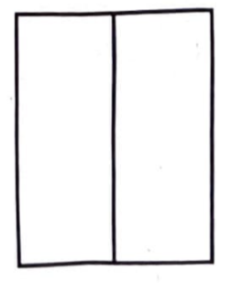
A. cylinder
B. pyramid
C. prism
D. cube

Q35. The diagram above shows isometric axes. What is the value of angle? [Angles & Construction]
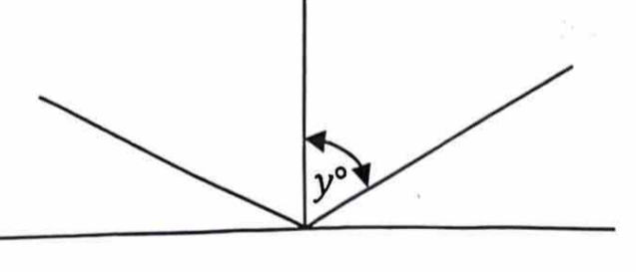
A. 30°
B. 45°
C. 60°
D. 120°

Q36. Isometric projection is … dimensional form of drawing. [Projections]
A. 4
B. 3
C. 2
D. 1

Q37. Which of the diagrams above shows isometric projection? [Projections]
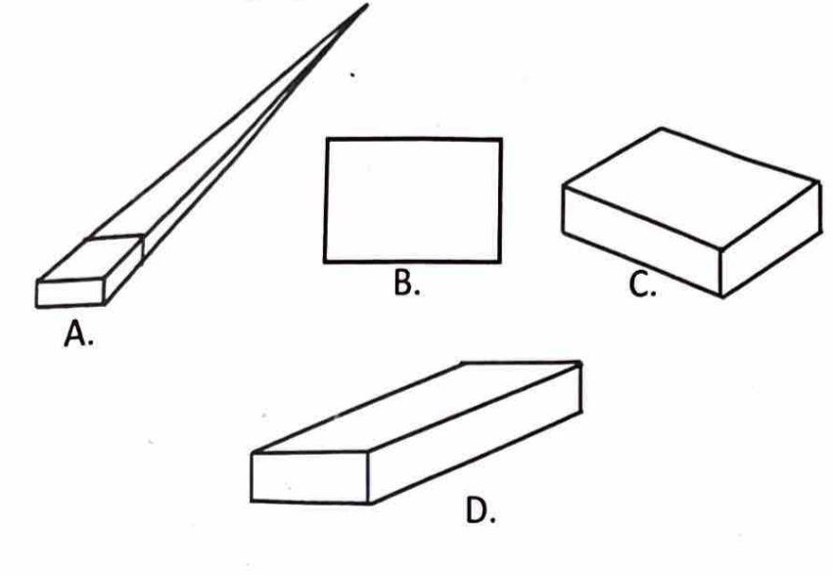
Q38. The cavalier principle of pictorial projection is used in the method of … drawing. [Projections]
A. oblique
B. isometric
C. cabinet
D. orthographic

Q39. In the figure above, the symbol “Ø” before the dimension figure 30 represents the … of the circle. [Circles & Ellipses]
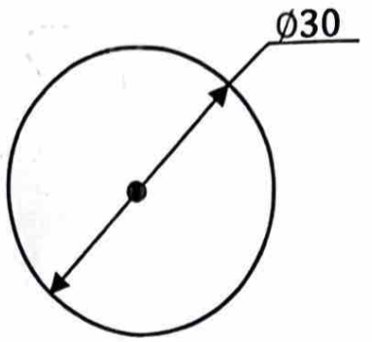
A. circumference
B. radius
C. chord
D. diameter

Q40. In the diagram above, line EF is called a/an … [Lines & Conventions]
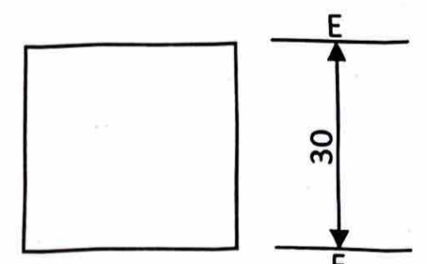
A. limit line
B. dimension line
C. outline
D. chain line

Q41. The following are members of the organizational structure of a typical drawing office except [General]
A. chief draftsman
B. section leader
C. designer
D. manager

Q42. Technical drawing is said to be the … language of an industry. [General]
A. general
B. universal
C. mechanical
D. industrial

Q43. The blade and the stock of the tee-square are joined together by means of … [Drawing Instruments]
A. wedges
B. screws
C. rivets
D. welding

Q44. The instrument most suitable for linear measurement is called … [Drawing Instruments]
A. protractor
B. try square
C. set square
D. ruler

GABECE 2016 — Answer Key
Q# | Answer | Explanation
1 | A | Line TU is a transverssal line cutting the two parallel lines.
2 | B | Lines PQ and RS are parallel, maintaining constant distance.
3 | C | Drawings begin with thin continuous lines for layout.
4 | A | The line shown is a hidden line.
5 | B | Line LM is parallel to line PQ.
6 | D | Stencils help maintain uniform lettering.
7 | B | A3 paper measures 297 mm × 420 mm.
8 | C | The standard margin is 10 mm.
9 | C | Angle PRS measures 90°.
10 | D | The sum of opposite angles equals 180°.
11 | C | Two intersecting lines form an angle.
12 | A | Angle x measures 70°.
13 | D | Angle y equals v° + u°.
14 | C | The triangle shown has two equal sides, making it isosceles.
15 | B | Lines QS and PT are medians of the triangle.
16 | A | Side EF measures 41 mm based on perimeter calculation.
17 | C | Quadrilaterals have four angles summing to 360°.
18 | B | Line FH connects opposite corners, making it a diagonal.
19 | D | The figure shown has all sides equal hence it is a square.
20 | A | A seven-sided polygon is called a heptagon.
21 | A | The central angle of a hexagon is 360° ÷ 6 = 60°.
22 | B | Any four-sided figure is a quadrilateral.
23 | C | The figure shown has only one pair of opposite sides parallel, making it a trapezium
24 | D | The figure shown has an inward angle, making it a re-entrant polygon.
25 | C | Stepping off the radius six times produces a hexagon.
26 | B | Circles with different centres are eccentric.
27 | A | Line PQ is a chord common to both circles.
28 | B | join E and F and bisect the line to locates the centre of the arc.
29 | B | An angle subtended by a semicircle is always 90° therefore x = 180-(44+90) = 46.
30 | A | Proportionality and neatness are key in freehand sketching.
31 | D | F2G corresponds to half the major axis.
32 | C | The foci method is a standard way to construct an ellipse.
33 | B | A cylinder has circular bases, while a prism has polygonal bases.
34 | C | The elevation shown corresponds to a prism.
35 | C | Isometric axes are drawn at 120° apart.
36 | B | Isometric projection represents objects in three dimensions.
37 | C | Diagram C correctly illustrates isometric projection.
38 | A | The cavalier principle applies to oblique projection.
39 | D | The symbol Ø indicates diameter.
40 | B | Line EF is a dimension line used to show measurements.
41 | D | A manager is not typically part of the drawing office structure.
42 | B | Technical drawing is considered the universal language of industry.
43 | B | screws are used to join the blade and stock of a tee-square.
44 | D | A ruler is the most suitable instrument for linear measurement.

GABECE Technical Drawing — 2020
Paper: 2020 | Total Questions: 50

Q1. When two set squares are placed together as shown above, what is the value of angle QRS? [Angles & Construction]

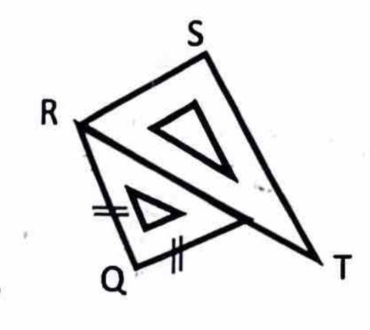
A. 105°
B. 75°
C. 90°
D. 180°

Q2. The most important feature of a tee-square is the … [Drawing Instruments]
A. edge
B. 90° angle
C. stock
D. blade

Q3. If the distance NQ in the diagram above is one meter, what does the distance OQ represent in centimeters? [Freehand & Solids]
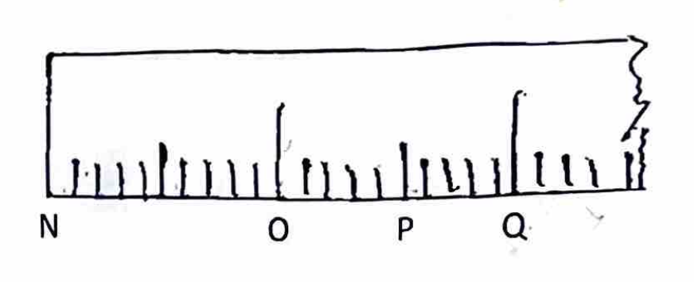
A. 75 cm
B. 50 cm
C. 25 cm
D. 15 cm

Q4. Convert 65 millimeters to centimeters. [General]
A. 650 cm
B. 56.00 cm
C. 6.50 cm
D. 0.65 cm

Q5. A line which is neither vertical nor horizontal is known as … line. [Lines & Conventions]
A. diagonal
B. diverging
C. perpendicular
D. converging

Q6. How many bisections can be made on a right angle to get an angle of 22.5°? [Angles & Construction]
A. 2
B. 3
C. 4
D. 5

Q7. A drawing is started with a type of line called … [Lines & Conventions]
A. thick line
B. thin line
C. small line
D. center line

Q8. In the diagram above, if line LN is 250 mm, what will LM represent? [Lines & Conventions]

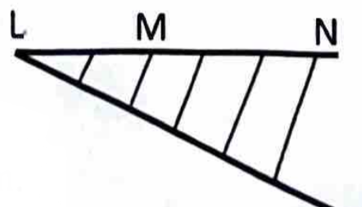
A. 50 mm
B. 100 mm
C. 150 mm
D. 200 mm

Q9. The relationship between the normal and a tangent at a point on a circle is that they are … to each other. [Circles & Ellipses]
A. inclined at 60°
B. parallel
C. perpendicular
D. inclined at 120°

Q10. An object can be drawn to scale when it is too … [Dimensioning & Lettering]
A. complicated
B. intricate
C. large
D. rough

Q11. The distance between the border line and the edge of an A4 drawing paper is … [Dimensioning & Lettering]
A. 20 mm
B. 15 mm
C. 10 mm
D. 5 mm

Q12. The minimum height of block letters and numbers when printing is … [General]
A. 2 mm
B. 3 mm
C. 4 mm
D. 5 mm

Q13. In the diagram above the sum of angles O and Q is … [Angles & Construction]

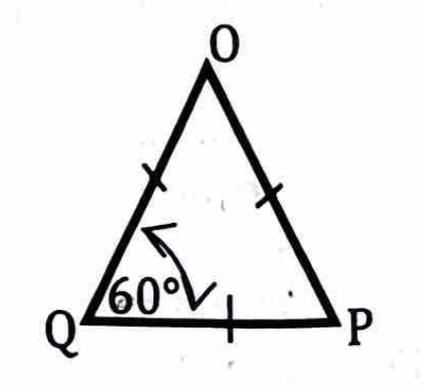
A. 45°
B. 120°
C. 125°
D. 135°

Q14. An angle is called reflex when it is … [Angles & Construction]
A. 90°
B. less than 90°
C. greater than 90°
D. greater than 180°

Q15. The sum of interior angles of a quadrilateral is … degrees. [Angles & Construction]
A. 90
B. 120
C. 180
D. 360

Q16. What is the name of point R? [Angles & Construction]
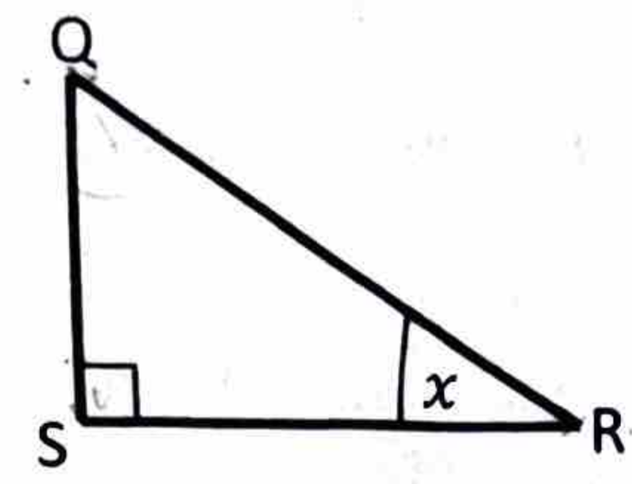
A. Vertex
B. Apex
C. Angle
D. Altitude

Q17. To circumscribe this triangle, it is necessary to bisect … [Angles & Construction]
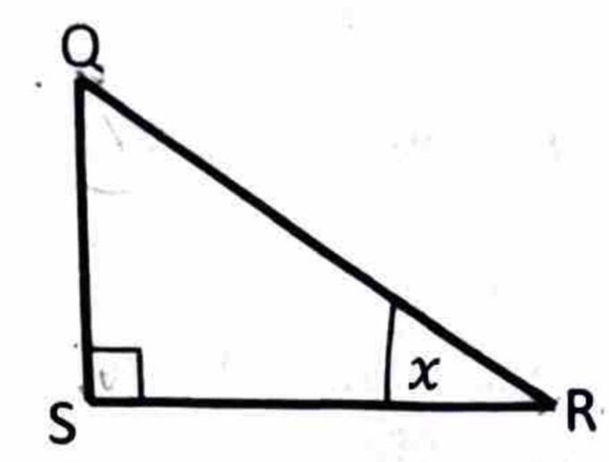
A. angle QRS
B. angle QRS and QR
C. QS only
D. QS and QR only

Q18. The interior angles of a triangle add up to … [Angles & Construction]
A. 120°
B. 150°
C. 180°
D. 360°

Q19. If two angles of a triangle add up to 165°, what is the other angle? [Angles & Construction]
A. 15°
B. 30°
C. 60°
D. 90°

Q20. When two right angled triangles of equal sides are put together on a common hypotenuse, it will represent a … [Angles & Construction]
A. triangle
B. rhombus
C. square
D. trapezium

Q21. A square pushed sideways gives a shape called … [Quadrilaterals]
A. trapezium
B. rectangle
C. kite
D. rhombus

Q22. A square and a rectangle are similar because … [Quadrilaterals]
A. they have equal sides
B. their opposite angles are not equal
C. both have sixty degree angles
D. adjacent angles are equal for both

Q23. The figure shown above is a … [Quadrilaterals]
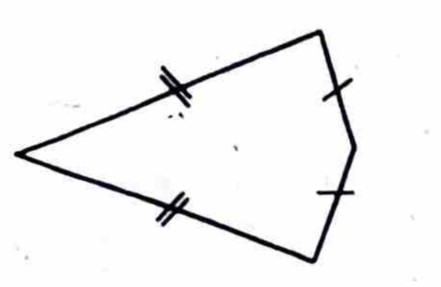
A. kite
B. trapezium
C. square
D. trapezoid

Q24. The figure shown above is a … [Lines & Conventions]
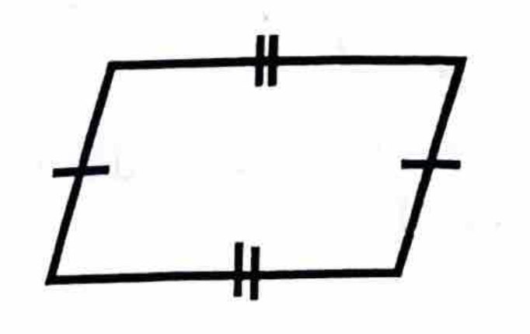
A. parallelogram
B. rectangle
C. trapezium
D. rhombus

Q25. The distance marked x in the diagram above is known as … [Polygons]
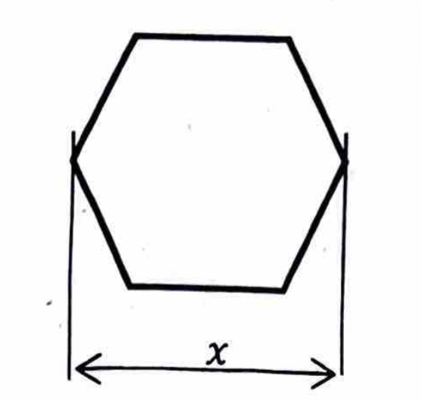
A. across flat
B. across corners
C. diameter
D. diagonal

Q26. The exterior angle of a regular pentagon is … [Polygons]
A. 45°
B. 51°
C. 60°
D. 72°

Q27. Which of the following polygons can be constructed using the 30–60 degree set square? [Polygons]
A. Heptagon
B. Hexagon
C. Pentagon
D. Octagon

Q28. If the formula 360 ÷ 45° is used to construct a particular polygon, what is the name of the polygon? [Polygons]
A. Pentagon
B. Hexagon
C. Heptagon
D. Octagon

Q29. How many right angles will the line VW and XY form on the outside of the circumference of the circle shown above? [Angles & Construction]
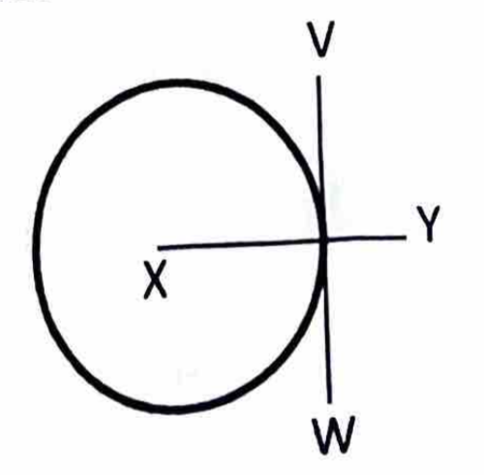
A. 5
B. 4
C. 3
D. 2

Q30. The circles shown above are known as … circles. [Circles & Ellipses]
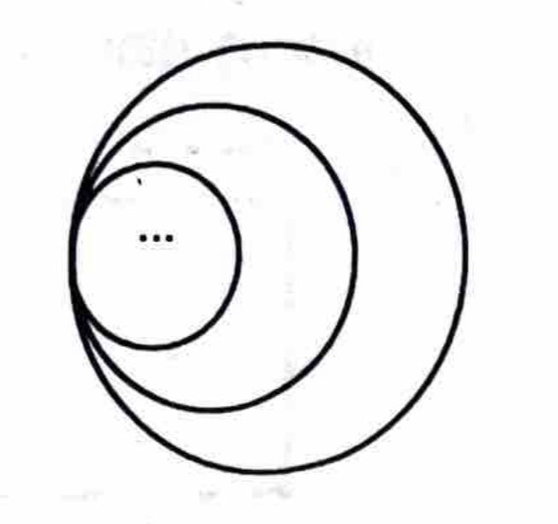
A. concentric
B. eccentric
C. ascribed
D. inscribed

Q31. The portion labelled D is called a … [Circles & Ellipses]
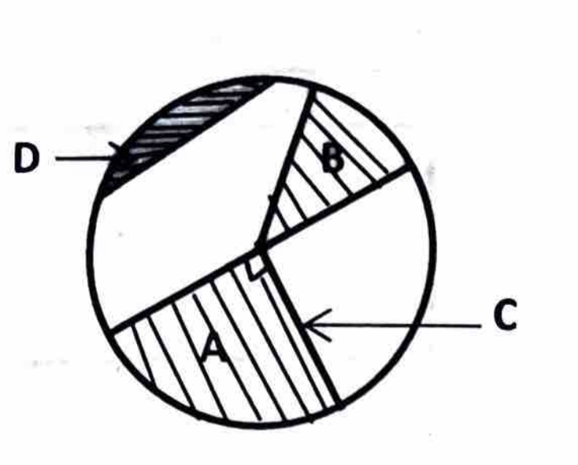
A. sector
B. secant
C. chord
D. segment

Q32. Which of the portions is a quadrant? [Circles & Ellipses]
A. D
B. C
C. B
D. A

Q33. Which of the following methods is not used to construct an ellipse? [Angles & Construction]
A. Rectangular
B. Square
C. Circular
D. Trammel

Q34. The distance F2 to G is equal to … of the ellipse. [Circles & Ellipses]
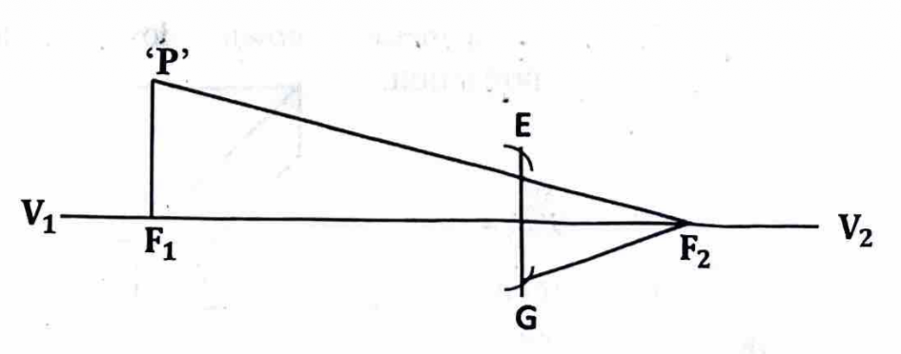
A. half the major axis
B. half the minor axis
C. the major axis
D. the minor axis

Q35. A possible method that could be used to construct the ellipse is … method. [Circles & Ellipses]
A. foci
B. auxiliary circle
C. concentric circle
D. rectangular

Q36. What is the name given to the geometrical solid shown above? [Freehand & Solids]
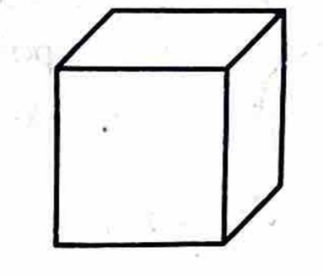
A. Pyramid
B. Prism
C. Cylinder
D. Cube

Q37. Another name given to a square prism is … [Freehand & Solids]
A. pyramid
B. cube
C. cone
D. cylinder

Q38. The cutting plane EE of a cone is shown above. What section will be exposed by the cutting plane? [Projections]
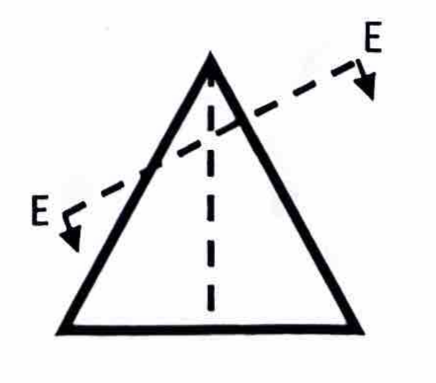
A. Parabola
B. Hyperbola
C. Ellipse
D. Circle

Q39. The drawing method shown above is called … projection. [Projections]
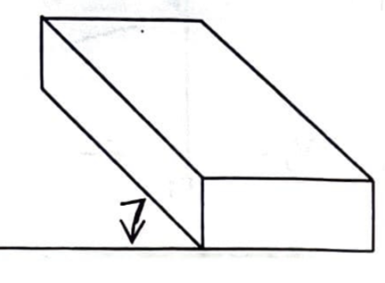
A. oblique
B. isometric
C. orthographic
D. first angle

Q40. Oblique views have their receding sides drawn at an angle of … [Projections]
A. 35°
B. 45°
C. 65°
D. 70°

Q41. A pictorial drawing is a form of … dimensional drawing. [Projections]
A. one
B. two
C. three
D. four

Q42. Which of the following can be used to draw an isometric circle? [Circles & Ellipses]
A. Square
B. Rectangular
C. Focal point
D. Ordinates

Q43. The dimensions of a plane figure are given by its … [Dimensioning & Lettering]
A. length and thickness
B. breadth and thickness
C. length and breadth
D. height and thickness

Q44. Which of the following figures above is correctly dimensioned? [Dimensioning & Lettering]
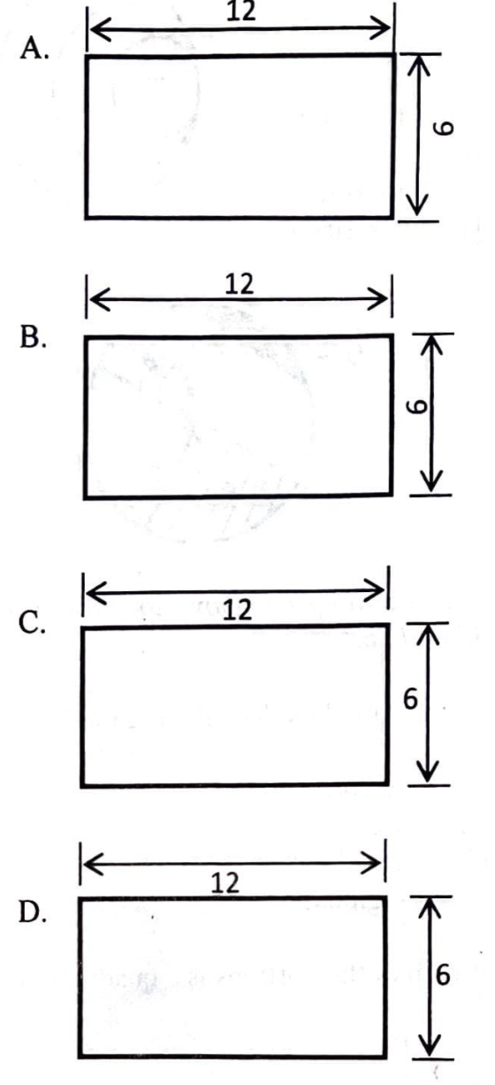
Q45. The angle of projection for a true shape on a cutting plane is at … [Projections]
A. 100°
B. 90°
C. 80°
D. 70°

Q46. The diagram above shows the principal planes used in orthographic projection. In first angle projection, the front elevation is drawn on the portion labelled … [Projections]
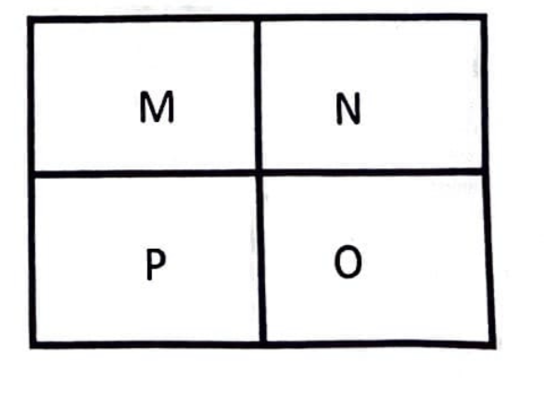
A. M
B. N
C. O
D. P

Q47. Which of the following is not a member of the organizational structure of a typical drawing office? [General]
A. Chief draughtsman
B. Section leader
C. Designer
D. Manager

Q48. A drawing skill in which one uses the hands during operation is called … skill. [Freehand & Solids]
A. visual
B. intellectual
C. motor
D. power

Q49. If a circle with a diameter above 250 cm is to be drawn using a compass, it is recommended to use … [Drawing Instruments]
A. an extension bar fixed to the compass
B. a trammel fixed to the compass
C. a spring bow compass
D. a pin fixed to the compass

Q50. Which of the following instruments has one of its angles at 60°? [Drawing Instruments]
A. 45° set square
B. 30° set square
C. Tee-square
D. Adjustable set square

GABECE 2020 — Answer Key
Q# | Answer | Explanation
1 | A | The arrangement produces a right angle of 105°.
2 | B | The 90° angle ensures perpendicular alignment.
3 | B | Proportional measurement shows OQ is 50 cm.
4 | C | 65 mm ÷ 10 = 6.5 cm.
5 | A | A diagonal line is neither vertical nor horizontal.
6 | A | Bisecting 90° twice gives 22.5°.
7 | B | Drawings begin with thin lines for layout.
8 | B | LM measures 100 mm based on proportion.
9 | C | A tangent is perpendicular to the radius at the point of contact.
10 | C | Large objects are drawn to scale to fit on paper.
11 | C | The standard margin is 10 mm.
12 | B | The minimum height for legibility is 3 mm.
13 | B | Angles O and Q sum to 120°.
14 | D | Reflex angles are greater than 180° but less than 360°.
15 | D | Quadrilaterals have four angles summing to 360°.
16 | A | Point R is a vertex of the triangle.
17 | D | Bisecting angle QS and QR helps locate the circumcircle.
18 | C | The sum of interior angles in a triangle is 180°.
19 | A | The third angle is 180° - 165° = 15°.
20 | C | Two right triangles form a square when joined on the hypotenuse.
21 | D | A square pushed sideways becomes a rhombus.
22 | D | Squares and rectangles both have adjacent angles equal to 90°.
23 | A | The figure shown has two pairs of adjacent equal sides, making it a kite.
24 | A | The figure shown has opposite sides equal and parallel angles other than 90, identifying it as a par...
25 | B | The distance across opposite corners is called across corners.
26 | D | Exterior angle = 360° ÷ 5 = 72°.
27 | B | A hexagon can be constructed using a 30–60° set square.
28 | D | 360 ÷ 45 = 8, so the polygon is an octagon.
29 | D | The line VW forms two(2) right angles outside the circle.
30 | B | Circles with different centre are eccentric.
31 | D | The portion labelled D is a segment of the circle.
32 | D | Portion A represents a quadrant (one quarter of the circle).
33 | B | The square method is not a recognized method for ellipse construction.
34 | A | F2G corresponds to half the major axis.
35 | A | The foci method is a standard way to construct an ellipse.
36 | D | The figure shown is a cube.
37 | B | A square prism with equal sides is a cube.
38 | C | A slanted cut through a cone produces an ellipse.
39 | A | The method shown is oblique projection.
40 | B | Oblique views use receding sides at 45°.
41 | C | Pictorial drawings represent objects in three dimensions.
42 | D | Isometric circles are drawn using the ordinate method.
43 | C | Plane figures are defined by length and breadth.
44 | A | Option A follows correct dimensioning standards.
45 | B | True shapes are projected at 90° to the cutting plane.
46 | A | In first angle projection, the front elevation is drawn on portion M.
47 | D | A manager is not typically part of the drawing office structure.
48 | C | Motor skills involve the use of hands and physical movement.
49 | A | An extension bar allows a compass to draw very large circles.
50 | B | The 30° set square has angles of 30°, 60°, and 90°.

GABECE Technical Drawing — 2021
Paper: 2021 | Total Questions: 48

Q1. The figure above shows two 45 degree set squares placed together, what is the value of angle x? [Drawing Instruments]
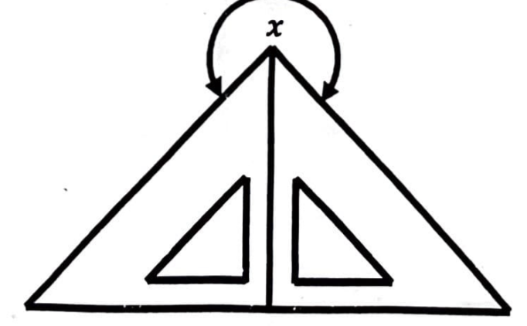
A. 45°
B. 60°
C. 90°
D. 270°

Q2. To draw a perfect irregular curve, one needs to use a … [Drawing Instruments]
A. pair of compasses
B. pair of dividers
C. trammel
D. French curve

Q3. In the diagram above, the symbol Ø before the dimension figure 40 represents … [Dimensioning & Lettering]
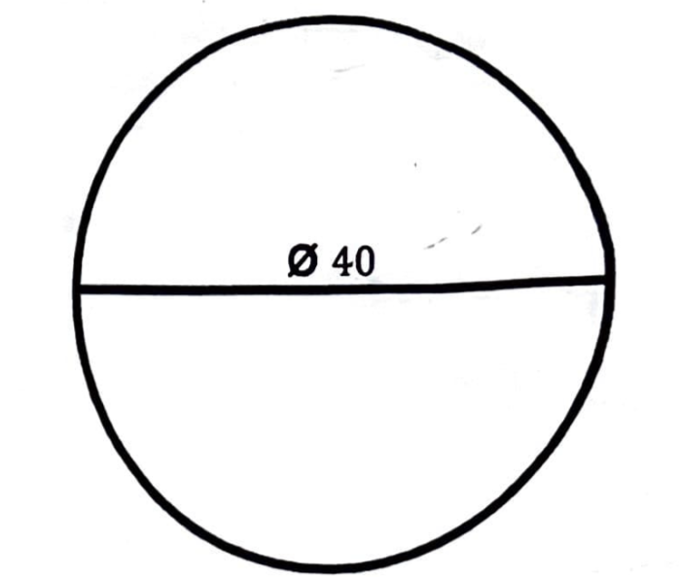
A. diameter
B. radius
C. circumference
D. arc

Q4. 1.5 meters is equal to … [General]
A. 15 cm
B. 150 cm
C. 1500 cm
D. 15000 cm

Q5. In the diagram above, line OP and QR are … [Lines & Conventions]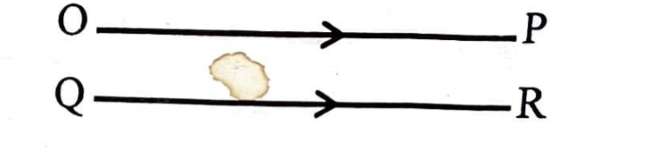
A. slanting lines
B. inclined lines
C. parallel lines
D. perpendicular lines

Q6. The line OR drawn above is called a … [Lines & Conventions]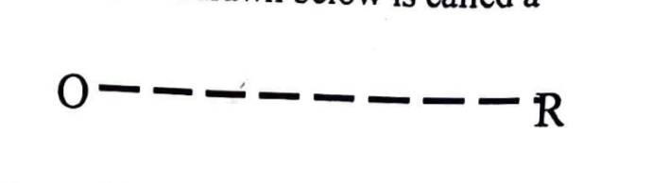
A. thin line
B. dimension line
C. hidden line
D. center line

Q7. The meeting point of two lines crossing each other is called … [Lines & Conventions]
A. crossing point
B. tangential point
C. sectional point
D. intersecting point

Q8. Which of the following lines is used to indicate long break line? [Lines & Conventions]
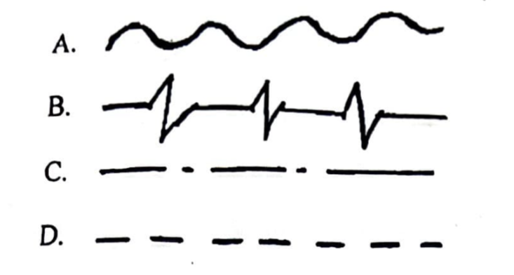
Q9. Measurements on a drawing are shown by … [Lines & Conventions]
A. leader lines
B. dimension lines
C. extension lines
D. break lines

Q10. In lettering and numbering, letters are made uniform in height, spacing and width by the use of … [Lines & Conventions]
A. dimension lines
B. thin lines
C. outlines
D. guide lines

Q11. If the long side of a drawing paper is aligned horizontally, it is said to be … [Dimensioning & Lettering]
A. landscape
B. portrait
C. horizontal scape
D. ground scape

Q12. The descriptions of a drawing are stated on a … [Dimensioning & Lettering]
A. drawing block
B. name block
C. title block
D. corner block

Q13. An angle more than 180° but less than 360° is called … [Angles & Construction]
A. right angle
B. obtuse angle
C. acute angle
D. reflex angle

Q14. When two angles add up to 180°, they are said to be … [Angles & Construction]
A. reflex angles
B. adjacent angles
C. supplementary angles
D. complementary angles

Q15. In the diagram above, angle x and y add up to 180°. What will be the sum of angles O and P? [Angles & Construction]
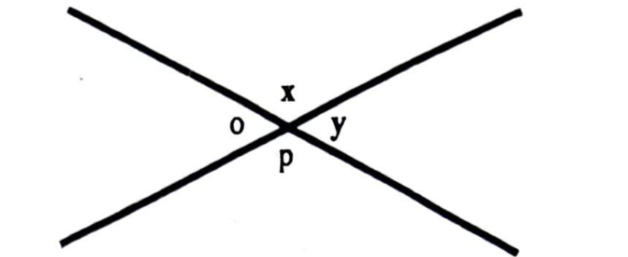
A. 90°
B. 180°
C. 360°
D. 450°

Q16. What is the name given to the triangle shown above? [Triangles]
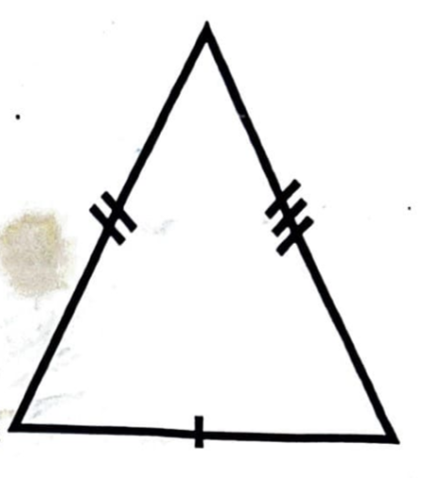
A. Isosceles triangle
B. Scalene triangle
C. Equilateral triangle
D. Right angled triangle

Q17. What is the sum of the interior angles of a triangle? [Angles & Construction]
A. 45°
B. 90°
C. 180°
D. 360°

Q18. What is the length of side MO in the triangle above? [Angles & Construction]
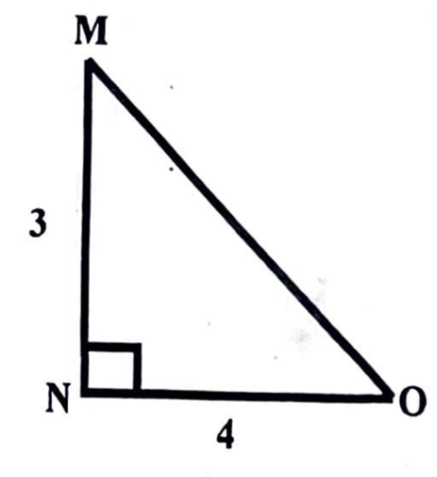
A. 5
B. 6
C. 7
D. 8

Q19. A triangle that has none of its angles equal is called … [Triangles]
A. an equilateral triangle
B. an isosceles triangle
C. a scalene triangle
D. a right angled triangle

Q20. A quadrilateral with all its sides equal but unequal diagonals is called a … [Quadrilaterals]
A. parallelogram
B. square
C. rhombus
D. trapezoid

Q21. A parallelogram is also known as a … [Quadrilaterals]
A. rhomboid
B. trapezoid
C. paralloid
D. trapezoid

Q22. The sum of the interior angles of a quadrilateral is … [Angles & Construction]
A. 45°
B. 90°
C. 180°
D. 360°

Q23. All four-sided geometric figures are known as … [Quadrilaterals]
A. squares
B. polygons
C. cubes
D. quadrilaterals

Q24. [Angles & Construction]
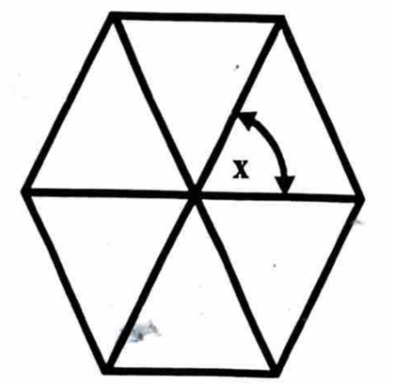
A. 30°
B. 60°
C. 45°
D. 72°

Q25. How many times should the circumference of a circle be stepped off to construct a regular hexagon in it? [Circles & Ellipses]
A. 4
B. 5
C. 6
D. 7

Q26. Which of the following polygons can be constructed using a 45° set-square? [Drawing Instruments]
A. Pentagon
B. Hexagon
C. Octagon
D. Heptagon

Q27. What is the name given to the figure shown above? [Polygons]
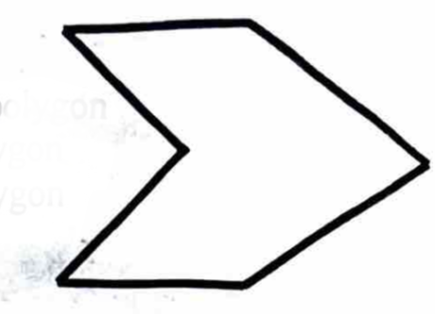
A. Re-entrant polygon
B. Convex polygon
C. Regular polygon
D. Heptagon

Q28. A straight line that joins two points on the circumference of a circle is called … [Circles & Ellipses]
A. radius
B. chord
C. segment
D. diameter

Q29. The figure above shows … circles. [Circles & Ellipses]
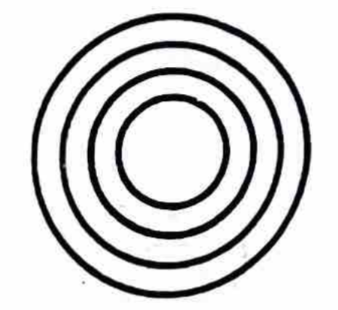
A. semi
B. concentric
C. eccentric
D. common

Q30. In the diagram below, line x is equal to... [Lines & Conventions]
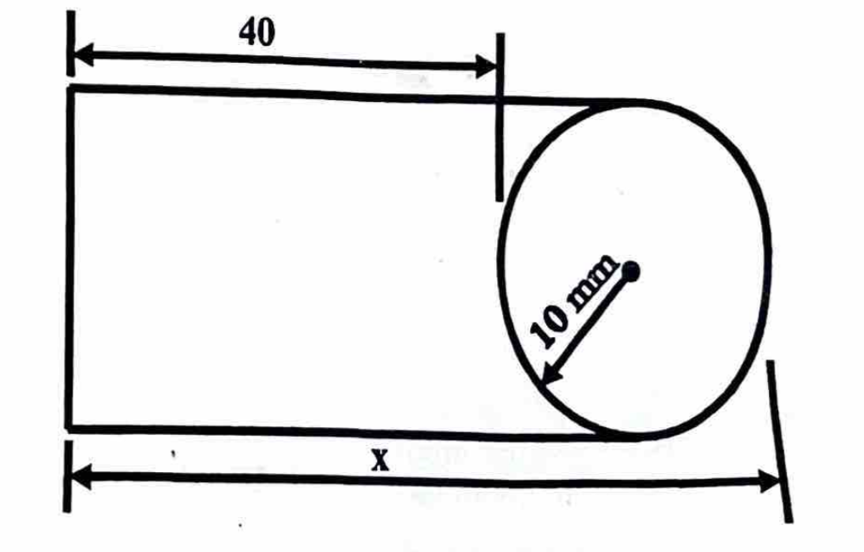
A. 50 mm
B. 60 mm
C. 70 mm
D. 80 mm

Q31. Circles with the same center but different radii are called … [Circles & Ellipses]
A. concentric circles
B. eccentric circles
C. tangential circles
D. pa

Q32. The diagram above shows a triangle inscribed in a circle. What is the value of angle y? [Circles & Ellipses]
A. 30°
B. 45°
C. 60°
D. 50°

Q33. The line OR in the diagram above is called… [Circles & Ellipses]
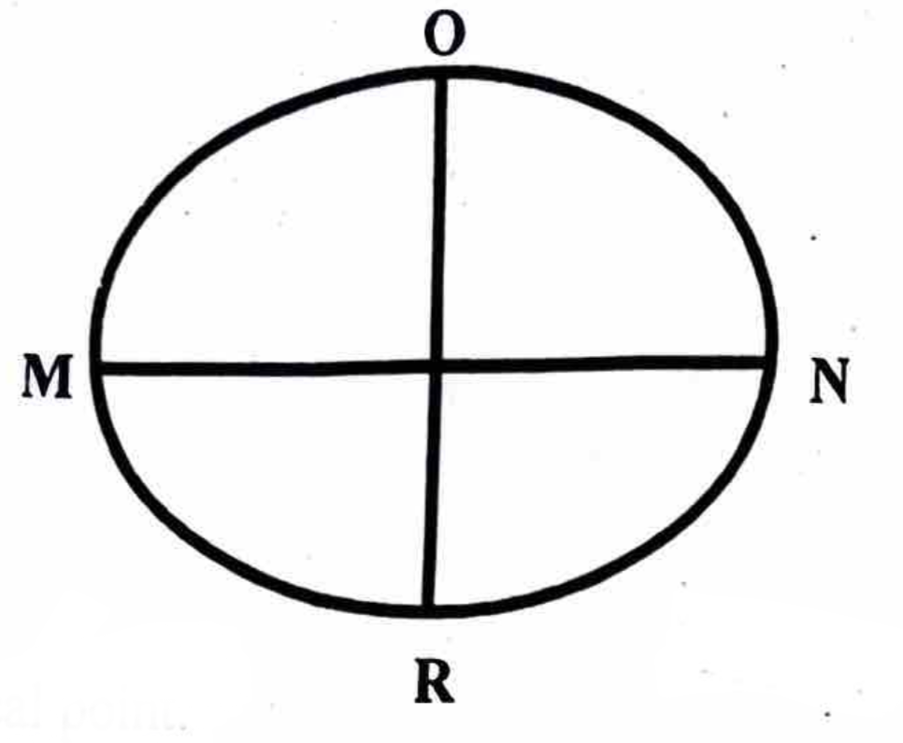
A. the minor axis
B. the major axis
C. quadrant
D. focal point

Q34. The figure above shows a solid. What is its name? [Polygons]
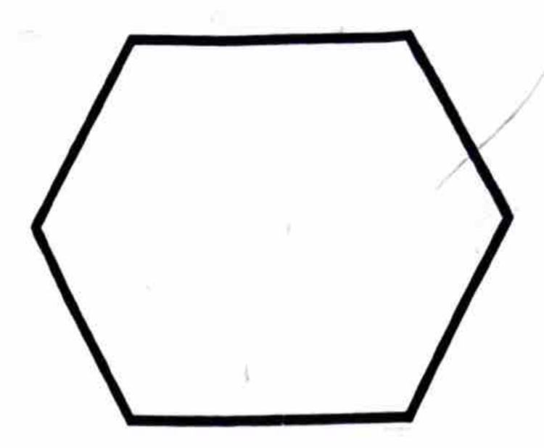
A. Hexagon
B. Heptagon
C. Cylinder
D. Cone

Q35. Another name given to a square prism is … [Freehand & Solids]
A. pyramid
B. cube
C. cone
D. cylinder

Q36. The cutting plane of a cone is shown above. What section will be exposed? [Projections]
A. Parabola
B. Hyperbola
C. Ellipse
D. Circle

Q37. The drawing method shown above is called … projection. [Projections]
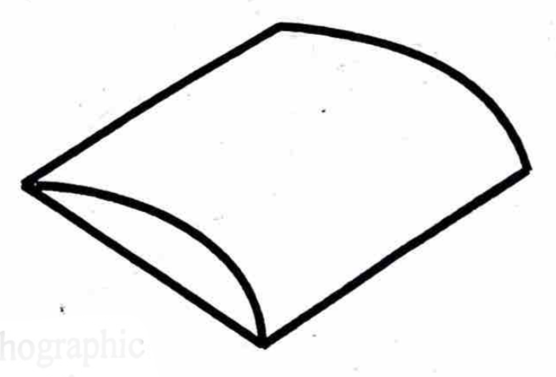
A. oblique
B. isometric
C. orthographic
D. first angle

Q38. Oblique views have their receding sides drawn at an angle of … [Projections]
A. 35°
B. 45°
C. 65°
D. 70°

Q39. A pictorial drawing is a form of … dimensional drawing. [Projections]
A. one
B. two
C. three
D. four

Q40. Which of the following can be used to draw an isometric circle? [Circles & Ellipses]
A. Square
B. Rectangular
C. Focal point
D. Ordinates

Q41. The dimensions of a plane figure are given by its … [Dimensioning & Lettering]
A. length and thickness
B. breadth and thickness
C. length and breadth
D. height and thickness

Q42. Which of the following figures above is correctly dimensioned? [Dimensioning & Lettering]
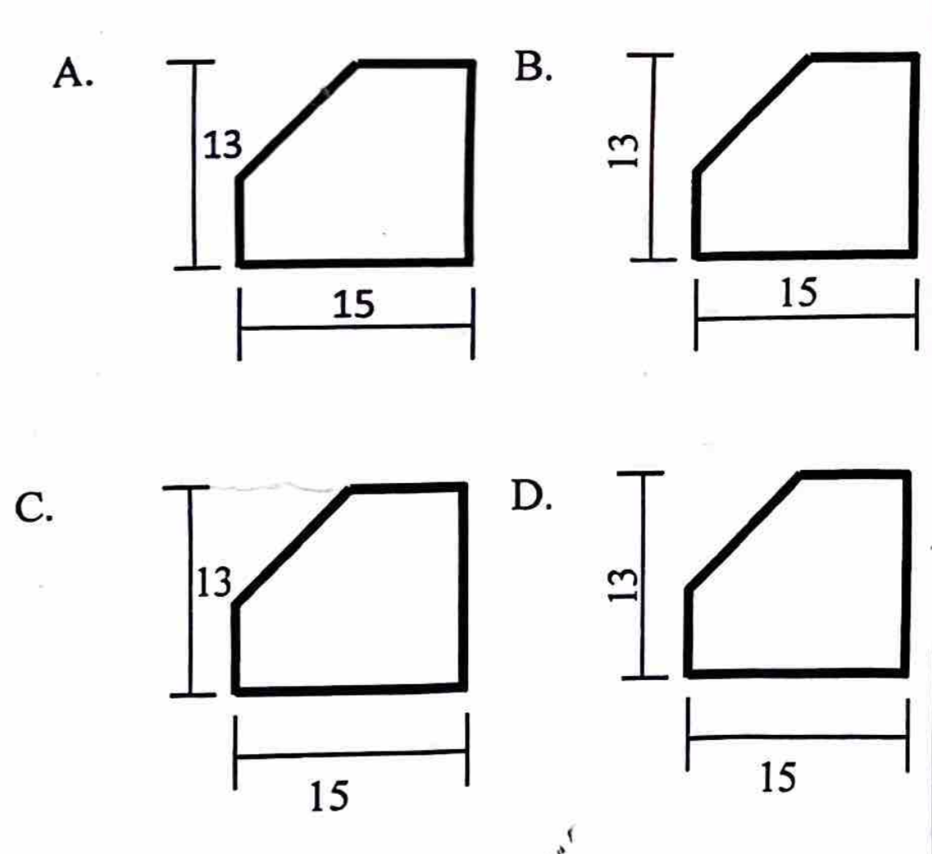
Q43. The angle of projection for a true shape on a cutting plane is at … [Projections]
A. 100°
B. 90°
C. 80°
D. 70°

Q44. Technical Drawing can also be referred to as communication. [General]
A. written
B. graphical
C. mental
D. oral

Q45. Which of the following is not a branch of Technical Drawing? [General]
A. Intellectual Drawing
B. Building Drawing
C. Geometrical Drawing
D. Mechanical Drawing

Q46. One of the main features of a drawing board is [Drawing Instruments]
A. to have smooth edges
B. to have a smooth surface
C. to have unsquared surface
D. to have a rough surface

Q47. Which of the following angles is not found on set-squares? [Drawing Instruments]
A. 100°
B. 90°
C. 60°
D. 45°

Q48. Short pencil is recommended for use with a pair of compasses in order to [Drawing Instruments]
A. keep the pair of compasses in good shape
B. avoid obstruction when drawing arcs
C. utilise the pencil economically
D. decorate the pair of compasses

GABECE 2021 — Answer Key
Q# | Answer | Explanation
1 | D | The diagram shows two 45 degree set squares placed together, so (360)-(45+45)=270°.
2 | D | French curves are used to draw irregular curves.
3 | A | The symbol Ø indicates diameter.
4 | B | 1.5 m = 150 cm.
5 | C | Lines OP and QR are parallel.
6 | C | Line OR is a hidden line used to indicate hidden parts of objects.
7 | D | Two lines crossing form an intersecting point.
8 | A | Long break lines are shown with wavy lines.
9 | B | Dimension lines indicate measurements.
10 | D | Guide lines ensure uniform lettering.
11 | A | Landscape orientation means the long side is horizontal.
12 | C | Title blocks contain descriptions of the drawing.
13 | D | Angles greater than 180° but less than 360° are reflex angles.
14 | C | Supplementary angles sum to 180°.
15 | B | Angles O and P sum to 180°.
16 | B | The triangle shown has no equal sides, making it a scalene triangle.
17 | C | The sum of interior angles in a triangle is 180°.
18 | C | Side MO measures 7 units.
19 | C | In a scalene triangle, all sides and angles are unequal.
20 | C | A rhombus has equal sides but diagonals of different lengths.
21 | A | A parallelogram is also referred to as a rhomboid.
22 | D | Quadrilaterals have four angles summing to 360°.
23 | D | Any four-sided figure is a quadrilateral.
24 | B | The diagram shows angle x as 60°.
25 | C | The radius is stepped off six times to form a hexagon.
26 | C | An octagon can be constructed using a 45° set-square.
27 | A | The figure shown has an inward angle, making it a re-entrant polygon.
28 | B | A chord joins two points on the circumference.
29 | B | Circles with the same centre but different radii are concentric.
30 | B | The dimension marked x measures 60 mm.
31 | A | Concentric circles share the same centre but have different radii.
32 | D | Angle y is 40 + 90 + y = 180, hence y = 180-130 ans:50°.
33 | A | The minor axis of an ellipse is the shortest diameter of an ellipse
34 | A | The figure shown is a hexagon.
35 | B | A square prism with equal sides is a cube.
36 | C | A slanted cut through a cone produces an ellipse.
37 | B | The method shown is isometric projection.
38 | B | Oblique views use receding sides at 45°.
39 | C | Pictorial drawings represent objects in three dimensions.
40 | D | Isometric circles are drawn using the ordinate method.
41 | C | Plane figures are defined by length and breadth.
42 | D | Option D follows correct dimensioning standards.
43 | B | True shapes are projected at 90° to the cutting plane.
44 | B | Technical drawing is a graphical form of communication.
45 | A | Intellectual drawing is not a recognized branch of technical drawing.
46 | B | A drawing board must have a smooth surface for accurate work.
47 | A | Set-squares provide 90°, 60°, and 45° angles, but not 100°.
48 | B | A short pencil prevents obstruction when drawing arcs.

GABECE Technical Drawing — 2022
Paper: 2022 | Total Questions: 52

Q1. Identify the drawing instrument above. [Drawing Instruments]
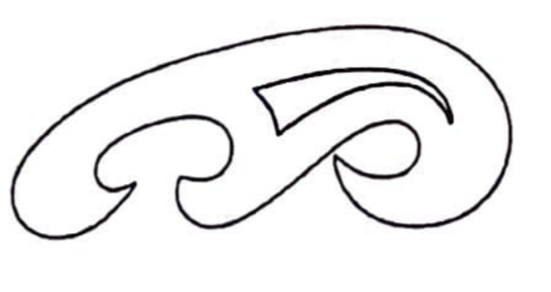
A. Divider
B. Eraser
C. French curve
D. Protractor

Q2. All the following are units of the metric system except [General]
A. inch
B. millimetre
C. metre
D. centimetre

Q3. Which of the figures below is equivalent to 706 mm? [General]
A. 70 cm
B. 70.60 cm
C. 7006 cm
D. 7060 cm

Q4. Which of the names is given to the figure above? [Angles & Construction]
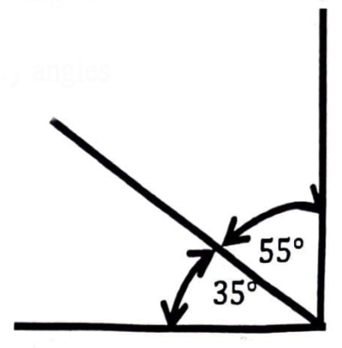
A. Reflex angles
B. Supplementary angles
C. Obtuse angles
D. Complementary angles

Q5. The type of line recommended to start a drawing is a [Lines & Conventions]
A. wavy line
B. thick continuous line
C. long chain
D. thin continuous line

Q6. The lines shown above are called … lines. [Lines & Conventions]
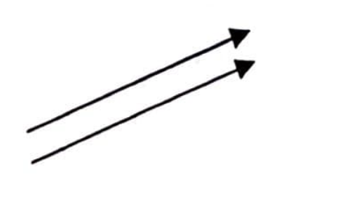
A. perpendicular
B. vertical
C. parallel
D. oblique

Q7. Point Y in the diagram above divides line XZ in the ratio of [Lines & Conventions]
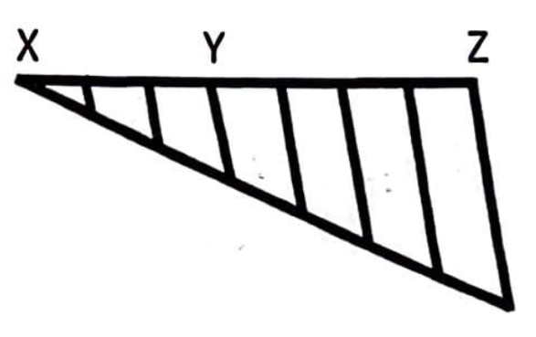
A. 4:5
B. 4:3
C. 3:4
D. 2:5

Q8. The shortest trace between two points is called a/an [Lines & Conventions]
A. arc
B. line
C. circumference
D. straight line

Q9. In lettering, one can either use the slanted or … style. [Lines & Conventions]
A. horizontal
B. vertical
C. new
D. old

Q10. The horizontal positioning of a drawing sheet is called … layout. [Dimensioning & Lettering]
A. formal
B. portrait
C. landscape
D. vertical

Q11. Which of the following is not part of a title block? [Dimensioning & Lettering]
A. Date
B. Scale
C. Name
D. Signature

Q12. The diagram above shows a/an … angle. [Angles & Construction]
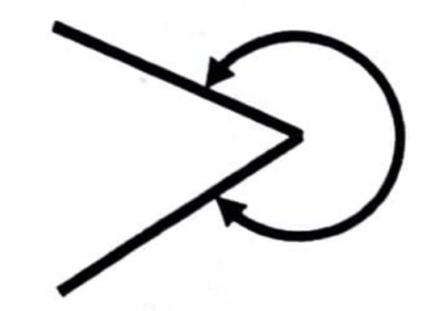
A. right
B. reflex
C. acute
D. obtuse

Q13. The diagram above illustrates … angles. [Angles & Construction]
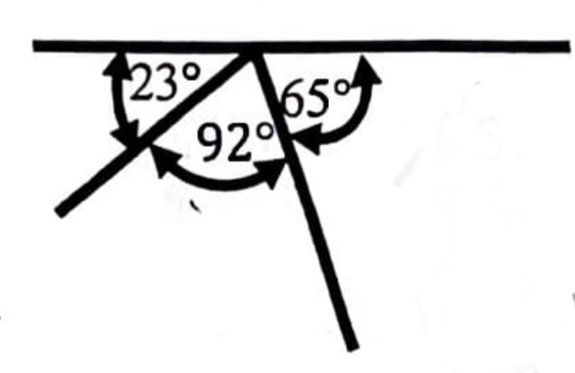
A. reflex
B. acute
C. supplementary
D. complementary

Q14. The altitude of a triangle is the same as its [Triangles]
A. apex
B. vertical height
C. vertex
D. hypotenuse

Q15. The best way to describe a triangle as a plane figure is that it has [Angles & Construction]
A. three angles
B. three sides and angles
C. three sides
D. three equal sides

Q16. The diagram above illustrates two 45° set-squares attached together. What is the value of angle ABC? [Drawing Instruments]
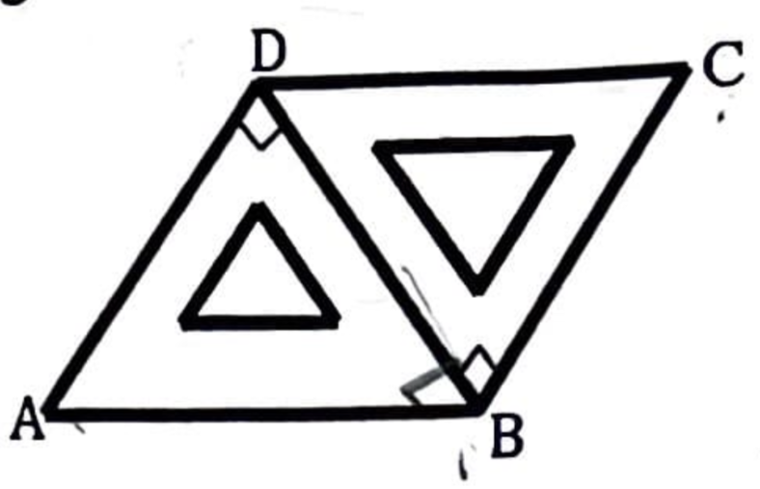
A. 135°
B. 120°
C. 100°
D. 90°

Q17. What is the sum of two angles of an equilateral triangle? [Triangles]
A. 60°
B. 90°
C. 120°
D. 180°

Q18. Which of the plane figures above does not have its diagonal at right angle? [Angles & Construction]
A. Rhombus
B. Rectangle
C. Deltoid
D. Square

Q19. The figure above represents a [Quadrilaterals]
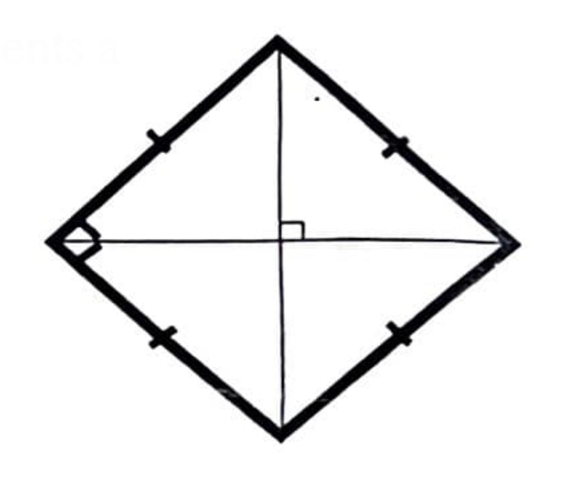
A. parallelogram
B. kite
C. square
D. rhombus

Q20. All quadrilaterals have [Lines & Conventions]
A. four sides and two angles
B. four sides and four diagonals
C. four angles and two diagonals
D. four sides and three diagonals

Q21. Which of the quadrilaterals above has none of its sides parallel? [Quadrilaterals]
A. Parallelogram
B. Trapezium
C. Deltoid
D. Square

Q22. A square when distorted to an angle other than 90° will become a [Angles & Construction]
A. trapezoid
B. parallelogram
C. rhombus
D. trapezium

Q23. The diagram shows angles of 60°. The sum of angle Q and OS is [Angles & Construction]

A. 60°
B. 90°
C. 120°
D. 180°

Q24. The distance marked 'Y' in the diagram above is called [General]
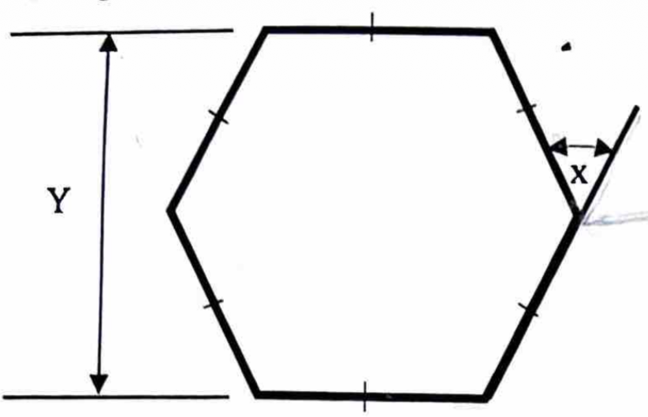
A. circumference
B. diagonal
C. across corners
D. across flat
Q25. The angle marked X is equal to [Angles & Construction]
A. 90°
B. 60°
C. 45°
D. 30°

Q26. A seven sided plane figure is called [Polygons]
A. octagon
B. hexagon
C. heptagon
D. pentagon

Q27. The diagram above shows an incomplete method of constructing a polygon. How many sides will this polygon have? [Angles & Construction]
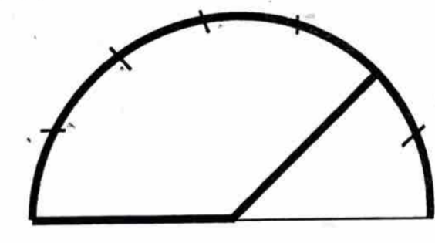
A. 5
B. 6
C. 7
D. 8

Q28. A straight line drawn at 90° to the tangent from the point of tangency is called [Lines & Conventions]
A. normal
B. diameter
C. tangent
D. radius

Q29. A sector is bounded by [Circles & Ellipses]
A. two radii and a chord
B. two radii and an arc
C. two radii and a tangent
D. a chord and an arc

Q30. How many semi-circles make up a complete circle? [Circles & Ellipses]
A. 2
B. 3
C. 4
D. 5

Q31. The diagram above shows … circles [Circles & Ellipses]
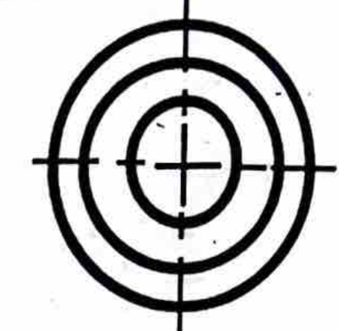
A. inscribed
B. circumscribed
C. eccentric
D. concentric

Q32. The longest diameter in an ellipse is called [Circles & Ellipses]
A. long axis
B. major axis
C. minor axis
D. focal point

Q33. In all ellipses, the distance from one end of the minor axis to the focal points is equal to half [Circles & Ellipses]
A. Half the major axis
B. diameter
C. radius
D. minor axis

Q34. An accurate freehand sketching depends on good [Freehand & Solids]
A. line work
B. proportion
C. spacing
D. layout

Q35. The figure illustrated above is called a [Freehand & Solids]
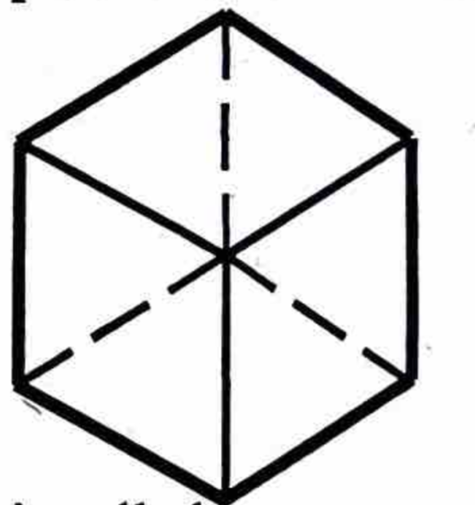
A. square pyramid
B. rectangular prism
C. cube
D. cuboid

Q36. The figure shown above has........faces [Freehand & Solids]
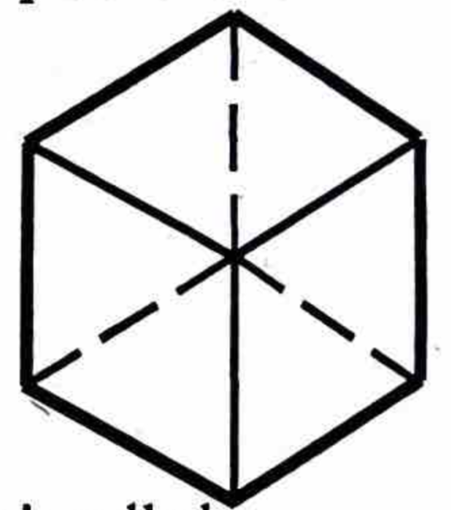
A. 4
B. 6
C. 8
D. 10

Q37. Which of the following is not a representation of an object in pictorial drawing? [Projections]
A. Orthographic drawing
B. Perspective
C. Oblique drawing
D. Isometric drawing

Q38. An elevation of a solid geometrical figure is shown above. The solid can possibly be a [Freehand & Solids]
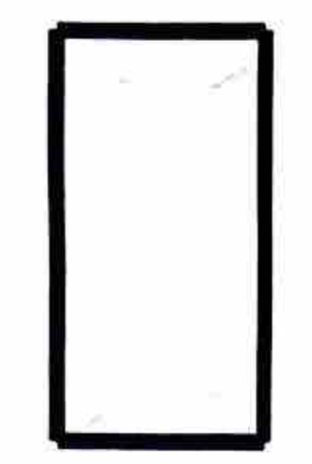
A. cube
B. prism
C. rectangular pyramid
D. cylinder

Q39. The diagram above shows isometric axis. The angle marked Y will be [Angles & Construction]
A. 30°
B. 45°
C. 60°
D. 120°

Q40. The figure drawn above represents … projection. [Projections]
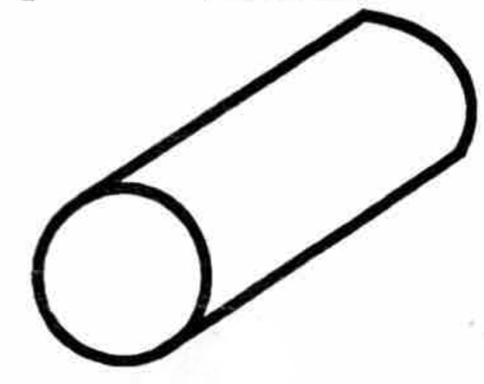
A. isometric
B. orthographic
C. oblique
D. perspective

Q41. Which of the following figures is correctly dimensioned? [Dimensioning & Lettering]
Q42. The line labeled 'S' in the diagram above is called … line. [Lines & Conventions]
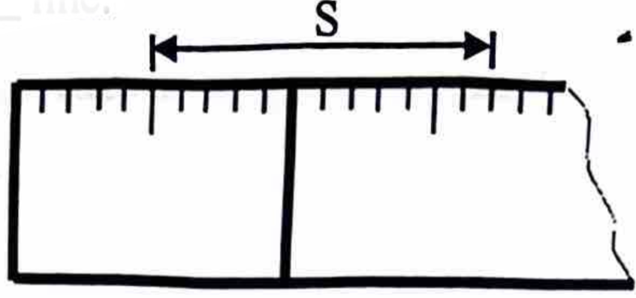
A. parallel
B. dimension
C. centre
D. projection

Q43. Which of the figures above represents a third angle projection? [Projections]
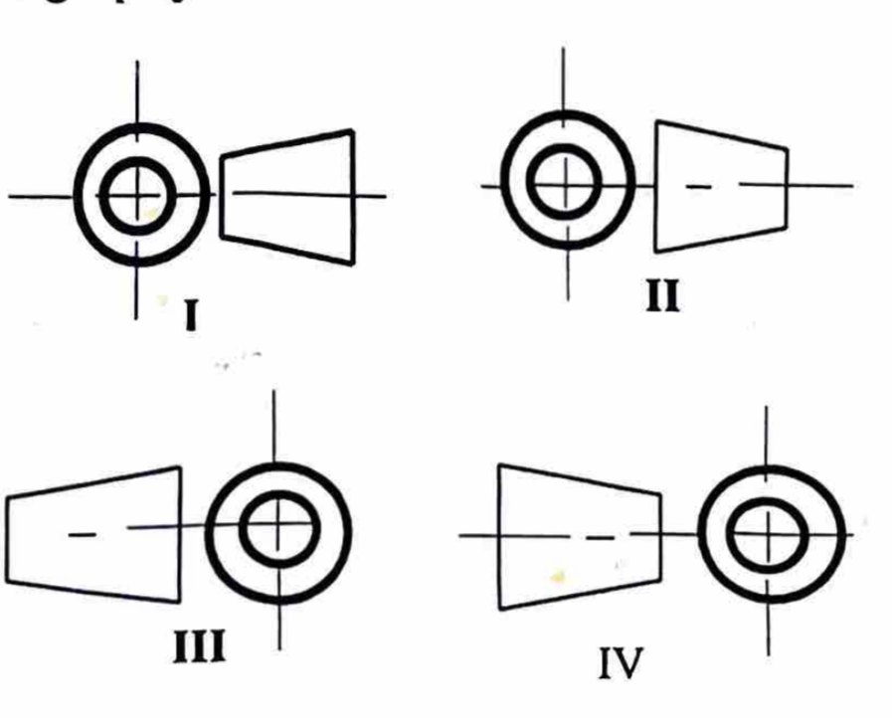
Q44. The angle of projection for the true shape on a cutting plane is [Projections]
A. 60°
B. 80°
C. 90°
D. 120°

Q45. The figure above shows an isometric drawing of a block. Identify the end view as in the direction of arrow E. [Projections]
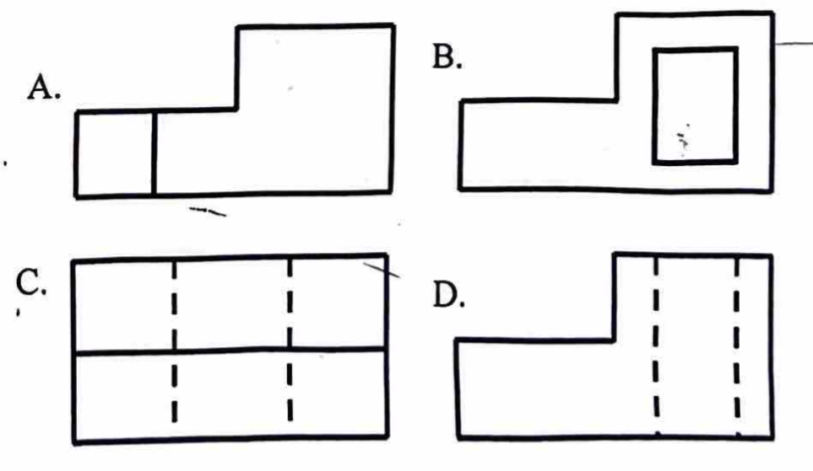
Q46. Good draughtmanship involves [Dimensioning & Lettering]
A. using all types of lines in drawing.
B. the use of compasses alone.
C. drawing border lines and title block.
D. division of the drawing area.

Q47. In perception, one uses [Freehand & Solids]
A. visual skills and coordination.
B. motor skills and intellectual skills.
C. intellectual skills and imagination.
D. coordination and motor skills.

Q48. The main function of the rule is to [General]
A. mark points on an object.
B. measure an object.
C. measure in kilometres.
D. transfer measurements from the rule to an object.

Q49. The instrument used to measure an angle is called [Drawing Instruments]
A. compasses.
B. French curve.
C. protractor.
D. ruler.

Q50. Which of the following is not a Technical Drawing equipment? [Drawing Instruments]
A. Set-square
B. French curve
C. File
D. Drawing board

Q51. Which of the following angles is not found on a set square? [Drawing Instruments]
A. 15°
B. 30°
C. 45°
D. 90°

Q52. What name is given to the old system of measuring? [General]
A. Imperial system
B. Metre standard
C. Metric system
D. Newton system

GABECE 2022 — Answer Key
Q# | Answer | Explanation
1 | C | The instrument shown is a french curve use to draw iregular curves.
2 | A | The inch belongs to the imperial system, not the metric system.
3 | B | 706 mm = 70.6 cm.
4 | D | The angles shown add up to 90°, making them complementary.
5 | D | Drawings begin with thin continuous lines for layout.
6 | C | The lines shown are parallel lines.
7 | C | Point Y divides line XZ in the ratio 3:4.
8 | D | The shortest distance between two points is a straight line.
9 | B | Lettering can be slanted or vertical in style.
10 | C | Landscape layout means the long side is horizontal.
11 | D | Signature is not typically included in a title block.
12 | B | The diagram shows a reflex angle.
13 | C | The angles shown are supplementary, summing to 180°.
14 | B | The altitude of a triangle is its vertical height.
15 | B | A triangle is defined by three sides and three angles.
16 | A | Two 45° set-squares together form an angle of 135°.
17 | C | Each angle of an equilateral triangle is 60°, so two angles sum to 120°.
18 | B | Rectangles have diagonals that bisect but not at right angles.
19 | C | The figure shown is a square.
20 | C | Quadrilaterals have four sides, four angles, and two diagonals.
21 | C | A deltoid (kite) has no parallel sides.
22 | C | A square distorted loses right angles and becomes a rhombus.
23 | C | The combined angle shown is 120°.
24 | D | The distance across the flat surface is called across the flat.
25 | B | The angle marked x is 360/6 = 60°.
26 | C | A seven-sided polygon is called a heptagon.
27 | C | The construction shown produces a polygon with 7 sides.
28 | A | A line perpendicular to a tangent is called a normal.
29 | B | A sector is bounded by two radii and an arc.
30 | A | Two semicircles make a complete circle.
31 | D | Circles with the same centre but different radii are concentric.
32 | B | The longest diameter of an ellipse is the major axis.
33 | A | This distance equals half the major axis.
34 | B | Proportion is key to accurate freehand sketching.
35 | C | The figure shown is a cube.
36 | B | A cube or cuboid has 6 faces.
37 | A | Orthographic drawing is not pictorial; it is multiview.
38 | B | The elevation shown corresponds to a prism.
39 | C | Isometric axes are drawn at 120° apart.
40 | C | The figure shown is an oblique projection.
41 | D | Option D follows correct dimensioning standards.
42 | B | Line S is a dimension line.
43 | B | Figures II and IV represent third angle projection.
44 | C | True shapes are projected at 90° to the cutting plane.
45 | A | Option A correctly represents the end view.
46 | C | drawing border lines and title block.i
47 | B | Perception in technical involves motor skills and intellectual skills.
48 | B | A rule is primarily used to measure objects.
49 | C | Angles are measured using a protractor.
50 | C | A file is not considered technical drawing equipment.
51 | A | Set squares typically have 30°, 45°, and 60° angles, not 15°.
52 | A | The old measuring system is the Imperial system.

GABECE Technical Drawing — 2025
Paper: 2025 | Total Questions: 43

Q1. What is the distance marked X in the diagram above? [General]
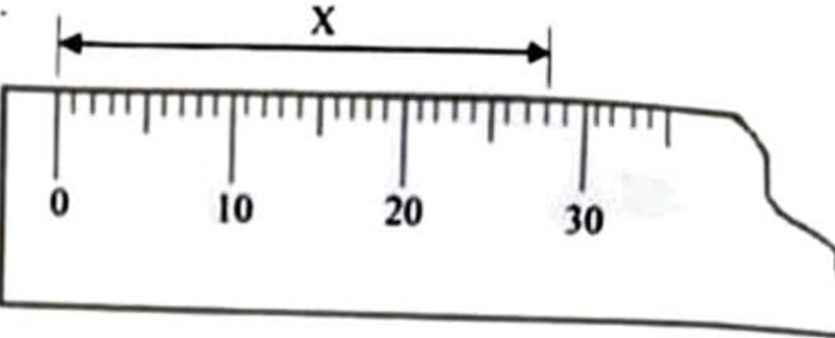
A. 20 mm
B. 26 mm
C. 28 mm
D. 30 mm

Q2. Lines that are equidistant throughout their length are said to be [Lines & Conventions]
A. equal.
B. horizontal.
C. parallel.
D. perpendicular.

Q3. The diagram below illustrates lines. [Lines & Conventions]
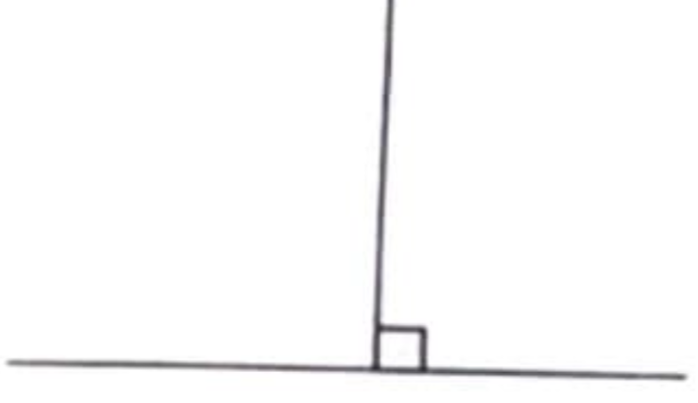
A. vertical
B. perpendicular
C. horizontal
D. diagonal

Q4. To bisect simply means to divide equally into.......parts. [Lines & Conventions]
A. two
B. three
C. four
D. five

Q5. To bisect line AB below, one needs to use points as centres to scribe the arcs. [Lines & Conventions]
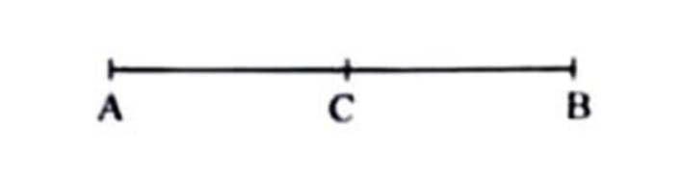
A. A and B
B. A and C
C. A, B and C
D. B and C

Q6. Lines ST and UV in the diagram below are......to each other. [Lines & Conventions]
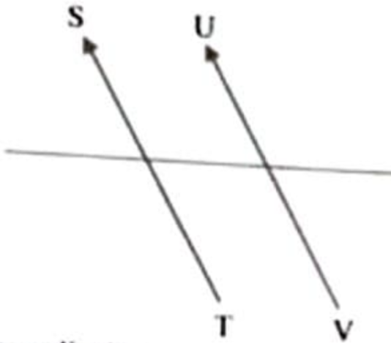
A. perpendicular
B. parallel
C. horizontal
D. converging

Q7. The most common type of lettering is the style. [Lines & Conventions]
A. vertical
B. slanted
C. horizontal
D. common

Q8. The part labelled X on the diagram below is the [Dimensioning & Lettering]
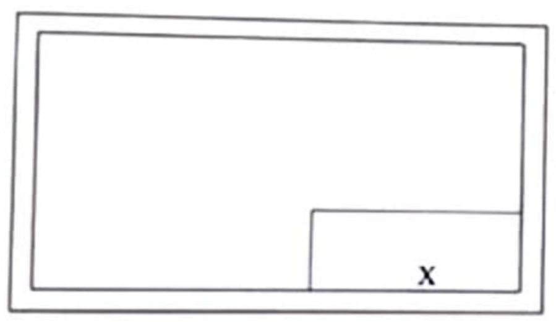
A. title block.
B. rectangle.
C. centre box.
D. border line.

Q9. The standard measurement of border lines on A4 paper is [Dimensioning & Lettering]
A. 8 mm.
B. 10 mm.
C. 12 mm.
D. 15 mm.

Q10. The construction below illustrates how to construct an angle of [Angles & Construction]
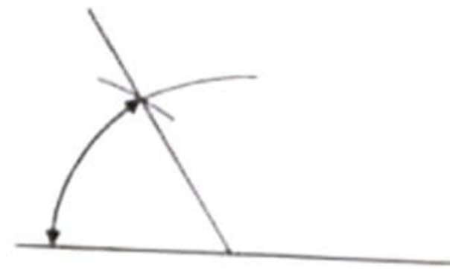
A. 30°
B. 60°
C. 90°
D. 180°

Q11. All angles are measured in [Angles & Construction]
A. centimetres.
B. degrees.
C. metres.
D. millimetres.

Q12. What is the value of angle X in the diagram below? [Angles & Construction]
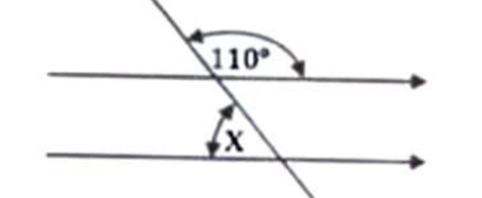
A. 70°
B. 90°
C. 110°
D. 180°

Q13. A triangle with all the sides and angles unequal is called triangle. [Triangles]
A. scalene
B. right angle
C. isosceles
D. equilateral

Q14. The value of X in the diagram below is [Angles & Construction]
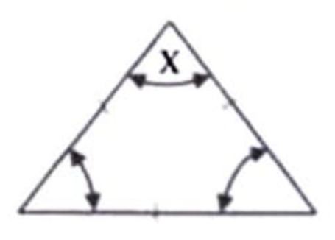
A. 20°
B. 30°
C. 45°
D. 60°

Q15. To inscribe a circle in a triangle, one needs to bisect two [Angles & Construction]
A. vertices.
B. sides.
C. apex.
D. angles

Q16. The longest side of a right angle triangle is known as [Triangles]
A. adjacent.
B. bisector.
C. hypotenuse.
D. perpendicular.

Q17. The difference between a rhombus and a square is their [Quadrilaterals]
A. angles.
B. arcas.
C. perimeters.
D. sides.

Q18. Identify the quadrilateral illustrated below. [Quadrilaterals]
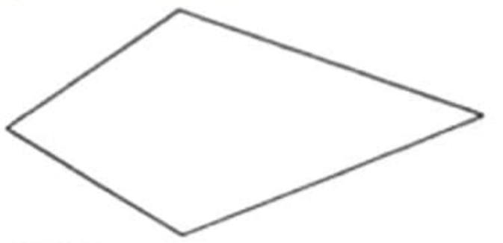
A. square
B. rhombus
C. rectangle
D. deltoid

Q19. The sum of the interior angles of a quadrilateral is [Angles & Construction]
A. 360°
B. 240°
C. 180°
D. 90°

Q20. A square when pushed to an angle other than 90° will become a [Quadrilaterals]
A. rhomboid
B. rhombus
C. trapezium
D. trapezoid

Q21. Which of the following does not have its diagonal at right angles? [Angles & Construction]
A. Kite
B. Rectangle
C. Rhombus
D. Square

Q22. Which of the following polygons can be constructed using a 45° set square? [Polygons]
A. Hexagon
B. Nonagon
C. Octagon
D. Pentagon

Q23. A regular polygon whose exterior angle is 72° is a [Polygons]
A. decagon
B. heptagon
C. octagon
D. pentagon

Q24. A polygon is simply a plane figure with [Polygons]
A. three sides.
B. more than four sides.
C. less than four sides.
D. four sides.

Q25. What name is given to the figure illustrated below? [Polygons]
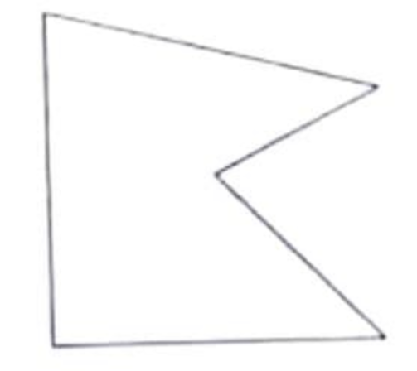
A. Polygon
B. Quadrilateral
C. Re-entrant polygon
D. Regular polygon

Q26. When a circle is drawn in isometric, the figure produced will be [Circles & Ellipses]
A. ellipse
B. cycloid
C. circle
D. involute

Q27. What is the name of the part labelled X? [Circles & Ellipses]
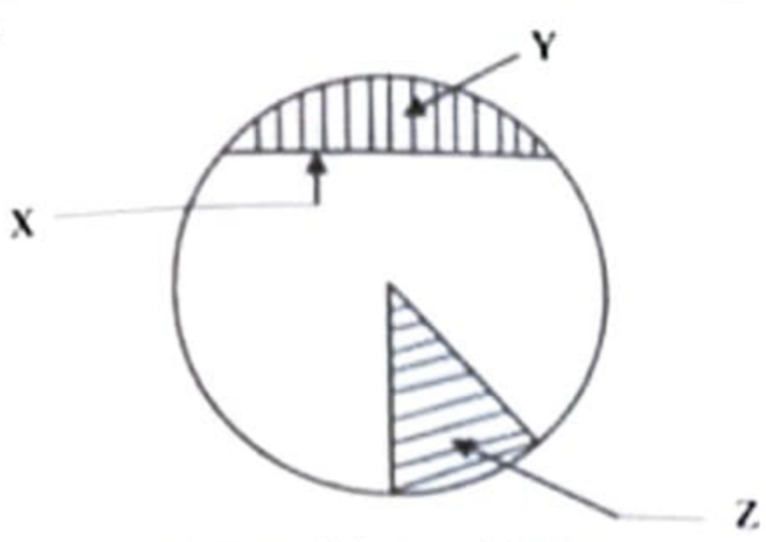
A. Chord
B. Radius
C. Sector
D. Segment

Q28. The part labelled Y is called [Circles & Ellipses]
A. segment
B. sector
C. quadrant
D. chord

Q29. What name is given to the part labelled Z? [Circles & Ellipses]
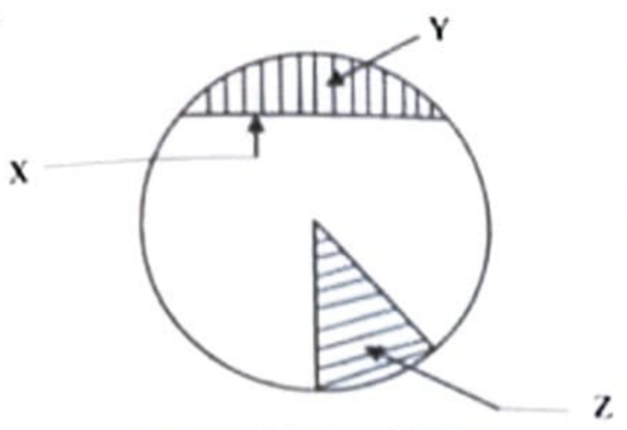
A. Diameter
B. Quadrant
C. Radius
D. Sector

Q30. The figure drawn below is called [Circles & Ellipses]
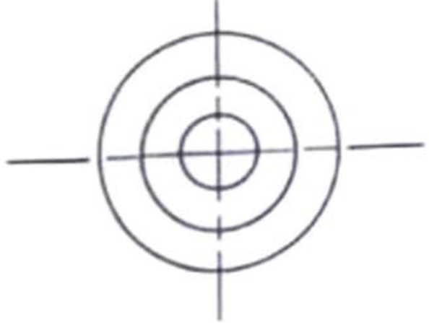
A. bisecting circles
B. common circles
C. concentric circles
D. eccentric circles

Q31. The outer boundary of a circle is called [Circles & Ellipses]
A. tangent
B. radius
C. diameter
D. circumference

Q32. In the diagram below, line OP is called the [Lines & Conventions]
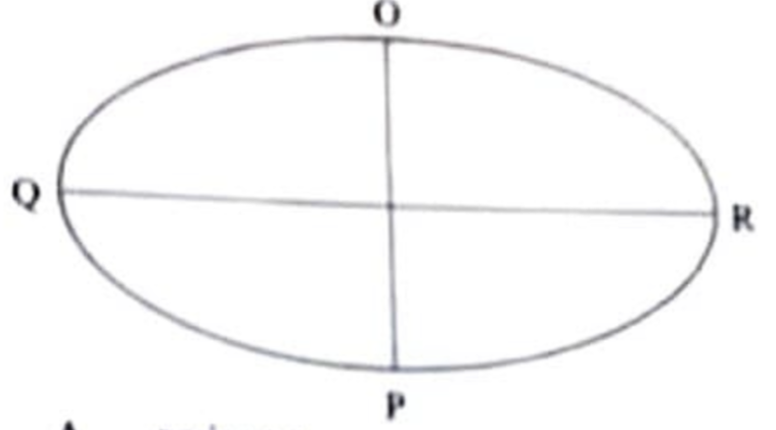
A. perimeter
B. minor axis
C. major axis
D. focal point

Q33. Which of the following is not a method of constructing an ellipse? [Angles & Construction]
A. Trammel
B. Square
C. Rectangle
D. Circle

Q34. Which of the following is the most important aspect in freehand sketching? [Freehand & Solids]
A. Accuracy
B. Clarity
C. Dimensioning
D. Proportionality

Q35. The diagram below shows a view of a square.......... [Quadrilaterals]
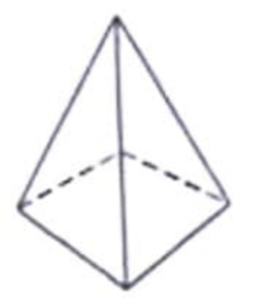
A. cone
B. cylinder
C. prism
D. pyramid

Q36. An elevation of a solid geometrical figure is shown below. The solid can possibly be a [Freehand & Solids]
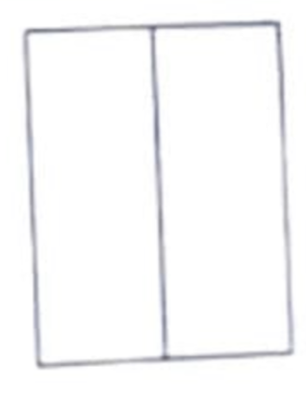
A. cube
B. cylinder
C. prism
D. pyramid

Q37. The diagram below shows isometric axes. What is the value of angle b? [Angles & Construction]
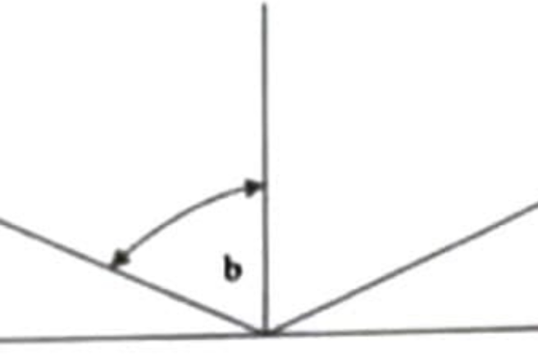
A. 120°
B. 90°
C. 60°
D. 30°

Q38. Isometric projection is a form of...........drawing. [Projections]
A. 2 dimensional
B. 3 dimensional
C. 4 dimensional
D. 5 dimensional

Q39. In the figure below, the symbol Ø before the dimension figure 20 represents the of the circle. [Circles & Ellipses]
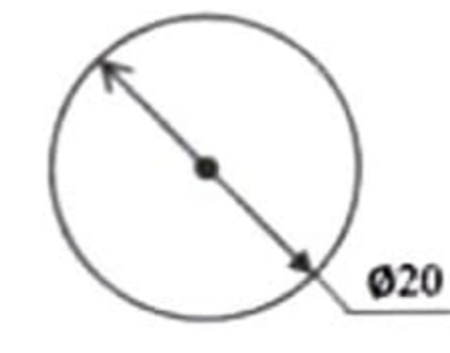
A. chord
B. circumference
C. diameter
D. radius

Q40. In the diagram below, line GH is called a/an [Lines & Conventions]
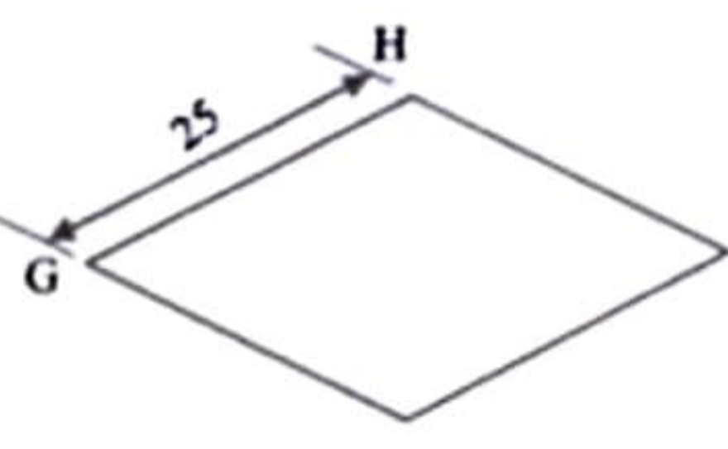
A. construction line
B. dimension line
C. extension line
D. outline

Q41. Isometric drawing gives the......... view of an object. [Projections]
A. pictorial
B. perspective
C. orthographic
D. oblique

Q42. The method used to draw the layout of the figures below is [Projections]
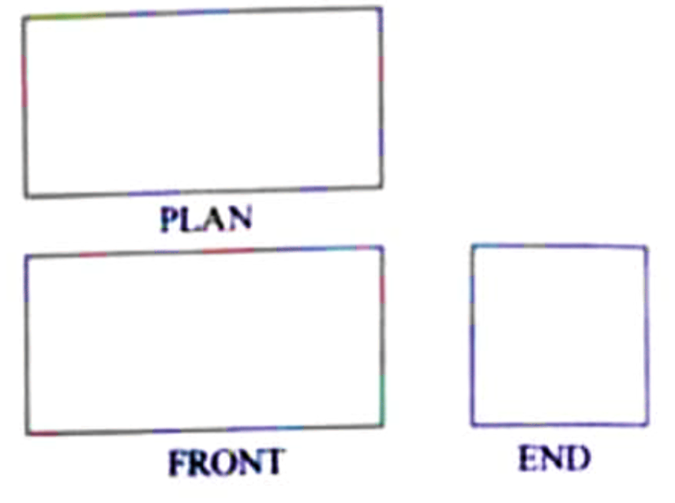
A. third angle projection
B. pictorial view
C. orthographic projection
D. first angle projection

Q43. How many views are usually shown in orthographic projection? [Projections]
A. 2
B. 3
C. 4
D. 5

GABECE 2025 — Answer Key
Q# | Answer | Explanation
1 | C | The marked distance X is 28 mm.
2 | C | Equidistant lines are parallel.
3 | B | The illustrated lines are perpendicular.
4 | A | Bisecting means dividing into two equal parts.
5 | A | Bisecting a line requires arcs from both endpoints A and B.
6 | B | Lines ST and UV are parallel.
7 | A | Vertical lettering is the most common style.
8 | A | The labelled part X is the Title block.
9 | B | Border lines on A4 paper are typically 10 mm.
10 | B | The construction shown is for a 60° angle.
11 | B | Angles are measured in degrees.
12 | A | The value of angle X is 70°.
13 | A | A scalene triangle has all sides and angles unequal.
14 | D | The value of angle X is 60°.
15 | D | Inscribe a circle by bisecting two angles of the triangle.
16 | C | The longest side of a right triangle is the hypotenuse.
17 | A | A rhombus and a square differ in their angles.
18 | D | The illustrated quadrilateral is a deltoid.
19 | A | The sum of interior angles of a quadrilateral is always 360°.
20 | B | A square tilted becomes a rhombus.
21 | B | Rectangles do not have diagonals intersecting at right angles.
22 | C | A 45° set square can be used to construct an octagon.
23 | D | Exterior angle of 72° corresponds to a regular pentagon.
24 | B | In technical drawing polygons are plane figures with more than four sides.
25 | C | The illustrated figure is a re-entrant polygon.
26 | A | In isometric projection, circles appear as ellipses.
27 | A | The part labelled X is a chord.
28 | A | The part labelled Y is a segment.
29 | D | The part labelled Z is the sector.
30 | C | Circles sharing the same centre are concentric circles.
31 | D | The boundary of a circle is its circumference.
32 | B | Line OP is the minor axis.
33 | B | square is not a method of constructing an ellipse.
34 | D | proportionality is the most important aspect in freehand sketching.
35 | D | The view shown is of a pyramid.
36 | C | The elevation shown corresponds to a prism.
37 | C | The part label b is 60°.
38 | B | Isometric projection is a 3D form of drawing.
39 | C | The symbol Ø indicates diameter.
40 | B | Line GH is a dimension line.
41 | A | Isometric drawing provides a pictorial view.
42 | A | The layout shown uses third angle projection. The plan is drawn above the front view
43 | B | Orthographic projection usually shows 3 views.

GABECE Technical Drawing — 2026
Paper: 2026 | Total Questions: 56

Q1. The area of technical drawing in which machine components are drawn is [General]
A. building.
B. electrical.
C. mechanical.
D. geometrical.

Q2. Technical drawing is a universal language that is communicated [General]
A. mentally.
B. intellectually.
C. graphically.
D. automatically.

Q3. What is the drawing board meant to support? [Drawing Instruments]
A. The drawing paper
B. The tee-square
C. The drawing clips
D. The protractor

Q4. The part of the Tee-square which is firmly pressed against the edge of the drawing board when drawing is called the [Drawing Instruments]
A. long edge.
B. blade.
C. stock.
D. head.

Q5. The instrument used in hatching a cutting surface is the ____ set square. [Drawing Instruments]
A. 30°
B. 35°
C. 45°
D. 50°

Q6. Which of the following instruments can be used to construct an octagon? [Drawing Instruments]
A. Ruler
B. 60° set square
C. 45° set square
D. Divider

Q7. Which of the following is the same as 71 mm? [General]
A. 0.71 cm
B. 7.07 cm
C. 7.10 cm
D. 70.10 cm

Q8. How many square meters is equal to 100 square centimeters? [Quadrilaterals]
A. 4 m²
B. 3 m²
C. 2 m²
D. 1 m²

Q9. Which type of line is used for dimensioning? [Lines & Conventions]
A. Continuous thick
B. Continuous irregular
C. Continuous thin
D. Chain thin

Q10. Lines which never meet when extended are said to be [Lines & Conventions]
A. horizontal.
B. vertical.
C. perpendicular.
D. parallel.

Q11. The diagram above illustrates [Lines & Conventions]
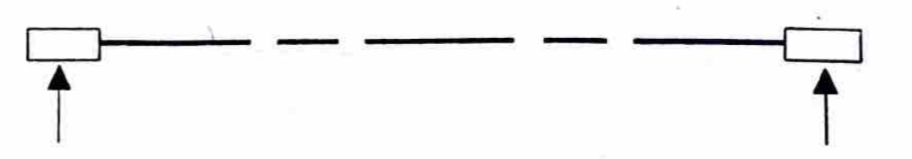
A. a centre line.
B. a cutting plane.
C. a dimension line.
D. an out line.

Q12. A perpendicular line is a line at an angle of [Lines & Conventions]
A. 30°.
B. 60°.
C. 90°.
D. 180°.

Q13. What is the ratio of RT to TQ in the diagram below? [General]
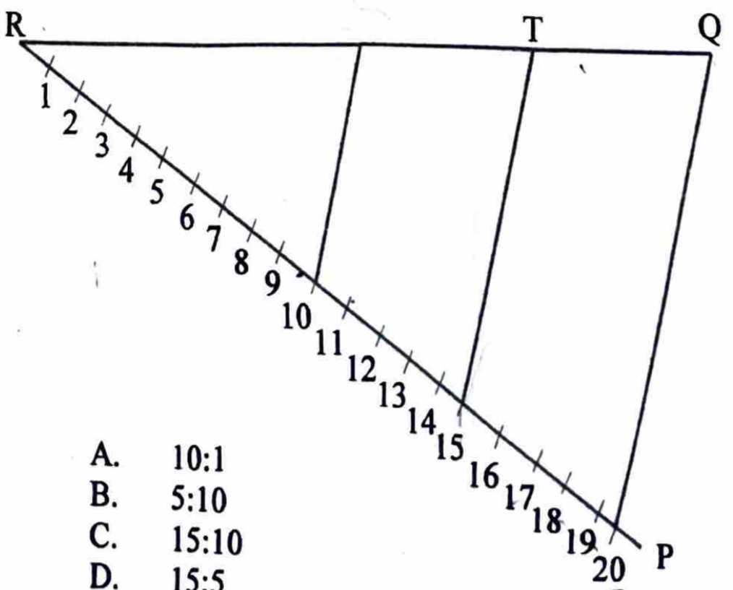
Q14. The diagram below illustrates ____ angles. [Angles & Construction]
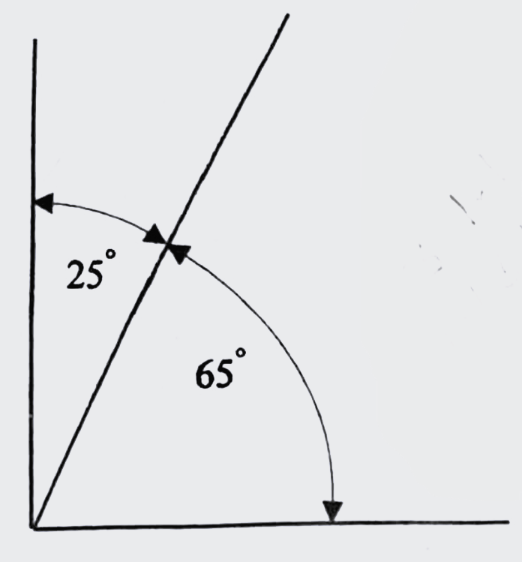
A. complementary
B. supplementary
C. reflex
D. obtuse

Q15. In the diagram below, angle OPR is [Lines & Conventions]
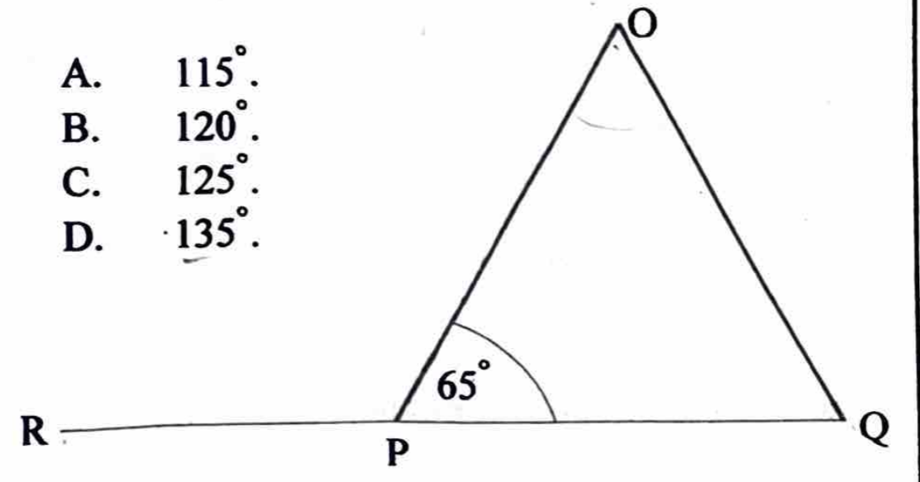
Q16. An angle which is greater than 180° but less than 360° is called a/an ____ angle. [Angles & Construction]
A. acute
B. right
C. reflex
D. obtuse

Q17. The diagram below shows the illustration of constructing an angle of [Angles & Construction]
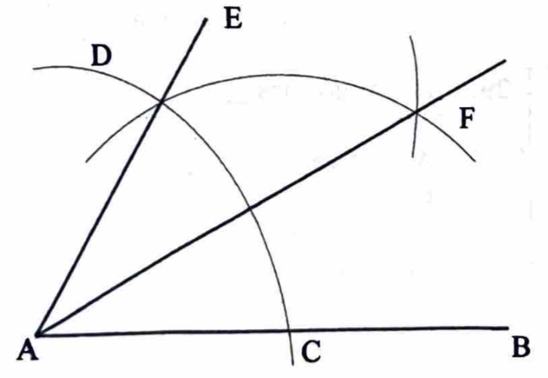
A. 25½°.
B. 30°.
C. 45°.
D. 90°.

Q18. Triangles on the same base and between the same parallels are [Lines & Conventions]
A. equal in area.
B. equal in perimeter.
C. similar in shape.
D. of the same ratio of sides.

Q19. The diagram below is called a/an ____ triangle. [Triangles]
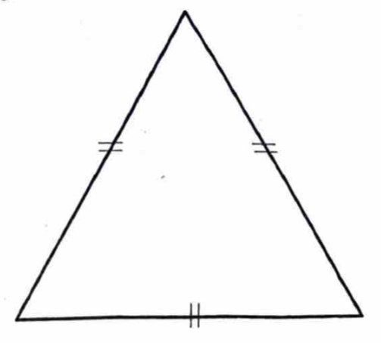
A. isosceles
B. equilateral
C. scalene
D. right-angled

Q20. The name given to a quadrilateral with equal sides and a pair of opposite angles greater than 90° is [Quadrilaterals]
A. square.
B. parallelogram.
C. rectangle.
D. rhombus.

Q21. The plane figure shown below is a [Lines & Conventions]
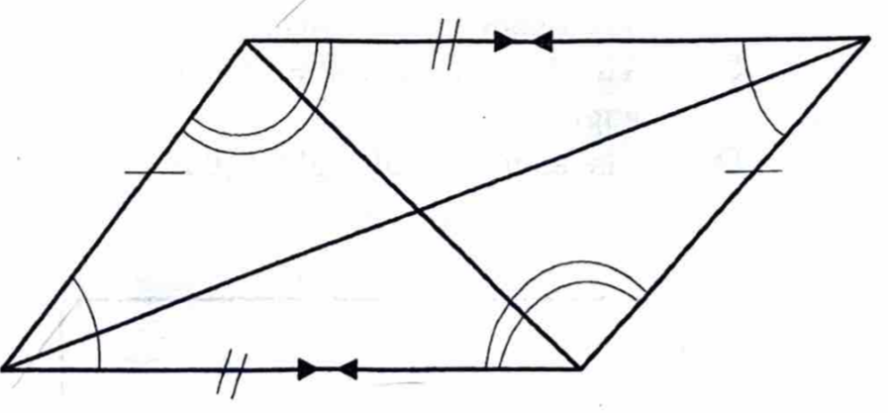
A. rhombus.
B. parallelogram.
C. trapezium.
D. square.

Q22. The illustration below is a [Quadrilaterals]
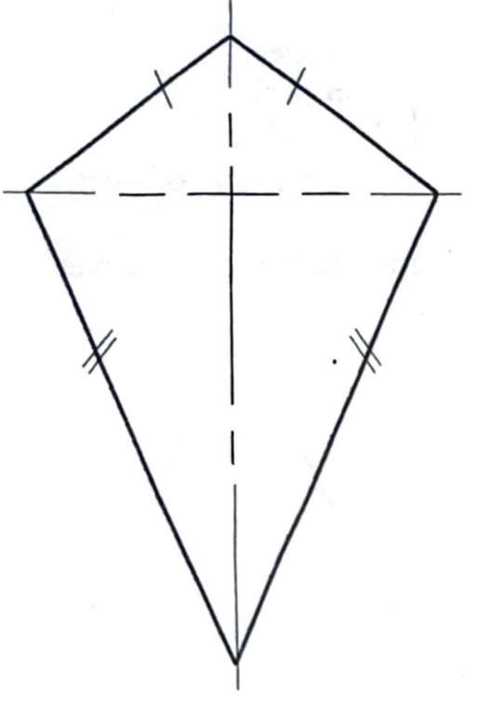
A. trapezoid.
B. deltoid.
C. rhombus.
D. trapezium.

Q23. A quadrilateral with only two sides parallel is a [Quadrilaterals]
A. square.
B. trapezium.
C. rectangle.
D. parallelogram.

Q24. What is common between a square and a rectangle? [Angles & Construction]
A. All sides are equal
B. The diameters are equal
C. The diagonals bisect each other at right-angle
D. The angles are all right angles

Q25. In the diagram above, line PQ is a [Lines & Conventions]
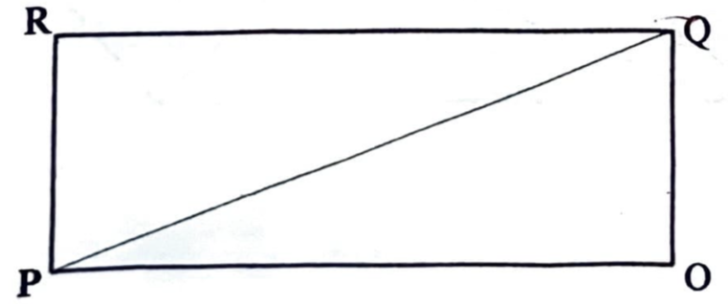
A. base line.
B. reference line.
C. diagonal line.
D. radial line.

Q26. If the radius of a circle is 45 mm, what is the length of side of a regular hexagon inscribed in the circle? [Circles & Ellipses]
A. Quarter of 45 mm
B. Half of 45 mm
C. Same as 45 mm
D. Twice 45 mm

Q27. The dimension ‘S’ of the hexagon shown below can be referred to as across [Polygons]
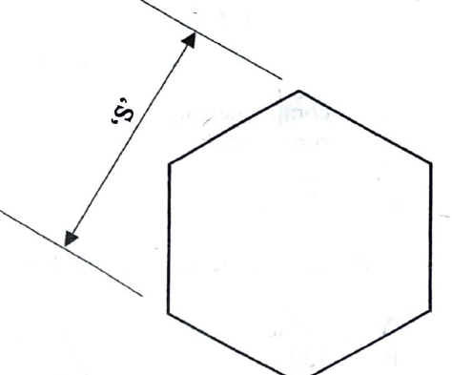
A. corners.
B. flats.
C. centres.
D. edges.

Q28. The diagram below shows a [Polygons]
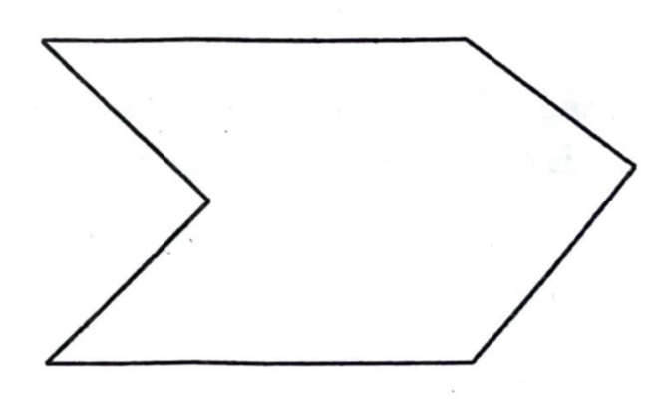
A. regular polygon.
B. convex hexagon.
C. trapezoid.
D. re-entrant hexagon.

Q29. A hexagon has ____ sides. [Polygons]
A. five
B. six
C. seven
D. eight

Q30. What is the name of line HK in the diagram below? [Lines & Conventions]
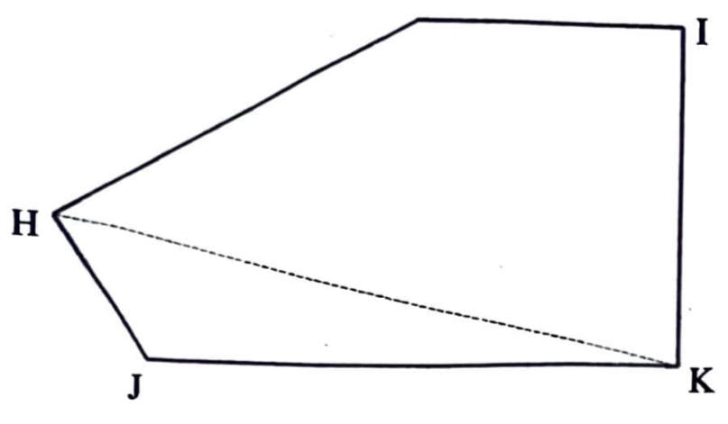
A. Axis
B. Connection
C. Diagonal
D. Hypotenuse

Q31. Circles that touch one another externally are said to be [Circles & Ellipses]
A. attached.
B. tangential.
C. concentric.
D. central.

Q32. The diagram below is a semi-circle and QR is the diameter. Angle PRQ is 50°. Find angle x. [Circles & Ellipses]
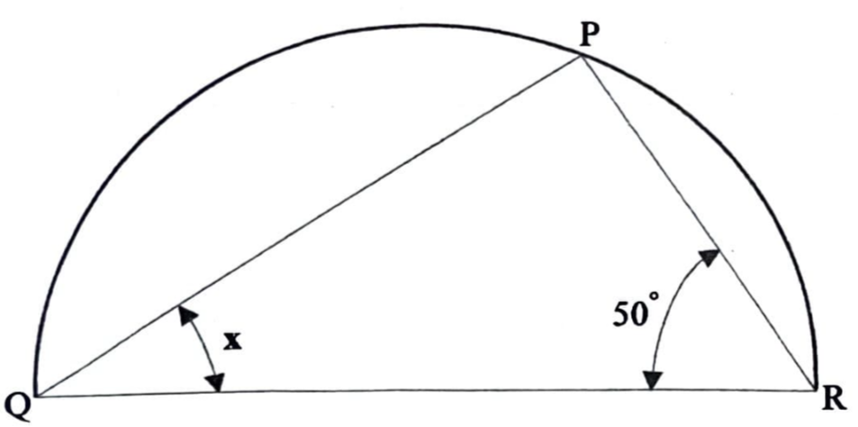
A. 40°
B. 45°
C. 60°
D. 90°

Q33. A sector of a circle is an area bounded by [Circles & Ellipses]
A. a chord and an arc.
B. a chord and a radius.
C. two radii and an arc.
D. two chords and an arc.

Q34. An ellipse is constructed using [Circles & Ellipses]
A. a rectangle.
B. concentric circles.
C. a square.
D. intersecting arcs.

Q35. The two axes of an ellipse are [Circles & Ellipses]
A. major and main axes.
B. main and minor axes.
C. major and focal axes.
D. major and minor axes.

Q36. What is line AB called? [Circles & Ellipses]
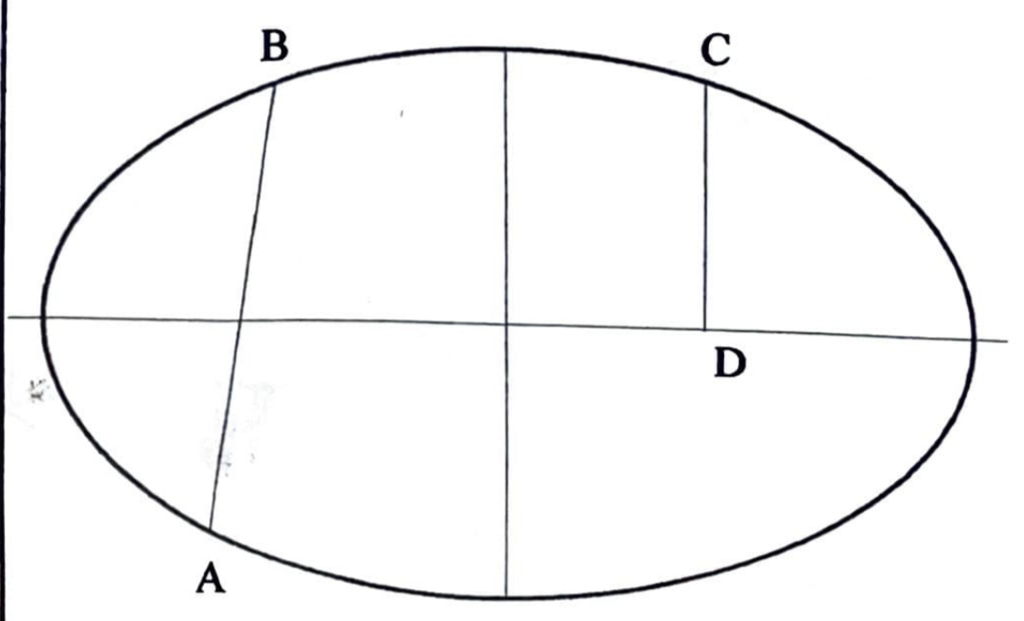
A. Minor axes
B. Chord
C. Normal
D. Tangent

Q37. What is line CD called? [Circles & Ellipses]
A. Foci
B. A hyperbola
C. A normal
D. An ordinate

Q38. The cabinet and cavalier projections are used in [Projections]
A. isometric projection.
B. oblique projection.
C. orthographic projection.
D. axonometric projection.

Q39. An isometric view of an object shows [Projections]
A. a pictorial view of the object.
B. a front elevation of the object.
C. a plan of the object.
D. an end view of the object.

Q40. Which of the following receding angles is the basis of an isometric drawing? [Projections]
A. 60°
B. 45°
C. 30°
D. 15°

Q41. Which of the following shows a pictorial view with half length? [Projections]
A. Orthographic projection
B. Oblique projection
C. Isometric projection
D. Oblique cabinet projection

Q42. Identify the method of drawing used to show the solid in the diagram below. [Projections]
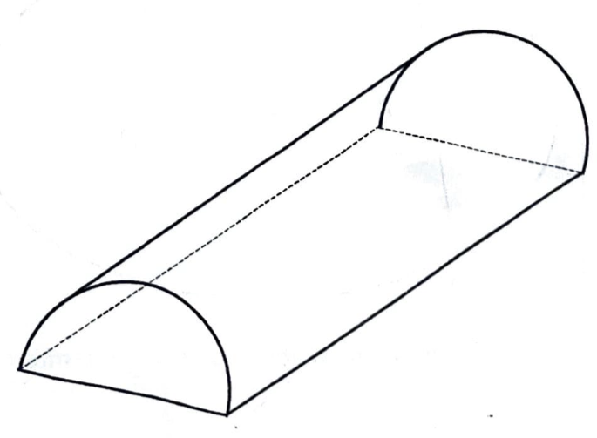
A. Isometric projection
B. Orthographic projection
C. Oblique projection
D. Perspective projection

Q43. The illustration below shows the receding lines in oblique projection. What is the value of angle x? [Lines & Conventions]
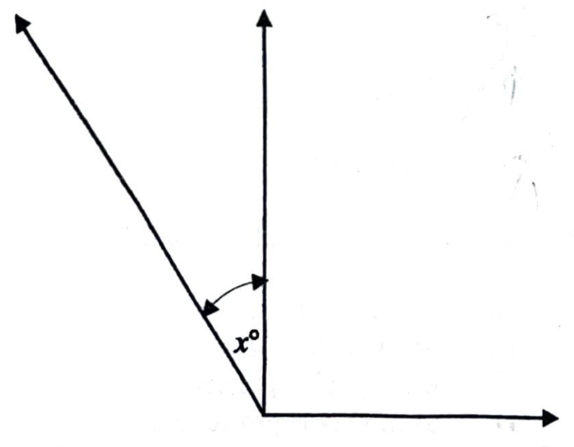
A. 30°
B. 45°
C. 60°
D. 90°

Q44. The form of dimensioning shown in the diagram below is commonly known as [Projections]
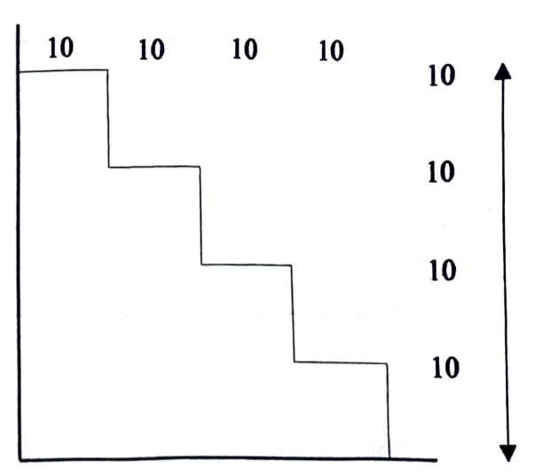
A. stepping.
B. chain.
C. datum.
D. conventional.

Q45. The line ‘S’ in the diagram is called ____ line. [Lines & Conventions]
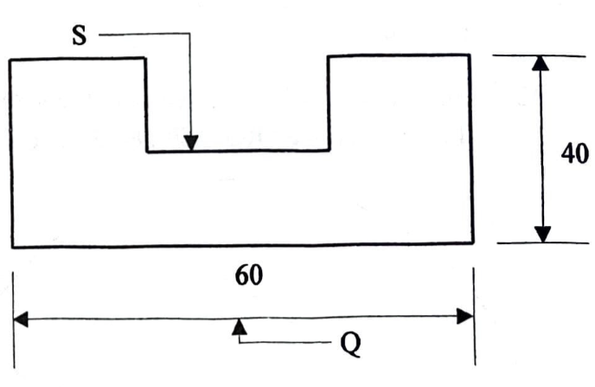
A. dimension
B. projection
C. leader
D. construction

Q46. The line marked ‘Q’ in the diagram is called a/an [Lines & Conventions]
A. projection line.
B. outline.
C. dimension line.
D. chain line.

Q47. Which of the following angles are normally used in orthographic projection? [Projections]
A. 1st and 3rd angle
B. 1st and 2nd angle
C. 1st and 4th angle
D. 2nd and 3rd angle

Q48. The plan view of an object is a drawing which shows a view from [Projections]
A. the front.
B. the left side.
C. the right side.
D. above.

Q49. Referring to the principal planes of projection, the plan view should always be drawn at the ____ plane. [Projections]
A. vertical
B. auxiliary
C. inclined
D. horizontal

Q50. Which of the drawings below shows the elevation FE of the object drawn above? [Projections]
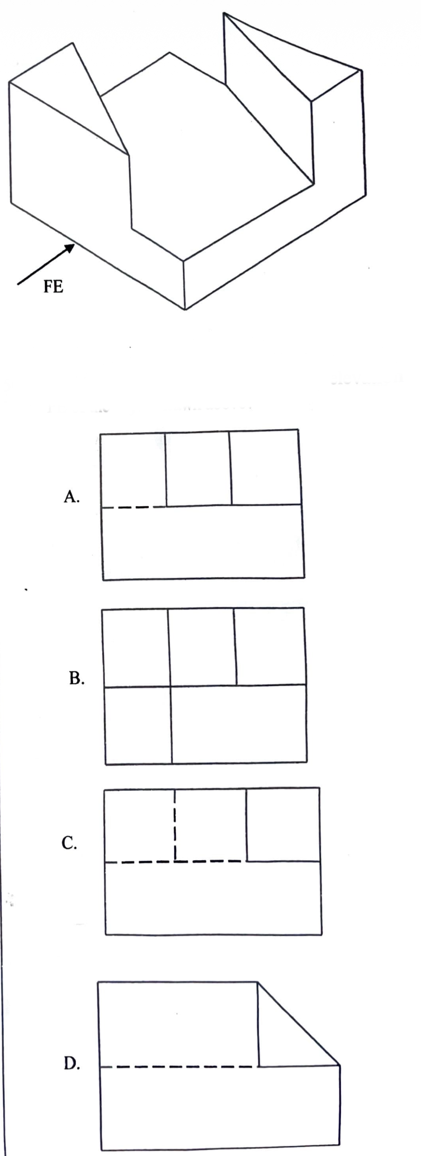

Q51. Technical drawing may be referred to as [General]
A. fine art
B. graphics
C. sketching
D. technology

Q52. The ability of making a mental picture of an object is called [Freehand & Solids]
A. concentration
B. memorization
C. projection
D. visualization

Q53. The angle between the blade and the stock of a T-square is … degrees. [Drawing Instruments]
A. 90
B. 60
C. 45
D. 30

Q54. The instrument used to measure angles is a [Drawing Instruments]
A. pair of compasses
B. protractor
C. set square
D. scale rule

Q55. The instrument used in hatching a cutting surface is the … set square. [Drawing Instruments]
A. 30°
B. 30°/60°
C. 45°
D. 30°/90°

Q56. The units of the metric system is based on the [General]
A. centimetre
B. decimetre
C. hectometre
D. metre

GABECE 2026 — Answer Key
Q# | Answer | Explanation
1 | C | Mechanical drawing deals with the representation of machine parts and components.
2 | C | Technical drawing communicates ideas and information graphically.
3 | A | The drawing board provides a firm, flat surface on which the drawing paper is supported.
4 | C | The stock is the part of the T-square that rests firmly against the edge of the drawing board.
5 | C | A 45° set square is commonly used to draw standard hatching lines.
6 | C | A 45° set square provides the 45° directions needed when constructing a regular octagon.
7 | C | Since 10 mm equals 1 cm, 71 mm equals 7.10 cm.
8 | D | The supplied options do not contain the correct value: 100 cm² equals 0.01 m². The original question...
9 | C | Dimensions are normally indicated with continuous thin dimension lines.
10 | D | Parallel lines remain the same distance apart and do not meet when extended.
11 | A | long short dash line is use to indicate centres of round objects.
12 | C | Perpendicular lines meet at a right angle of 90°.
13 | D | From the equal divisions shown on RP, RT represents 15 parts while TQ represents 5 parts, giving 15:...
14 | A | The two marked angles are 25° and 65°, and 25° + 65° = 90°, so they are complementary angles.
15 | A | The 65° angle and angle OPR form a straight line, so OPR = 180° − 65° = 115°.
16 | C | A reflex angle is greater than 180° but less than 360°.
17 | B | The construction shown produces a 60° angle and then bisects it, giving 30°.
18 | A | Triangles on the same base and between the same parallel lines have equal areas.
19 | B | The diagram shown is triangle with all sides equal hence it is equilateral triangle.
20 | D | A rhombus has four equal sides and opposite angles that can be greater than 90°.
21 | B | The diagram shown is a parallelogram.
22 | B | The figure has two pairs of adjacent equal sides, which identifies a deltoid (kite).
23 | B | A trapezium is a quadrilateral with one pair of parallel sides.
24 | D | Both squares and rectangles have four right angles.
25 | C | PQ joins two non-adjacent vertices of the rectangle, so it is a diagonal line.
26 | C | In a regular hexagon inscribed in a circle, each side equals the radius of the circle.
27 | B | The shown dimension spans between opposite parallel sides of the hexagon, so it is across flats.
28 | D | The figure has six sides and an inward angle, making it a re-entrant hexagon.
29 | B | The prefix 'hex-' denotes six, so a hexagon has six sides.
30 | C | HK joins two non-adjacent vertices of the polygon, so it is a diagonal.
31 | B | Circles that touch at exactly one point are tangent to one another.
32 | A | An angle subtended by a diameter is 90°. Therefore x = 180° − 90° − 50° = 40°.
33 | C | A sector is bounded by two radii and the included arc.
34 | B | One standard graphical construction of an ellipse uses concentric circles.
35 | D | The two principal axes of an ellipse are the major axis and the minor axis.
36 | B | AB joins two points on the ellipse, so it is a chord.
37 | D | CD is the perpendicular segment from the ellipse to the major axis, known as an ordinate.
38 | B | Cabinet and cavalier are forms of oblique projection.
39 | A | Isometric projection gives a pictorial three-dimensional representation of an object.
40 | C | Isometric receding axes are drawn at 30° to the horizontal.
41 | D | Cabinet oblique projection uses half the true depth length for the receding lines.
42 | C | The solid has a face drawn in true shape with receding lines at an oblique angle, identifying obliqu...
43 | B | The receding line is shown at 45° to the horizontal, making 45° with the vertical in the diagram.
44 | A | Each successive feature is dimensioned from the preceding feature, forming a stepping dimensioning a...
45 | C | The S line points from the feature to the dimension or note, so it is a leader line.
46 | C | Q is the line carrying the 60 measurement, so it is a dimension line.
47 | A | The standard orthographic projection systems commonly used are first-angle and third-angle projectio...
48 | D | A plan view represents the object as seen from above.
49 | D | The plan is projected onto the horizontal plane.
50 | D | The elevation corresponding to the indicated FE viewing direction is represented by option D.
51 | B | Technical drawing is a form of graphics used to communicate ideas precisely.
52 | D | Visualization is the skill of forming mental images of objects before drawing.
53 | A | A T-square is designed with a 90° angle to ensure perpendicular alignment.
54 | B | A protractor is specifically used for measuring and constructing angles.
55 | C | The 45° set square is commonly used for hatching lines at consistent angles.
56 | D | The metre is the base unit of the metric system.

Topic Cross-Reference Index
Find all questions on a specific topic across all years. Use this for focused revision on your weak areas.

Angles & Construction (68 questions)
Year | Q# | Question (preview)
2002 | 3 | In the diagram above, line YZ is known as...
2002 | 11 | Two angles that add up to 180º are called … angles....
2002 | 12 | The diagram above shows a triangle drawn in a circle, centre O. The value of ang...
2002 | 13 | In the diagram above the sum of angles x and y is … degrees....
2002 | 16 | To inscribe a circle in a triangle, it is necessary to bisect any...
2002 | 17 | In the diagram above, angle ACD is...
2002 | 18 | The minimum number of arcs needed to bisect an angle is...
2002 | 22 | The sum of the angles in any quadrilateral add up to … degrees....
2002 | 30 | The sum of the angles in a circle is equal to … degrees....
2015 | 14 | To triset an angle means to divide an angle into … equal parts....
2015 | 15 | In the diagram above angle P is called … angle....
2015 | 16 | Which of the following angles can be called an acute angle?...
2015 | 17 | The sum of the angles in a triangle totals to...
2015 | 18 | If angle a and angle b in the diagram above are equal to 60° each, what is angle...
2015 | 19 | Which of the angles above cannot be constructed using a compass?...
2015 | 20 | The diagram above shows the relationship of three angles. What name could be giv...
2015 | 23 | Which of the following is not true about a rhombus?...
2015 | 32 | What is the value of angle Xº as shown in the diagram above?...
2016 | 9 | In the diagram above angle PRS is equal to …...
2016 | 10 | In the figure above …...
2016 | 12 | The value of angle x in the figure above is …...
2016 | 13 | In the figure above, angle y is equal to …...
2016 | 16 | The perimeter of the triangle shown above is 130 mm. The length of side EF is eq...
2016 | 17 | The sum of the interior angles in a quadrilateral is equal to …...
2016 | 21 | In the figure above, angle X° is given by …...
2016 | 35 | The diagram above shows isometric axes. What is the value of angle?...
2020 | 1 | When two set squares are placed together as shown above, what is the value of an...
2020 | 6 | How many bisections can be made on a right angle to get an angle of 22.5°?...
2020 | 13 | In the diagram above the sum of angles O and Q is …...
2020 | 14 | An angle is called reflex when it is …...
2020 | 15 | The sum of interior angles of a quadrilateral is … degrees....
2020 | 16 | What is the name of point R?...
2020 | 17 | To circumscribe this triangle, it is necessary to bisect …...
2020 | 18 | The interior angles of a triangle add up to …...
2020 | 19 | If two angles of a triangle add up to 165°, what is the other angle?...
2020 | 20 | When two right angled triangles of equal sides are put together on a common hypo...
2020 | 29 | How many right angles will the line VW and XY form on the outside of the circumf...
2020 | 33 | Which of the following methods is not used to construct an ellipse?...
2021 | 13 | An angle more than 180° but less than 360° is called …...
2021 | 14 | When two angles add up to 180°, they are said to be …...
2021 | 15 | In the diagram above, angle x and y add up to 180°. What will be the sum of angl...
2021 | 17 | What is the sum of the interior angles of a triangle?...
2021 | 18 | What is the length of side MO in the triangle above?...
2021 | 22 | The sum of the interior angles of a quadrilateral is …...
2021 | 24 | ...
2022 | 4 | Which of the names is given to the figure above?...
2022 | 12 | The diagram above shows a/an … angle....
2022 | 13 | The diagram above illustrates … angles....
2022 | 15 | The best way to describe a triangle as a plane figure is that it has...
2022 | 18 | Which of the plane figures above does not have its diagonal at right angle?...
2022 | 22 | A square when distorted to an angle other than 90° will become a...
2022 | 23 | The diagram shows angles of 60°. The sum of angle Q and OS is...
2022 | 25 | The angle marked X is equal to...
2022 | 27 | The diagram above shows an incomplete method of constructing a polygon. How many...
2022 | 39 | The diagram above shows isometric axis. The angle marked Y will be...
2025 | 10 | The construction below illustrates how to construct an angle of...
2025 | 11 | All angles are measured in...
2025 | 12 | What is the value of angle X in the diagram below?...
2025 | 14 | The value of X in the diagram below is...
2025 | 15 | To inscribe a circle in a triangle, one needs to bisect two...
2025 | 19 | The sum of the interior angles of a quadrilateral is...
2025 | 21 | Which of the following does not have its diagonal at right angles?...
2025 | 33 | Which of the following is not a method of constructing an ellipse?...
2025 | 37 | The diagram below shows isometric axes. What is the value of angle b?...
2026 | 14 | The diagram below illustrates ____ angles....
2026 | 16 | An angle which is greater than 180° but less than 360° is called a/an ____ angle...
2026 | 17 | The diagram below shows the illustration of constructing an angle of...
2026 | 24 | What is common between a square and a rectangle?...

Circles & Ellipses (54 questions)
Year | Q# | Question (preview)
2002 | 26 | To construct a regular hexagon in a given circle, the radius of the circle is st...
2002 | 28 | The portion marked Q is called a/an...
2002 | 29 | The portion marked R is called a/an...
2002 | 31 | In which of the drawings above is the line X–Y a tangent?...
2002 | 32 | The diagram above shows VW as the major axis and ST as the minor axis of an elli...
2002 | 44 | The skills of movement controlled by the brain are called...
2015 | 22 | Which of the following is not an example of a quadrilateral?...
2015 | 25 | The radius of a circle in a square as shown above is 40 mm. What is the length o...
2015 | 30 | Circles with the same centre but different radiuses are called … circles....
2015 | 31 | The angle between the normal and the tangent is...
2015 | 33 | What fraction of the circle does the shaded portion cover?...
2015 | 34 | Which of the following parts cannot be found on an ellipse?...
2015 | 35 | F1 and F2 are usually points located on an ellipse. What does “F” stand for?...
2016 | 25 | How many times can the radius R of the circle above be stepped off the circumfer...
2016 | 26 | The type of circles shown above is described as … circles....
2016 | 27 | In the diagram, line PQ can be referred to as a common …...
2016 | 29 | In the diagram above, line EF is the diameter of the semicircle. Angle x is equa...
2016 | 31 | The distance F2 to G is equal to … of the ellipse....
2016 | 32 | A possible method that could be used to construct the ellipse is …...
2016 | 39 | In the figure above, the symbol “Ø” before the dimension figure 30 represents th...
2020 | 9 | The relationship between the normal and a tangent at a point on a circle is that...
2020 | 30 | The circles shown above are known as … circles....
2020 | 31 | The portion labelled D is called a …...
2020 | 32 | Which of the portions is a quadrant?...
2020 | 34 | The distance F2 to G is equal to … of the ellipse....
2020 | 35 | A possible method that could be used to construct the ellipse is … method....
2020 | 42 | Which of the following can be used to draw an isometric circle?...
2021 | 25 | How many times should the circumference of a circle be stepped off to construct ...
2021 | 28 | A straight line that joins two points on the circumference of a circle is called...
2021 | 29 | The figure above shows … circles....
2021 | 31 | Circles with the same center but different radii are called …...
2021 | 32 | The diagram above shows a triangle inscribed in a circle. What is the value of a...
2021 | 33 | The line OR in the diagram above is called…...
2021 | 40 | Which of the following can be used to draw an isometric circle?...
2022 | 29 | A sector is bounded by...
2022 | 30 | How many semi-circles make up a complete circle?...
2022 | 31 | The diagram above shows … circles...
2022 | 32 | The longest diameter in an ellipse is called...
2022 | 33 | In all ellipses, the distance from one end of the minor axis to the focal points...
2025 | 26 | When a circle is drawn in isometric, the figure produced will be...
2025 | 27 | What is the name of the part labelled X?...
2025 | 28 | The part labelled Y is called...
2025 | 29 | What name is given to the part labelled Z?...
2025 | 30 | The figure drawn below is called...
2025 | 31 | The outer boundary of a circle is called...
2025 | 39 | In the figure below, the symbol Ø before the dimension figure 20 represents the ...
2026 | 26 | If the radius of a circle is 45 mm, what is the length of side of a regular hexa...
2026 | 31 | Circles that touch one another externally are said to be...
2026 | 32 | The diagram below is a semi-circle and QR is the diameter. Angle PRQ is 50°. Fin...
2026 | 33 | A sector of a circle is an area bounded by...
2026 | 34 | An ellipse is constructed using...
2026 | 35 | The two axes of an ellipse are...
2026 | 36 | What is line AB called?...
2026 | 37 | What is line CD called?...

Dimensioning & Lettering (26 questions)
Year | Q# | Question (preview)
2002 | 8 | The height of letters used for upper case or capitals should be … millimetres....
2002 | 14 | A plane figure has … dimensions....
2002 | 42 | Which of the figures above is correctly dimensioned?...
2015 | 11 | Which of the following points need to be considered when lettering on a diagram?...
2015 | 12 | The horizontal position of a drawing sheet is known as … layout....
2015 | 13 | Which of the following is likely not to be included in a title block?...
2015 | 43 | What is the standard dimension of an A4 paper?...
2015 | 47 | Good draughtmanship involves …...
2016 | 6 | Which of the following could be of good help in lettering and numerals?...
2016 | 7 | The size of A3 drawing paper is …...
2016 | 8 | The distance between the border line and the edge of a drawing paper is …...
2020 | 10 | An object can be drawn to scale when it is too …...
2020 | 11 | The distance between the border line and the edge of an A4 drawing paper is …...
2020 | 43 | The dimensions of a plane figure are given by its …...
2020 | 44 | Which of the following figures above is correctly dimensioned?...
2021 | 3 | In the diagram above, the symbol Ø before the dimension figure 40 represents …...
2021 | 11 | If the long side of a drawing paper is aligned horizontally, it is said to be …...
2021 | 12 | The descriptions of a drawing are stated on a …...
2021 | 41 | The dimensions of a plane figure are given by its …...
2021 | 42 | Which of the following figures above is correctly dimensioned?...
2022 | 10 | The horizontal positioning of a drawing sheet is called … layout....
2022 | 11 | Which of the following is not part of a title block?...
2022 | 41 | Which of the following figures is correctly dimensioned?...
2022 | 46 | Good draughtmanship involves...
2025 | 8 | The part labelled X on the diagram below is the...
2025 | 9 | The standard measurement of border lines on A4 paper is...

Drawing Instruments (33 questions)
Year | Q# | Question (preview)
2002 | 19 | In the diagram above X is a 45° set square and Y a 30°/60° set square. What is t...
2002 | 46 | Which of the following items could be used in the absence of drawing clips?...
2015 | 1 | In the diagram above, part “y” and “z” are fixed together at x°. The value of an...
2015 | 2 | The part labeled “y” is called the...
2015 | 3 | Which of the following equipment is used for measuring angles?...
2015 | 28 | Which of the polygons can be constructed using 45° set-square?...
2015 | 49 | The main function of a ruler is to …...
2015 | 50 | The instrument used to measure angles is a …...
2015 | 51 | The drawing sheet is set parallel to the top edge of the drawing board using …...
2015 | 52 | All the following pencils are used in technical drawing except …...
2016 | 43 | The blade and the stock of the tee-square are joined together by means of …...
2016 | 44 | The instrument most suitable for linear measurement is called …...
2020 | 2 | The most important feature of a tee-square is the …...
2020 | 49 | If a circle with a diameter above 250 cm is to be drawn using a compass, it is r...
2020 | 50 | Which of the following instruments has one of its angles at 60°?...
2021 | 1 | The figure above shows two 45 degree set squares placed together, what is the va...
2021 | 2 | To draw a perfect irregular curve, one needs to use a …...
2021 | 26 | Which of the following polygons can be constructed using a 45° set-square?...
2021 | 46 | One of the main features of a drawing board is...
2021 | 47 | Which of the following angles is not found on set-squares?...
2021 | 48 | Short pencil is recommended for use with a pair of compasses in order to...
2022 | 1 | Identify the drawing instrument above....
2022 | 16 | The diagram above illustrates two 45° set-squares attached together. What is the...
2022 | 49 | The instrument used to measure an angle is called...
2022 | 50 | Which of the following is not a Technical Drawing equipment?...
2022 | 51 | Which of the following angles is not found on a set square?...
2026 | 3 | What is the drawing board meant to support?...
2026 | 4 | The part of the Tee-square which is firmly pressed against the edge of the drawi...
2026 | 5 | The instrument used in hatching a cutting surface is the ____ set square....
2026 | 6 | Which of the following instruments can be used to construct an octagon?...
2026 | 53 | The angle between the blade and the stock of a T-square is … degrees....
2026 | 54 | The instrument used to measure angles is a...
2026 | 55 | The instrument used in hatching a cutting surface is the … set square....

Freehand & Solids (24 questions)
Year | Q# | Question (preview)
2002 | 1 | The distance PO in the diagram above is one metre. What does OQ represent in mm?...
2002 | 33 | In freehand sketching emphasis should be laid on...
2002 | 35 | The figure above is called a...
2002 | 37 | A pyramid can be identified by...
2015 | 36 | A good freehand sketch can be determined by its...
2015 | 37 | What is the name given to the geometrical solid shown above?...
2015 | 38 | Another name given to a square prism is called...
2015 | 48 | In visualization one uses …...
2016 | 30 | Freehand sketching emphasizes …...
2016 | 33 | The main difference between a cylinder and a prism is that …...
2016 | 34 | An elevation of a solid geometrical figure is shown above. The solid can possibl...
2020 | 3 | If the distance NQ in the diagram above is one meter, what does the distance OQ ...
2020 | 36 | What is the name given to the geometrical solid shown above?...
2020 | 37 | Another name given to a square prism is …...
2020 | 48 | A drawing skill in which one uses the hands during operation is called … skill....
2021 | 35 | Another name given to a square prism is …...
2022 | 34 | An accurate freehand sketching depends on good...
2022 | 35 | The figure illustrated above is called a...
2022 | 36 | The figure shown above has........faces...
2022 | 38 | An elevation of a solid geometrical figure is shown above. The solid can possibl...
2022 | 47 | In perception, one uses...
2025 | 34 | Which of the following is the most important aspect in freehand sketching?...
2025 | 36 | An elevation of a solid geometrical figure is shown below. The solid can possibl...
2026 | 52 | The ability of making a mental picture of an object is called...

General (24 questions)
Year | Q# | Question (preview)
2002 | 45 | Which of the following is true about Technical Drawing?...
2015 | 4 | In measuring distance, how many millimetres will be equal to 9.6 cm?...
2015 | 5 | What name is given to the old system of measuring?...
2015 | 53 | What is the base unit for measuring distance in the metric system?...
2016 | 41 | The following are members of the organizational structure of a typical drawing o...
2016 | 42 | Technical drawing is said to be the … language of an industry....
2020 | 4 | Convert 65 millimeters to centimeters....
2020 | 12 | The minimum height of block letters and numbers when printing is …...
2020 | 47 | Which of the following is not a member of the organizational structure of a typi...
2021 | 4 | 1.5 meters is equal to …...
2021 | 44 | Technical Drawing can also be referred to as communication....
2021 | 45 | Which of the following is not a branch of Technical Drawing?...
2022 | 2 | All the following are units of the metric system except...
2022 | 3 | Which of the figures below is equivalent to 706 mm?...
2022 | 24 | The distance marked 'Y' in the diagram above is called...
2022 | 48 | The main function of the rule is to...
2022 | 52 | What name is given to the old system of measuring?...
2025 | 1 | What is the distance marked X in the diagram above?...
2026 | 1 | The area of technical drawing in which machine components are drawn is...
2026 | 2 | Technical drawing is a universal language that is communicated...
2026 | 7 | Which of the following is the same as 71 mm?...
2026 | 13 | What is the ratio of RT to TQ in the diagram below?...
2026 | 51 | Technical drawing may be referred to as...
2026 | 56 | The units of the metric system is based on the...

Lines & Conventions (66 questions)
Year | Q# | Question (preview)
2002 | 2 | The diagram above illustrates a/an...
2002 | 4 | In triangle ABC above, line CD is called a/an...
2002 | 5 | In the diagram above X is called a … line....
2002 | 6 | Hidden details of objects are shown by...
2002 | 7 | When two lines are equidistant throughout their lengths, they are said to be...
2002 | 21 | The diagram above is called a...
2002 | 34 | The cut surface of an object is shown by...
2002 | 38 | The diagram of a cone is shown above, what shape would be produced by the cutrin...
2015 | 6 | Line XY above is divided in the ratio of...
2015 | 7 | Which of the following represent perpendicular lines?...
2015 | 8 | Lines which move towards a point are known as … lines....
2015 | 9 | … lines are used to show long break lines....
2015 | 10 | Lines that are equidistant throughout their length are said to be...
2015 | 21 | The distance between the opposite corners of a quadrilateral is called the...
2015 | 44 | The line marked Q in the diagram above is called a/an...
2015 | 54 | The common unit of linear measurement on drawings is …...
2016 | 1 | Line TU is called … line....
2016 | 2 | One property of lines PQ and RS is that they …...
2016 | 3 | The recommended type of line that drawings should start with is a … line....
2016 | 4 | The line shown above is used for …...
2016 | 5 | The construction shown above indicates that line LM is … to line PQ....
2016 | 11 | When two straight lines meet at a point, they form a/an …...
2016 | 18 | Line FH in the figure is called …...
2016 | 22 | A plane figure bounded by four straight lines is called a …...
2016 | 23 | The figure above shows a …...
2016 | 28 | To find the centre of the arc EF …...
2016 | 40 | In the diagram above, line EF is called a/an …...
2020 | 5 | A line which is neither vertical nor horizontal is known as … line....
2020 | 7 | A drawing is started with a type of line called …...
2020 | 8 | In the diagram above, if line LN is 250 mm, what will LM represent?...
2020 | 24 | The figure shown above is a …...
2021 | 5 | In the diagram above, line OP and QR are …...
2021 | 6 | The line OR drawn above is called a …...
2021 | 7 | The meeting point of two lines crossing each other is called …...
2021 | 8 | Which of the following lines is used to indicate long break line?...
2021 | 9 | Measurements on a drawing are shown by …...
2021 | 10 | In lettering and numbering, letters are made uniform in height, spacing and widt...
2021 | 30 | In the diagram below, line x is equal to......
2022 | 5 | The type of line recommended to start a drawing is a...
2022 | 6 | The lines shown above are called … lines....
2022 | 7 | Point Y in the diagram above divides line XZ in the ratio of...
2022 | 8 | The shortest trace between two points is called a/an...
2022 | 9 | In lettering, one can either use the slanted or … style....
2022 | 20 | All quadrilaterals have...
2022 | 28 | A straight line drawn at 90° to the tangent from the point of tangency is called...
2022 | 42 | The line labeled 'S' in the diagram above is called … line....
2025 | 2 | Lines that are equidistant throughout their length are said to be...
2025 | 3 | The diagram below illustrates lines....
2025 | 4 | To bisect simply means to divide equally into.......parts....
2025 | 5 | To bisect line AB below, one needs to use points as centres to scribe the arcs....
2025 | 6 | Lines ST and UV in the diagram below are......to each other....
2025 | 7 | The most common type of lettering is the style....
2025 | 32 | In the diagram below, line OP is called the...
2025 | 40 | In the diagram below, line GH is called a/an...
2026 | 9 | Which type of line is used for dimensioning?...
2026 | 10 | Lines which never meet when extended are said to be...
2026 | 11 | The diagram above illustrates...
2026 | 12 | A perpendicular line is a line at an angle of...
2026 | 15 | In the diagram below, angle OPR is...
2026 | 18 | Triangles on the same base and between the same parallels are...
2026 | 21 | The plane figure shown below is a...
2026 | 25 | In the diagram above, line PQ is a...
2026 | 30 | What is the name of line HK in the diagram below?...
2026 | 43 | The illustration below shows the receding lines in oblique projection. What is t...
2026 | 45 | The line ‘S’ in the diagram is called ____ line....
2026 | 46 | The line marked ‘Q’ in the diagram is called a/an...

Polygons (22 questions)
Year | Q# | Question (preview)
2002 | 24 | A nine-sided polygon is called a...
2002 | 25 | The figure above shows a regular pentagon. What is the value of angle QRS?...
2002 | 27 | The regular polygon which can be drawn using 60° set square and a Tee square onl...
2015 | 26 | A polygon is a plane figure with more than … sides....
2015 | 27 | A regular polygon which contains exactly ten sides is called...
2015 | 29 | What are the internal angles of a pentagon?...
2016 | 20 | A plane figure bounded by seven sides is known as …...
2016 | 24 | The figure above is called a/an …...
2020 | 25 | The distance marked x in the diagram above is known as …...
2020 | 26 | The exterior angle of a regular pentagon is …...
2020 | 27 | Which of the following polygons can be constructed using the 30–60 degree set sq...
2020 | 28 | If the formula 360 ÷ 45° is used to construct a particular polygon, what is the ...
2021 | 27 | What is the name given to the figure shown above?...
2021 | 34 | The figure above shows a solid. What is its name?...
2022 | 26 | A seven sided plane figure is called...
2025 | 22 | Which of the following polygons can be constructed using a 45° set square?...
2025 | 23 | A regular polygon whose exterior angle is 72° is a...
2025 | 24 | A polygon is simply a plane figure with...
2025 | 25 | What name is given to the figure illustrated below?...
2026 | 27 | The dimension ‘S’ of the hexagon shown below can be referred to as across...
2026 | 28 | The diagram below shows a...
2026 | 29 | A hexagon has ____ sides....

Projections (46 questions)
Year | Q# | Question (preview)
2002 | 9 | In third angle projection the plan is normally drawn...
2002 | 10 | The number of views shown in an isometric drawing is...
2002 | 36 | In an isometric projection, receding lines are drawn at … degrees to the horizon...
2002 | 39 | The diagram above shows a/an … view of a cuboid....
2002 | 40 | In an oblique cabinet drawing the length of the object is divided by...
2002 | 41 | The diagram above illustrates a/an … axis....
2002 | 43 | The two main methods of drawing an object in orthographic projection are the … a...
2015 | 39 | A cutting plane P–P of a cone is shown above. What section will be exposed by th...
2015 | 40 | The drawing method shown above is called...
2015 | 41 | Which of the following angle projections is normally used in orthographic projec...
2015 | 42 | The receding angle generally used in isometric projection is...
2015 | 45 | The true shape of a section can be shaded using hatching lines usually at an ang...
2015 | 46 | The plan view of an object is a drawing which shows the view from...
2016 | 36 | Isometric projection is … dimensional form of drawing....
2016 | 37 | Which of the diagrams above shows isometric projection?...
2016 | 38 | The cavalier principle of pictorial projection is used in the method of … drawin...
2020 | 38 | The cutting plane EE of a cone is shown above. What section will be exposed by t...
2020 | 39 | The drawing method shown above is called … projection....
2020 | 40 | Oblique views have their receding sides drawn at an angle of …...
2020 | 41 | A pictorial drawing is a form of … dimensional drawing....
2020 | 45 | The angle of projection for a true shape on a cutting plane is at …...
2020 | 46 | The diagram above shows the principal planes used in orthographic projection. In...
2021 | 36 | The cutting plane of a cone is shown above. What section will be exposed?...
2021 | 37 | The drawing method shown above is called … projection....
2021 | 38 | Oblique views have their receding sides drawn at an angle of …...
2021 | 39 | A pictorial drawing is a form of … dimensional drawing....
2021 | 43 | The angle of projection for a true shape on a cutting plane is at …...
2022 | 37 | Which of the following is not a representation of an object in pictorial drawing...
2022 | 40 | The figure drawn above represents … projection....
2022 | 43 | Which of the figures above represents a third angle projection?...
2022 | 44 | The angle of projection for the true shape on a cutting plane is...
2022 | 45 | The figure above shows an isometric drawing of a block. Identify the end view as...
2025 | 38 | Isometric projection is a form of...........drawing....
2025 | 41 | Isometric drawing gives the......... view of an object....
2025 | 42 | The method used to draw the layout of the figures below is...
2025 | 43 | How many views are usually shown in orthographic projection?...
2026 | 38 | The cabinet and cavalier projections are used in...
2026 | 39 | An isometric view of an object shows...
2026 | 40 | Which of the following receding angles is the basis of an isometric drawing?...
2026 | 41 | Which of the following shows a pictorial view with half length?...
2026 | 42 | Identify the method of drawing used to show the solid in the diagram below....
2026 | 44 | The form of dimensioning shown in the diagram below is commonly known as...
2026 | 47 | Which of the following angles are normally used in orthographic projection?...
2026 | 48 | The plan view of an object is a drawing which shows a view from...
2026 | 49 | Referring to the principal planes of projection, the plan view should always be ...
2026 | 50 | Which of the drawings below shows the elevation FE of the object drawn above?...

Quadrilaterals (19 questions)
Year | Q# | Question (preview)
2002 | 23 | The figure above is called a/an...
2015 | 24 | In quadrilaterals, a rectangle is to parallelogram as square is to...
2016 | 19 | The figure above represents a …...
2020 | 21 | A square pushed sideways gives a shape called …...
2020 | 22 | A square and a rectangle are similar because …...
2020 | 23 | The figure shown above is a …...
2021 | 20 | A quadrilateral with all its sides equal but unequal diagonals is called a …...
2021 | 21 | A parallelogram is also known as a …...
2021 | 23 | All four-sided geometric figures are known as …...
2022 | 19 | The figure above represents a...
2022 | 21 | Which of the quadrilaterals above has none of its sides parallel?...
2025 | 17 | The difference between a rhombus and a square is their...
2025 | 18 | Identify the quadrilateral illustrated below....
2025 | 20 | A square when pushed to an angle other than 90° will become a...
2025 | 35 | The diagram below shows a view of a square.............
2026 | 8 | How many square meters is equal to 100 square centimeters?...
2026 | 20 | The name given to a quadrilateral with equal sides and a pair of opposite angles...
2026 | 22 | The illustration below is a...
2026 | 23 | A quadrilateral with only two sides parallel is a...

Triangles (11 questions)
Year | Q# | Question (preview)
2002 | 15 | A triangle that has none of its sides and angles equal is called a/an … triangle...
2002 | 20 | The vertical angle of an isosceles triangle is 70°. What is the value of each of...
2016 | 14 | The type of triangle shown above is … triangle....
2016 | 15 | In the figure above, line QS and line PT are called …...
2021 | 16 | What is the name given to the triangle shown above?...
2021 | 19 | A triangle that has none of its angles equal is called …...
2022 | 14 | The altitude of a triangle is the same as its...
2022 | 17 | What is the sum of two angles of an equilateral triangle?...
2025 | 13 | A triangle with all the sides and angles unequal is called triangle....
2025 | 16 | The longest side of a right angle triangle is known as...
2026 | 19 | The diagram below is called a/an ____ triangle....

Mock Exam Paper 1
This mock paper contains 40 questions mixed from all years. Time yourself: 2 hours 30 minutes. Good luck!

Q1. The distance PO in the diagram above is one metre. What does OQ represent in mm? [Freehand & Solids]
A. 400 mm
B. 600 mm
C. 800 mm
D. 900 mm

Q2. In the diagram above X is called a … line. [Lines & Conventions]
A. dimension
B. extension
C. horizontal
D. projection

Q3. The height of letters used for upper case or capitals should be … millimetres. [Dimensioning & Lettering]
A. 3
B. 4
C. 5
D. 8

Q4. Two angles that add up to 180º are called … angles. [Angles & Construction]
A. alternate
B. complimentary
C. supplementary
D. vertically opposite

Q5. A triangle that has none of its sides and angles equal is called a/an … triangle. [Triangles]
A. equilateral
B. isosceles
C. right-angled
D. scalene

Q6. The part labeled “y” is called the [Drawing Instruments]
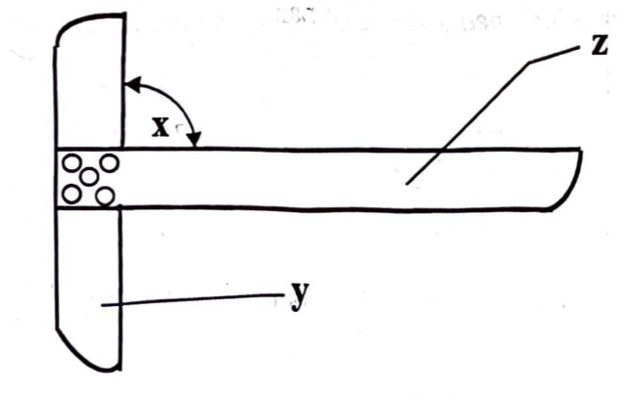
A. blade
B. long piece
C. stock
D. handle

Q7. What name is given to the old system of measuring? [General]
A. Imperial system
B. New system
C. Poles
D. Metric system

Q8. Lines which move towards a point are known as … lines. [Lines & Conventions]
A. inclined
B. converging
C. radial
D. diverging

Q9. The horizontal position of a drawing sheet is known as … layout. [Dimensioning & Lettering]
A. artistic
B. landscape
C. up-right
D. portrait

Q10. If angle a and angle b in the diagram above are equal to 60° each, what is angle ĉ? [Angles & Construction]
A. 30°
B. 45°
C. 60°
D. 90°

Q11. Line TU is called … line. [Lines & Conventions]
A. transversal
B. intersecting
C. bisecting
D. perpendicular

Q12. The construction shown above indicates that line LM is … to line PQ. [Lines & Conventions]
A. perpendicular
B. parallel
C. similar
D. equal

Q13. In the figure above … [Angles & Construction]
A. angle MOQ = angle PON
B. angle MOP = angle MOQ
C. angle QON = angle PON
D. angle MOP + angle PON = 180°

Q14. In the figure above, line QS and line PT are called … [Triangles]
A. slant heights
B. medians
C. diagonals
D. attitudes

Q15. A plane figure bounded by seven sides is known as … [Polygons]
A. heptagon
B. hexagon
C. pentagon
D. octagon

Q16. If the distance NQ in the diagram above is one meter, what does the distance OQ represent in centimeters? [Freehand & Solids]
A. 75 cm
B. 50 cm
C. 25 cm
D. 15 cm

Q17. A drawing is started with a type of line called … [Lines & Conventions]
A. thick line
B. thin line
C. small line
D. center line

Q18. An object can be drawn to scale when it is too … [Dimensioning & Lettering]
A. complicated
B. intricate
C. large
D. rough

Q19. The sum of interior angles of a quadrilateral is … degrees. [Angles & Construction]
A. 90
B. 120
C. 180
D. 360

Q20. The interior angles of a triangle add up to … [Angles & Construction]
A. 120°
B. 150°
C. 180°
D. 360°

Q21. The figure above shows two 45 degree set squares placed together, what is the value of angle x? [Drawing Instruments]
A. 45°
B. 60°
C. 90°
D. 270°

Q22. In the diagram above, line OP and QR are … [Lines & Conventions]
A. slanting lines
B. inclined lines
C. parallel lines
D. perpendicular lines

Q23. Which of the following lines is used to indicate long break line? [Lines & Conventions]
Q24. The descriptions of a drawing are stated on a … [Dimensioning & Lettering]
A. drawing block
B. name block
C. title block
D. corner block

Q25. What is the sum of the interior angles of a triangle? [Angles & Construction]
A. 45°
B. 90°
C. 180°
D. 360°

Q26. All the following are units of the metric system except [General]
A. inch
B. millimetre
C. metre
D. centimetre

Q27. The lines shown above are called … lines. [Lines & Conventions]
A. perpendicular
B. vertical
C. parallel
D. oblique

Q28. The horizontal positioning of a drawing sheet is called … layout. [Dimensioning & Lettering]
A. formal
B. portrait
C. landscape
D. vertical

Q29. The best way to describe a triangle as a plane figure is that it has [Angles & Construction]
A. three angles
B. three sides and angles
C. three sides
D. three equal sides

Q30. Which of the plane figures above does not have its diagonal at right angle? [Angles & Construction]
A. Rhombus
B. Rectangle
C. Deltoid
D. Square

Q31. What is the distance marked X in the diagram above? [General]
A. 20 mm
B. 26 mm
C. 28 mm
D. 30 mm

Q32. To bisect line AB below, one needs to use points as centres to scribe the arcs. [Lines & Conventions]
A. A and B
B. A and C
C. A, B and C
D. B and C

Q33. The part labelled X on the diagram below is the [Dimensioning & Lettering]
A. title block.
B. rectangle.
C. centre box.
D. border line.

Q34. What is the value of angle X in the diagram below? [Angles & Construction]
A. 70°
B. 90°
C. 110°
D. 180°

Q35. The difference between a rhombus and a square is their [Quadrilaterals]
A. angles.
B. arcas.
C. perimeters.
D. sides.

Q36. The area of technical drawing in which machine components are drawn is [General]
A. building.
B. electrical.
C. mechanical.
D. geometrical.

Q37. The instrument used in hatching a cutting surface is the ____ set square. [Drawing Instruments]
A. 30°
B. 35°
C. 45°
D. 50°

Q38. How many square meters is equal to 100 square centimeters? [Quadrilaterals]
A. 4 m²
B. 3 m²
C. 2 m²
D. 1 m²

Q39. A perpendicular line is a line at an angle of [Lines & Conventions]
A. 30°.
B. 60°.
C. 90°.
D. 180°.

Q40. The diagram below shows the illustration of constructing an angle of [Angles & Construction]
A. 25½°.
B. 30°.
C. 45°.
D. 90°.

Mock Exam 1 — Answer Key
Q# | Answer | Explanation | From Year
1 | C | 1 metre equals 1000 mm; proportionally OQ represents 800 mm. | 2002
2 | D | Projection lines are used to project views in technical drawing. | 2002
3 | C | Standard lettering height for capitals is 5 mm. | 2002
4 | C | Supplementary angles sum to 180°. | 2002
5 | D | A scalene triangle has all sides and angles unequal. | 2002
6 | C | The part label y is the stock. | 2015
7 | A | The Imperial system was used before the metric system. | 2015
8 | B | Converging lines meet at a point. | 2015
9 | B | Landscape layout means the long side is horizontal. | 2015
10 | C | The third angle is 180° - (60° + 60°) = 60°. | 2015
11 | A | Line TU is a transverssal line cutting the two parallel lines. | 2016
12 | B | Line LM is parallel to line PQ. | 2016
13 | D | The sum of opposite angles equals 180°. | 2016
14 | B | Lines QS and PT are medians of the triangle. | 2016
15 | A | A seven-sided polygon is called a heptagon. | 2016
16 | B | Proportional measurement shows OQ is 50 cm. | 2020
17 | B | Drawings begin with thin lines for layout. | 2020
18 | C | Large objects are drawn to scale to fit on paper. | 2020
19 | D | Quadrilaterals have four angles summing to 360°. | 2020
20 | C | The sum of interior angles in a triangle is 180°. | 2020
21 | D | The diagram shows two 45 degree set squares placed together, so (360)-(45+45)=270°. | 2021
22 | C | Lines OP and QR are parallel. | 2021
23 | A | Long break lines are shown with wavy lines. | 2021
24 | C | Title blocks contain descriptions of the drawing. | 2021
25 | C | The sum of interior angles in a triangle is 180°. | 2021
26 | A | The inch belongs to the imperial system, not the metric system. | 2022
27 | C | The lines shown are parallel lines. | 2022
28 | C | Landscape layout means the long side is horizontal. | 2022
29 | B | A triangle is defined by three sides and three angles. | 2022
30 | B | Rectangles have diagonals that bisect but not at right angles. | 2022
31 | C | The marked distance X is 28 mm. | 2025
32 | A | Bisecting a line requires arcs from both endpoints A and B. | 2025
33 | A | The labelled part X is the Title block. | 2025
34 | A | The value of angle X is 70°. | 2025
35 | A | A rhombus and a square differ in their angles. | 2025
36 | C | Mechanical drawing deals with the representation of machine parts and components. | 2026
37 | C | A 45° set square is commonly used to draw standard hatching lines. | 2026
38 | D | The supplied options do not contain the correct value: 100 cm² equals 0.01 m². The original question... | 2026
39 | C | Perpendicular lines meet at a right angle of 90°. | 2026
40 | B | The construction shown produces a 60° angle and then bisects it, giving 30°. | 2026

Mock Exam Paper 2
This mock paper contains 40 questions mixed from all years. Time yourself: 2 hours 30 minutes. Good luck!

Q1. The vertical angle of an isosceles triangle is 70°. What is the value of each of the other two angles? [Triangles]
A. 55°
B. 65°
C. 75°
D. 110°

Q2. The figure above shows a regular pentagon. What is the value of angle QRS? [Polygons]
A. 60°
B. 75°
C. 108°
D. 180°

Q3. The sum of the angles in a circle is equal to … degrees. [Angles & Construction]
A. 90
B. 180
C. 270
D. 360

Q4. The figure above is called a [Freehand & Solids]
A. bucket
B. cone
C. frustum of a cone
D. pyramid

Q5. In an oblique cabinet drawing the length of the object is divided by [Projections]
A. 2
B. 3
C. 4
D. 5

Q6. Which of the following is not an example of a quadrilateral? [Circles & Ellipses]
A. Kite
B. Trapezoid
C. Rhombus
D. Quadrant

Q7. The radius of a circle in a square as shown above is 40 mm. What is the length of sides of the square? [Circles & Ellipses]
A. 80 mm
B. 90 mm
C. 100 mm
D. 120 mm

Q8. Circles with the same centre but different radiuses are called … circles. [Circles & Ellipses]
A. central
B. concentric
C. eccentric
D. tangential

Q9. F1 and F2 are usually points located on an ellipse. What does “F” stand for? [Circles & Ellipses]
A. Fixed
B. First
C. Focal
D. Form

Q10. The drawing method shown above is called [Projections]
A. oblique projection
B. isometric projection
C. orthographic projection
D. first angle projection

Q11. A plane figure bounded by four straight lines is called a … [Lines & Conventions]
A. deltoid
B. quadrilateral
C. trapezoid
D. pentagon

Q12. How many times can the radius R of the circle above be stepped off the circumference of the circle to obtain a polygon? [Circles & Ellipses]
A. 8
B. 7
C. 6
D. 5

Q13. Freehand sketching emphasizes … [Freehand & Solids]
A. proportionality and neatness
B. accuracy and neatness
C. clarity and neatness
D. careful layout

Q14. The diagram above shows isometric axes. What is the value of angle? [Angles & Construction]
A. 30°
B. 45°
C. 60°
D. 120°

Q15. In the diagram above, line EF is called a/an … [Lines & Conventions]
A. limit line
B. dimension line
C. outline
D. chain line

Q16. When two right angled triangles of equal sides are put together on a common hypotenuse, it will represent a … [Angles & Construction]
A. triangle
B. rhombus
C. square
D. trapezium

Q17. The distance marked x in the diagram above is known as … [Polygons]
A. across flat
B. across corners
C. diameter
D. diagonal

Q18. The circles shown above are known as … circles. [Circles & Ellipses]
A. concentric
B. eccentric
C. ascribed
D. inscribed

Q19. A possible method that could be used to construct the ellipse is … method. [Circles & Ellipses]
A. foci
B. auxiliary circle
C. concentric circle
D. rectangular

Q20. Oblique views have their receding sides drawn at an angle of … [Projections]
A. 35°
B. 45°
C. 65°
D. 70°

Q21. A quadrilateral with all its sides equal but unequal diagonals is called a … [Quadrilaterals]
A. parallelogram
B. square
C. rhombus
D. trapezoid

Q22. How many times should the circumference of a circle be stepped off to construct a regular hexagon in it? [Circles & Ellipses]
A. 4
B. 5
C. 6
D. 7

Q23. In the diagram below, line x is equal to... [Lines & Conventions]
A. 50 mm
B. 60 mm
C. 70 mm
D. 80 mm

Q24. Another name given to a square prism is … [Freehand & Solids]
A. pyramid
B. cube
C. cone
D. cylinder

Q25. Which of the following can be used to draw an isometric circle? [Circles & Ellipses]
A. Square
B. Rectangular
C. Focal point
D. Ordinates

Q26. All quadrilaterals have [Lines & Conventions]
A. four sides and two angles
B. four sides and four diagonals
C. four angles and two diagonals
D. four sides and three diagonals

Q27. The angle marked X is equal to [Angles & Construction]
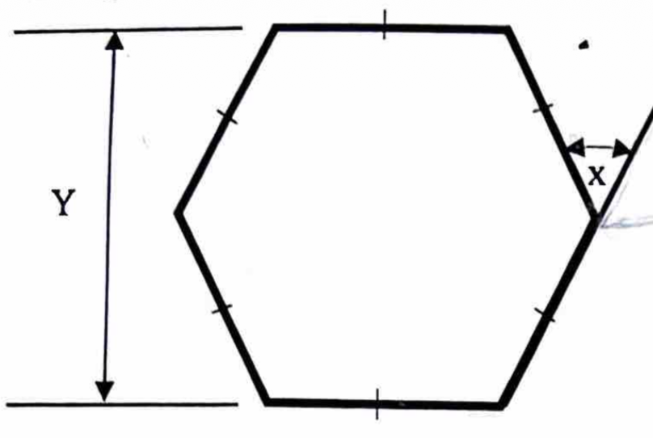
A. 90°
B. 60°
C. 45°
D. 30°

Q28. How many semi-circles make up a complete circle? [Circles & Ellipses]
A. 2
B. 3
C. 4
D. 5

Q29. The figure illustrated above is called a [Freehand & Solids]
A. square pyramid
B. rectangular prism
C. cube
D. cuboid

Q30. The figure drawn above represents … projection. [Projections]
A. isometric
B. orthographic
C. oblique
D. perspective

Q31. A square when pushed to an angle other than 90° will become a [Quadrilaterals]
A. rhomboid
B. rhombus
C. trapezium
D. trapezoid

Q32. What name is given to the figure illustrated below? [Polygons]
A. Polygon
B. Quadrilateral
C. Re-entrant polygon
D. Regular polygon

Q33. The figure drawn below is called [Circles & Ellipses]
A. bisecting circles
B. common circles
C. concentric circles
D. eccentric circles

Q34. The diagram below shows a view of a square.......... [Quadrilaterals]
A. cone
B. cylinder
C. prism
D. pyramid

Q35. In the diagram below, line GH is called a/an [Lines & Conventions]
A. construction line
B. dimension line
C. extension line
D. outline

Q36. The name given to a quadrilateral with equal sides and a pair of opposite angles greater than 90° is [Quadrilaterals]
A. square.
B. parallelogram.
C. rectangle.
D. rhombus.

Q37. In the diagram above, line PQ is a [Lines & Conventions]
A. base line.
B. reference line.
C. diagonal line.
D. radial line.

Q38. What is the name of line HK in the diagram below? [Lines & Conventions]
A. Axis
B. Connection
C. Diagonal
D. Hypotenuse

Q39. The two axes of an ellipse are [Circles & Ellipses]
A. major and main axes.
B. main and minor axes.
C. major and focal axes.
D. major and minor axes.

Q40. Which of the following receding angles is the basis of an isometric drawing? [Projections]
A. 60°
B. 45°
C. 30°
D. 15°

Mock Exam 2 — Answer Key
Q# | Answer | Explanation | From Year
1 | A | The base angles of an isosceles triangle are equal; each is (180° - 70°) ÷ 2 = 55°. | 2002
2 | C | Each interior angle of a regular pentagon is 108°. | 2002
3 | D | A full circle measures 360°. | 2002
4 | C | The figure shown is a frustum of a cone. | 2002
5 | A | Cabinet projection reduces receding lengths by half. | 2002
6 | D | A quadrant is not a quadrilateral; it is a quarter of a circle. | 2015
7 | A | The diameter is twice the radius (80 mm), equal to the side of the square. | 2015
8 | B | Concentric circles share the same centre but have different radii. | 2015
9 | C | F1 and F2 are focal points of the ellipse. | 2015
10 | A | The method shown is oblique projection. | 2015
11 | B | Any four-sided figure is a quadrilateral. | 2016
12 | C | Stepping off the radius six times produces a hexagon. | 2016
13 | A | Proportionality and neatness are key in freehand sketching. | 2016
14 | C | Isometric axes are drawn at 120° apart. | 2016
15 | B | Line EF is a dimension line used to show measurements. | 2016
16 | C | Two right triangles form a square when joined on the hypotenuse. | 2020
17 | B | The distance across opposite corners is called across corners. | 2020
18 | B | Circles with different centre are eccentric. | 2020
19 | A | The foci method is a standard way to construct an ellipse. | 2020
20 | B | Oblique views use receding sides at 45°. | 2020
21 | C | A rhombus has equal sides but diagonals of different lengths. | 2021
22 | C | The radius is stepped off six times to form a hexagon. | 2021
23 | B | The dimension marked x measures 60 mm. | 2021
24 | B | A square prism with equal sides is a cube. | 2021
25 | D | Isometric circles are drawn using the ordinate method. | 2021
26 | C | Quadrilaterals have four sides, four angles, and two diagonals. | 2022
27 | B | The angle marked x is 360/6 = 60°. | 2022
28 | A | Two semicircles make a complete circle. | 2022
29 | C | The figure shown is a cube. | 2022
30 | C | The figure shown is an oblique projection. | 2022
31 | B | A square tilted becomes a rhombus. | 2025
32 | C | The illustrated figure is a re-entrant polygon. | 2025
33 | C | Circles sharing the same centre are concentric circles. | 2025
34 | D | The view shown is of a pyramid. | 2025
35 | B | Line GH is a dimension line. | 2025
36 | D | A rhombus has four equal sides and opposite angles that can be greater than 90°. | 2026
37 | C | PQ joins two non-adjacent vertices of the rectangle, so it is a diagonal line. | 2026
38 | C | HK joins two non-adjacent vertices of the polygon, so it is a diagonal. | 2026
39 | D | The two principal axes of an ellipse are the major axis and the minor axis. | 2026
40 | C | Isometric receding axes are drawn at 30° to the horizontal. | 2026

Mock Exam Paper 3
This mock paper contains 30 questions mixed from all years. Time yourself: 2 hours 30 minutes. Good luck!

Q1. Which of the figures above is correctly dimensioned? [Dimensioning & Lettering]
Q2. The skills of movement controlled by the brain are called [Circles & Ellipses]
A. perception
B. motor skills
C. technical drawing
D. intellectual skill

Q3. Which of the following items could be used in the absence of drawing clips? [Drawing Instruments]
A. Paper tape
B. Glue
C. Screws
D. Nails

Q4. The receding angle generally used in isometric projection is [Projections]
A. 20°
B. 30°
C. 45°
D. 60°

Q5. The line marked Q in the diagram above is called a/an [Lines & Conventions]
A. projection line
B. dimension line
C. outline
D. chain line

Q6. The plan view of an object is a drawing which shows the view from [Projections]
A. left hand side
B. the front
C. above
D. right hand

Q7. In visualization one uses … [Freehand & Solids]
A. intellectual skills
B. visual skills
C. motor skills
D. light

Q8. The main function of a ruler is to … [Drawing Instruments]
A. transfer measurement from an object to a drawing
B. measure in meters
C. mark points on a drawing
D. measure distances on a drawing

Q9. Technical drawing is said to be the … language of an industry. [General]
A. general
B. universal
C. mechanical
D. industrial

Q10. The instrument most suitable for linear measurement is called … [Drawing Instruments]
A. protractor
B. try square
C. set square
D. ruler

Q11. Which of the following can be used to draw an isometric circle? [Circles & Ellipses]
A. Square
B. Rectangular
C. Focal point
D. Ordinates

Q12. Which of the following figures above is correctly dimensioned? [Dimensioning & Lettering]
Q13. The diagram above shows the principal planes used in orthographic projection. In first angle projection, the front elevation is drawn on the portion labelled … [Projections]
A. M
B. N
C. O
D. P

Q14. A drawing skill in which one uses the hands during operation is called … skill. [Freehand & Solids]
A. visual
B. intellectual
C. motor
D. power

Q15. Which of the following instruments has one of its angles at 60°? [Drawing Instruments]
A. 45° set square
B. 30° set square
C. Tee-square
D. Adjustable set square

Q16. Which of the following figures above is correctly dimensioned? [Dimensioning & Lettering]
Q17. Technical Drawing can also be referred to as communication. [General]
A. written
B. graphical
C. mental
D. oral

Q18. One of the main features of a drawing board is [Drawing Instruments]
A. to have smooth edges
B. to have a smooth surface
C. to have unsquared surface
D. to have a rough surface

Q19. Short pencil is recommended for use with a pair of compasses in order to [Drawing Instruments]
A. keep the pair of compasses in good shape
B. avoid obstruction when drawing arcs
C. utilise the pencil economically
D. decorate the pair of compasses

Q20. The line labeled 'S' in the diagram above is called … line. [Lines & Conventions]
A. parallel
B. dimension
C. centre
D. projection

Q21. The angle of projection for the true shape on a cutting plane is [Projections]
A. 60°
B. 80°
C. 90°
D. 120°

Q22. Good draughtmanship involves [Dimensioning & Lettering]
A. using all types of lines in drawing.
B. the use of compasses alone.
C. drawing border lines and title block.
D. division of the drawing area.

Q23. The main function of the rule is to [General]
A. mark points on an object.
B. measure an object.
C. measure in kilometres.
D. transfer measurements from the rule to an object.

Q24. Which of the following is not a Technical Drawing equipment? [Drawing Instruments]
A. Set-square
B. French curve
C. File
D. Drawing board

Q25. The method used to draw the layout of the figures below is [Projections]
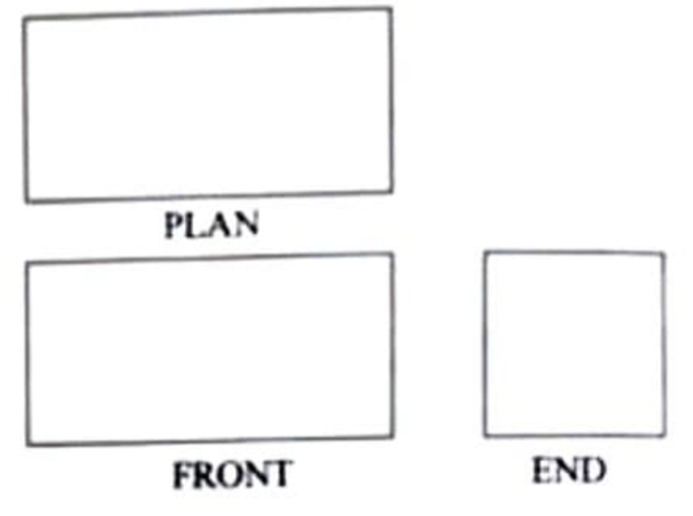
A. third angle projection
B. pictorial view
C. orthographic projection
D. first angle projection

Q26. Identify the method of drawing used to show the solid in the diagram below. [Projections]
A. Isometric projection
B. Orthographic projection
C. Oblique projection
D. Perspective projection

Q27. The form of dimensioning shown in the diagram below is commonly known as [Projections]
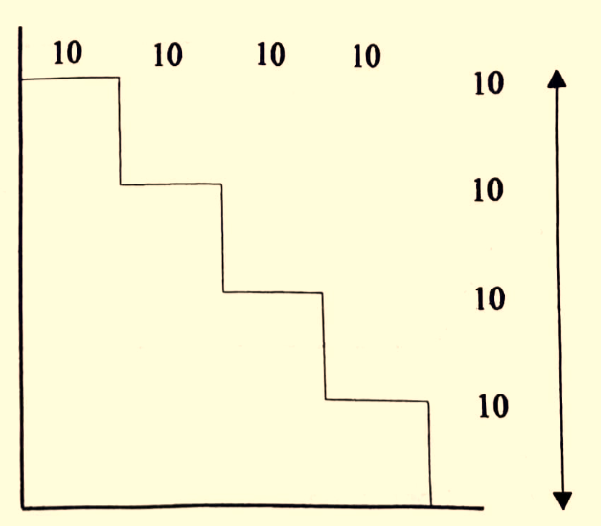
A. stepping.
B. chain.
C. datum.
D. conventional.

Q28. The line marked ‘Q’ in the diagram is called a/an [Lines & Conventions]
A. projection line.
B. outline.
C. dimension line.
D. chain line.

Q29. The plan view of an object is a drawing which shows a view from [Projections]
A. the front.
B. the left side.
C. the right side.
D. above.

Q30. Which of the drawings below shows the elevation FE of the object drawn above? [Projections]

Mock Exam 3 — Answer Key
Q# | Answer | Explanation | From Year
1 | A | Option A follows correct dimensioning standards. | 2002
2 | B | Motor skills are physical movements coordinated by the brain. | 2002
3 | A | Paper tape can temporarily hold drawing sheets in place. | 2002
4 | B | Isometric projection uses 30° receding angles. | 2015
5 | B | Dimension lines indicate measurements on drawings. | 2015
6 | C | Plan view shows the object as seen from above. | 2015
7 | B | Visualization depends on visual skills to imagine objects. | 2015
8 | D | A ruler is used to measure distances on a drawing. | 2015
9 | B | Technical drawing is considered the universal language of industry. | 2016
10 | D | A ruler is the most suitable instrument for linear measurement. | 2016
11 | D | Isometric circles are drawn using the ordinate method. | 2020
12 | A | Option A follows correct dimensioning standards. | 2020
13 | A | In first angle projection, the front elevation is drawn on portion M. | 2020
14 | C | Motor skills involve the use of hands and physical movement. | 2020
15 | B | The 30° set square has angles of 30°, 60°, and 90°. | 2020
16 | D | Option D follows correct dimensioning standards. | 2021
17 | B | Technical drawing is a graphical form of communication. | 2021
18 | B | A drawing board must have a smooth surface for accurate work. | 2021
19 | B | A short pencil prevents obstruction when drawing arcs. | 2021
20 | B | Line S is a dimension line. | 2022
21 | C | True shapes are projected at 90° to the cutting plane. | 2022
22 | C | drawing border lines and title block.i | 2022
23 | B | A rule is primarily used to measure objects. | 2022
24 | C | A file is not considered technical drawing equipment. | 2022
25 | A | The layout shown uses third angle projection. The plan is drawn above the front view | 2025
26 | C | The solid has a face drawn in true shape with receding lines at an oblique angle, identifying obliqu... | 2026
27 | A | Each successive feature is dimensioned from the preceding feature, forming a stepping dimensioning a... | 2026
28 | C | Q is the line carrying the 60 measurement, so it is a dimension line. | 2026
29 | D | A plan view represents the object as seen from above. | 2026
30 | D | The elevation corresponding to the indicated FE viewing direction is represented by option D. | 2026

Glossary of Technical Drawing Terms
Term | Definition
Arc | A portion of the circumference of a circle
Chord | A straight line joining two points on a curve
Concentric | Circles sharing the same centre but different radii
Circumscribe | To draw a circle passing through all vertices of a polygon
Diameter | A straight line passing through the centre of a circle, joining two points on the circumference
Eccentric | Circles with different centres
Elevation | A view of an object from the front, side, or back
Frustum | The portion of a cone or pyramid remaining after the top is cut off by a plane parallel to the base
Hatching | Parallel lines drawn at 45° to indicate cut surfaces in sectional views
Hypotenuse | The longest side of a right-angled triangle, opposite the right angle
Inscribe | To draw a circle inside a polygon touching all sides
Isometric | A pictorial drawing method where all three axes are equally inclined at 120°
Leader line | A thin line pointing from a note or dimension to a feature
Oblique | A pictorial drawing method where the front face is shown in true shape
Orthographic | A multi-view drawing method showing plan, elevation, and end views
Parallel | Lines that are equidistant at all points and never meet
Perpendicular | Lines that meet at an angle of 90°
Plan | A view of an object as seen from above
Projection | The representation of a 3D object on a 2D surface
Reflex angle | An angle greater than 180° but less than 360°
Rhombus | A quadrilateral with all four sides equal
Scalene triangle | A triangle with all sides and angles unequal
Sector | A portion of a circle bounded by two radii and an arc
Segment | A portion of a circle bounded by a chord and an arc
Tangent | A straight line that touches a circle at exactly one point
Trammel | A method of constructing an ellipse using a strip of paper

